The 1st week of April

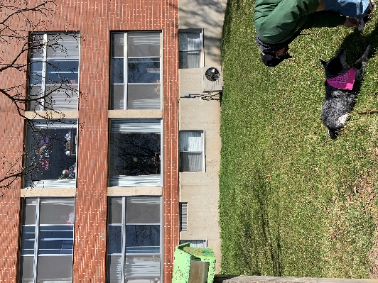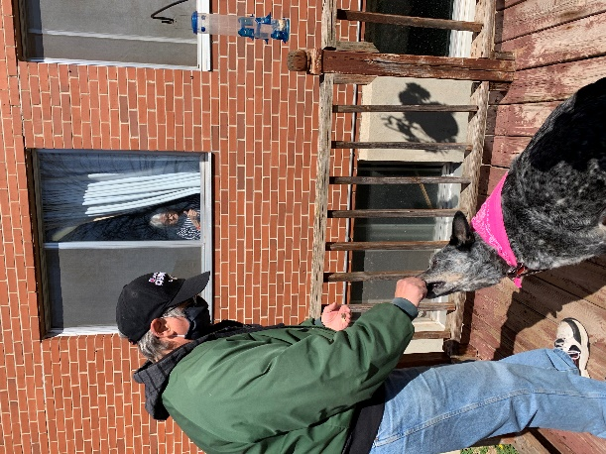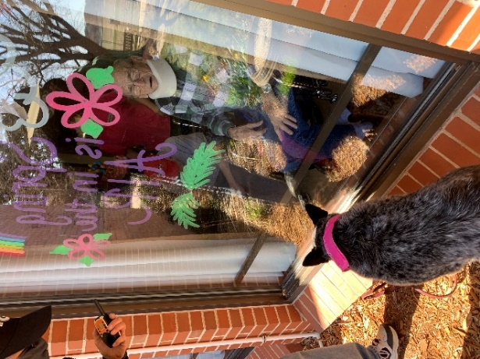

Keota entertaining us!

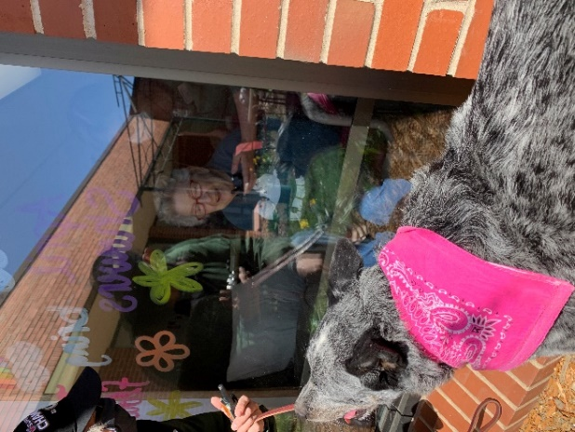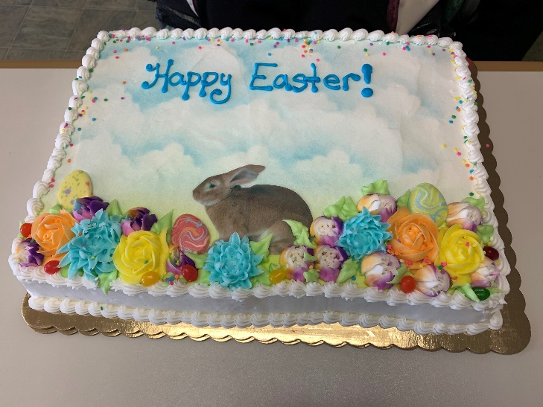

We hope you all had a nice Easter, this cake was a nice treat for all!

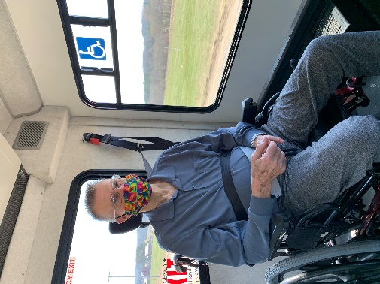 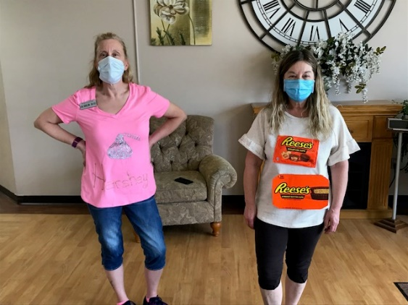 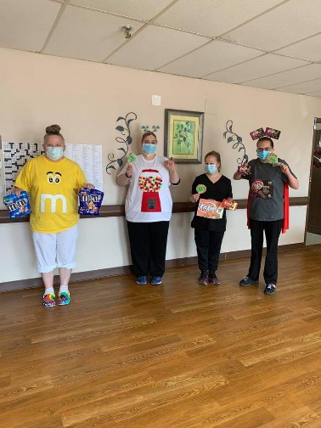

Car rides on a nice day! Dress as your favorite candy day!

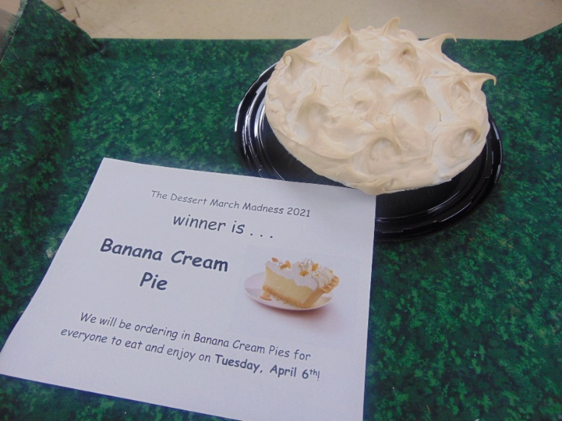Cake vs Pie March Madness was a hit!!!

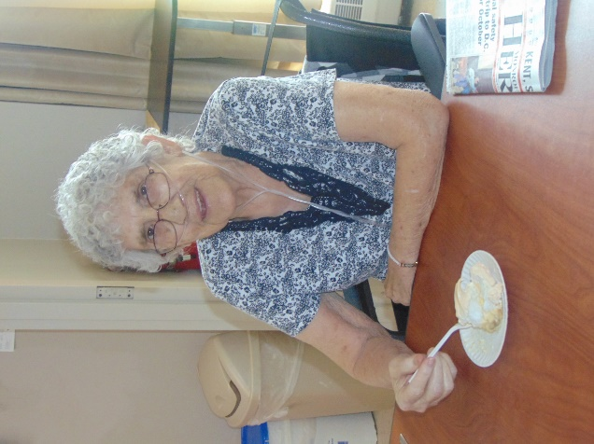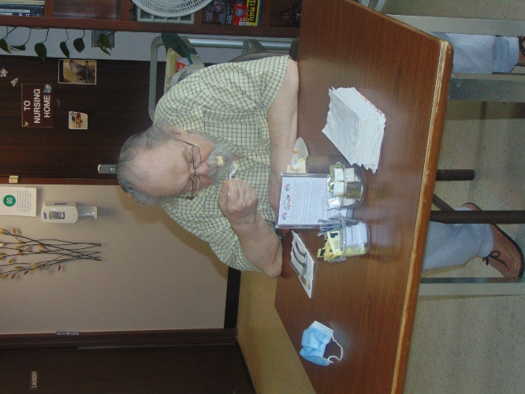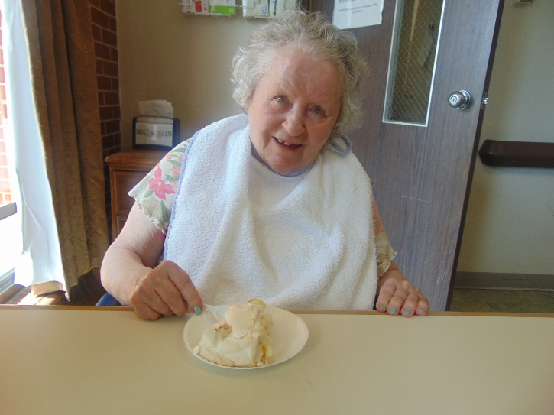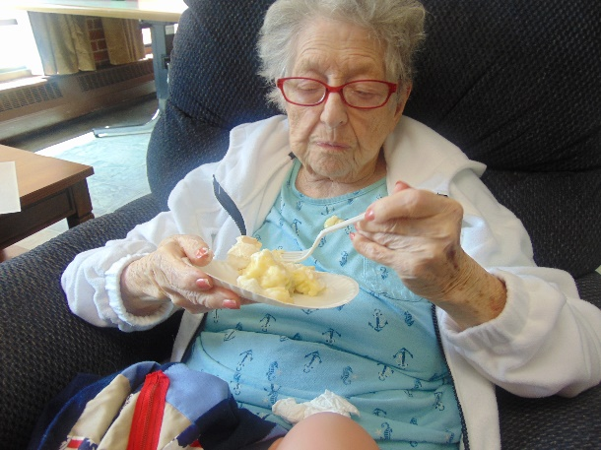

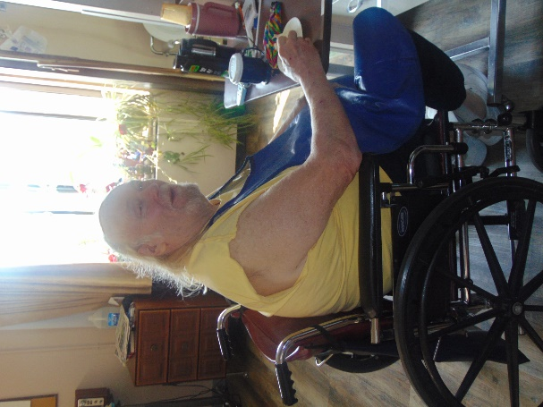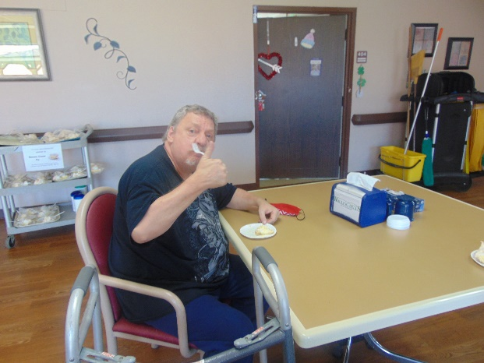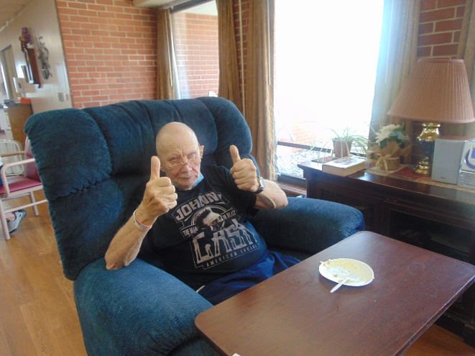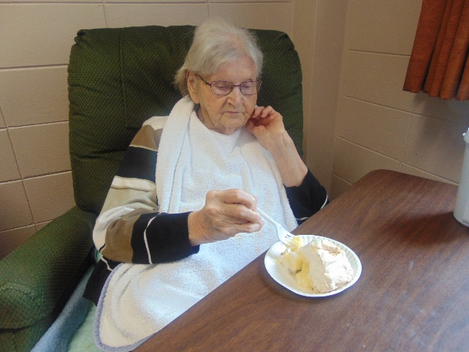

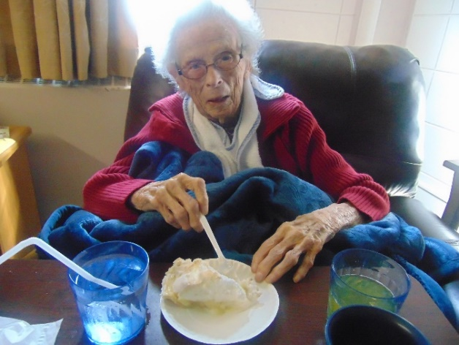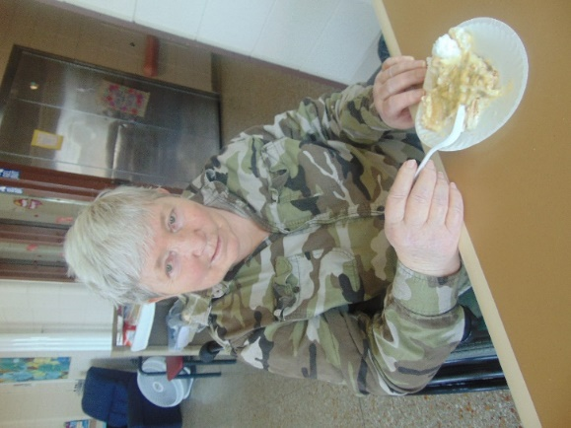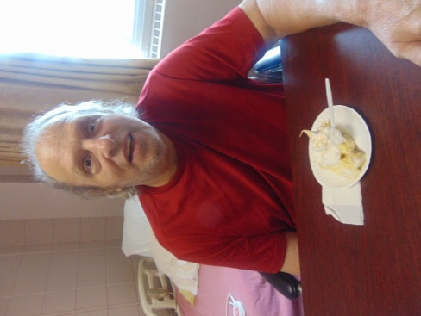

We hope everyone has been enjoying the nice weather we have been having.

This past week we took advantage of it to go for some scenic drives or just to sit out there. We were excited to enjoy the fruits of our voting and all were happy with the Banana cream pie! Some of us took the opportunity to play Hangman while others decided to catch a movie matinee called The War with Grandpa that was a cute comedy about family. Lisa filled the halls with her beautiful piano music one day too. We are so happy that this week we were able to hold our 1st in person religious service since covid began. The Catholic church, ELCA church and Wels church will be offering services once a month with social distancing guidelines in place. Until next week,

Linda