Last full week of March in Pictures

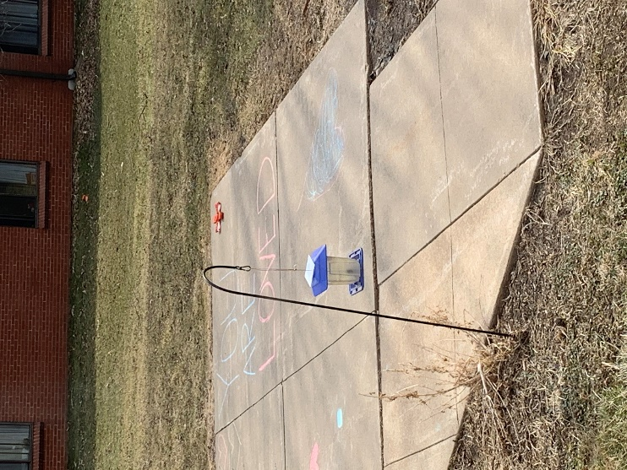 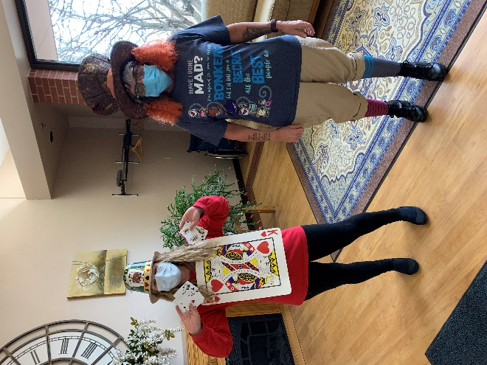

Nice sidewalk art appeared one day to brighten our spirits

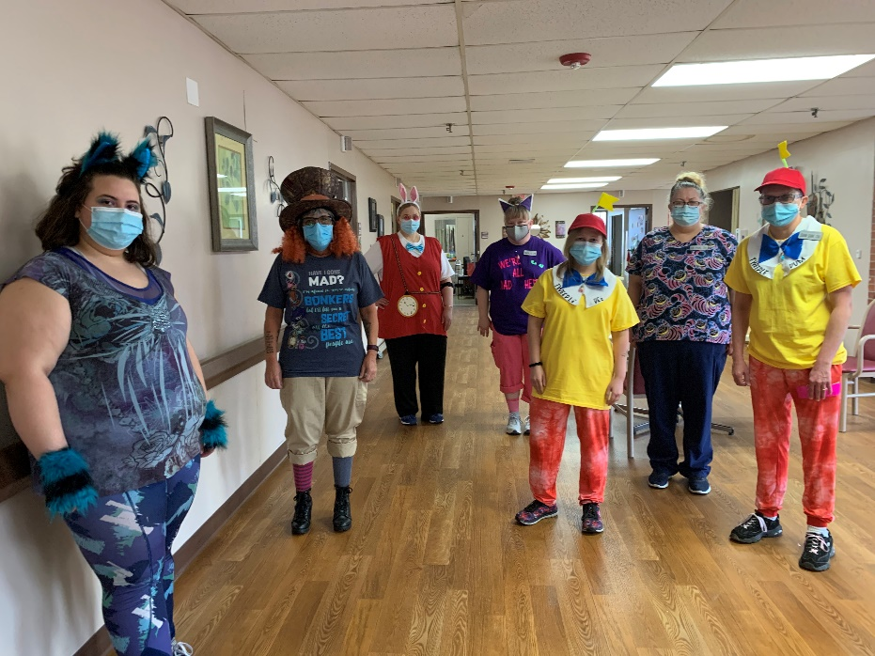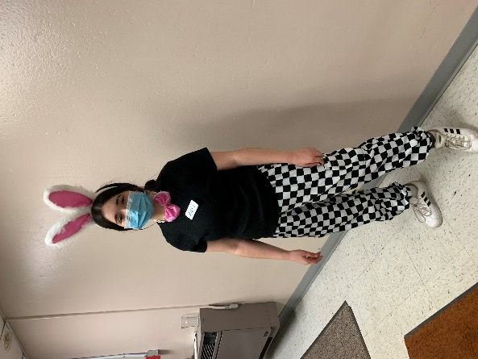

Alice in Wonderland was our theme

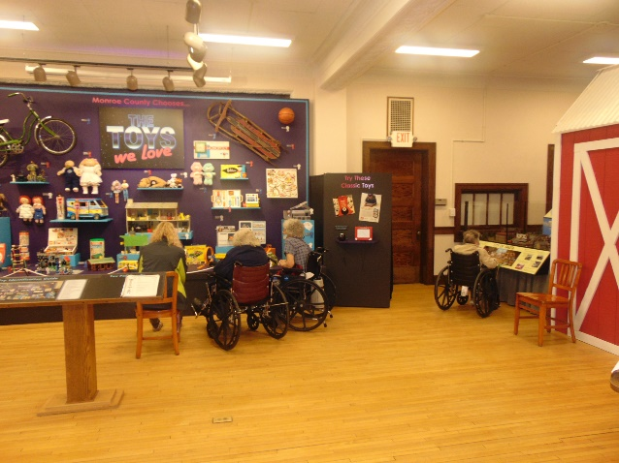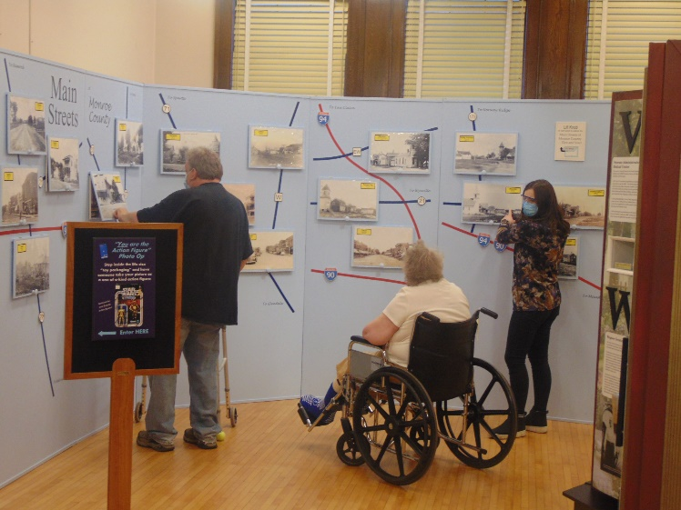

Museum trips continue

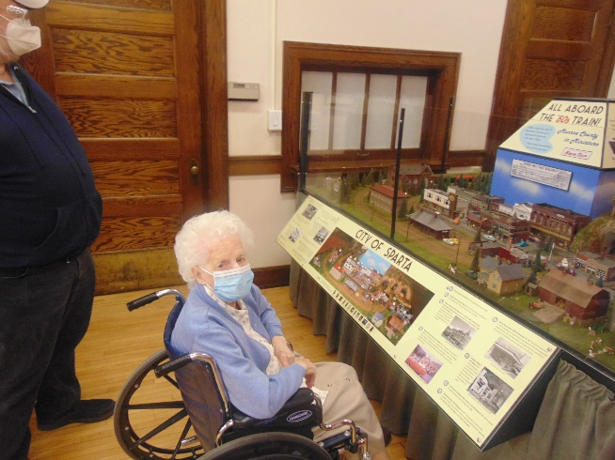 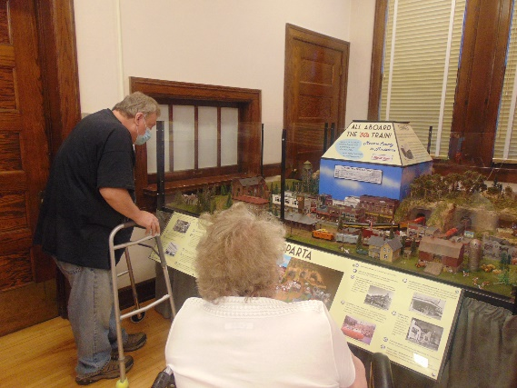

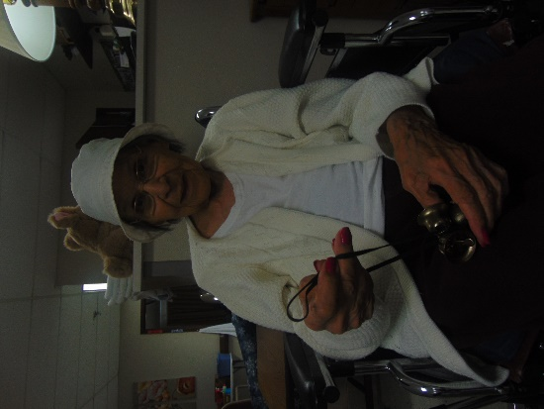

March is Music Month, so we made some



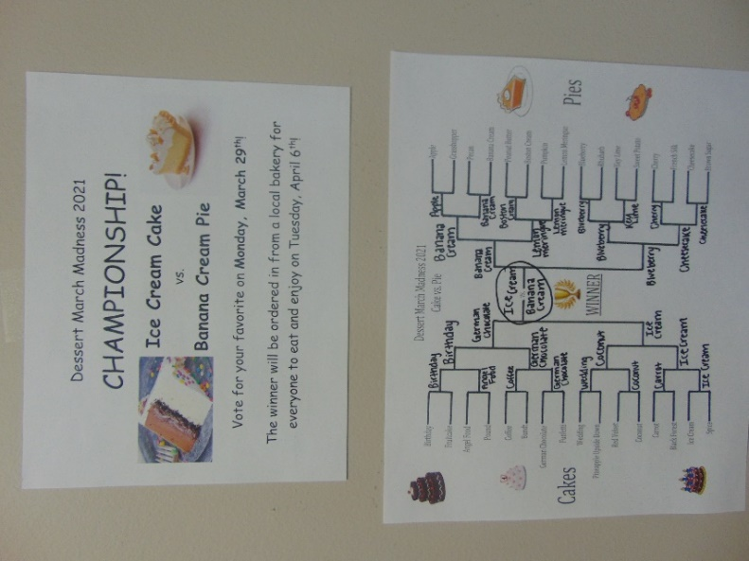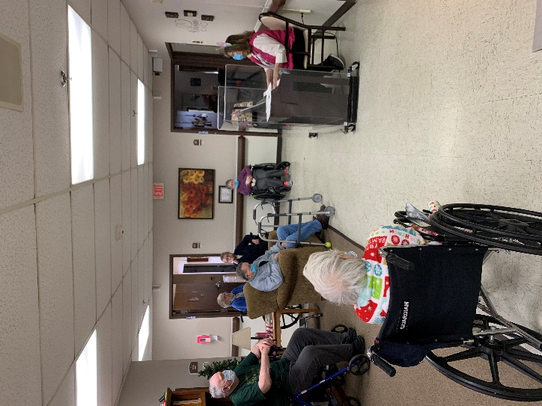

Down to the final 2: Ice Cream Cake vs Banana Cream Pie

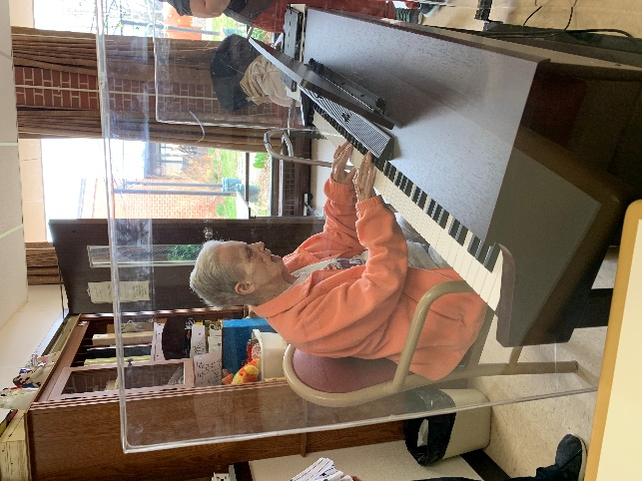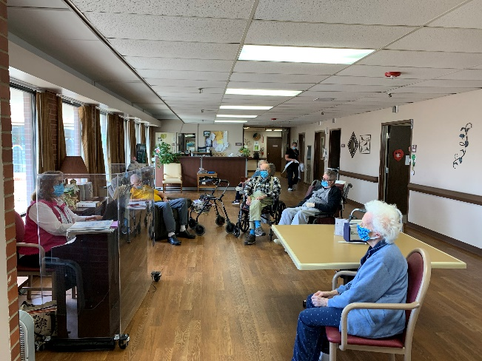

It is finally Friday!

This past week we have spent some time making and listening to music for National Music Month. We enjoyed listening to songs, trying to Name that Tune and learning facts about music. A few more of us were able to venture off to the museum as well. Our March Madness is down to the final 2, Ice Cream Cake vs. Banana Cream Pie, we can’t wait to see who the winner is!! Next week we will be having some Eater Themed fun! We hope you all have a nice weekend!

Linda