**2nd week of March in pictures**

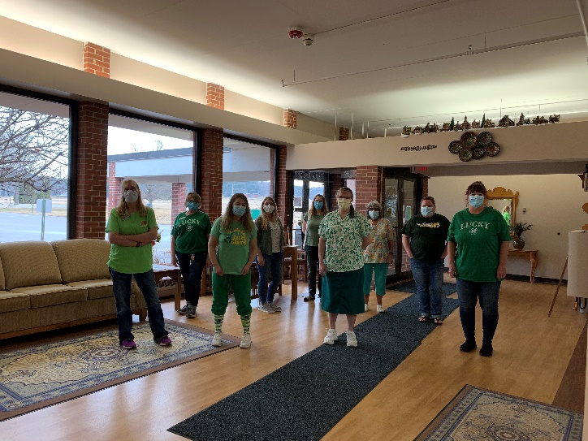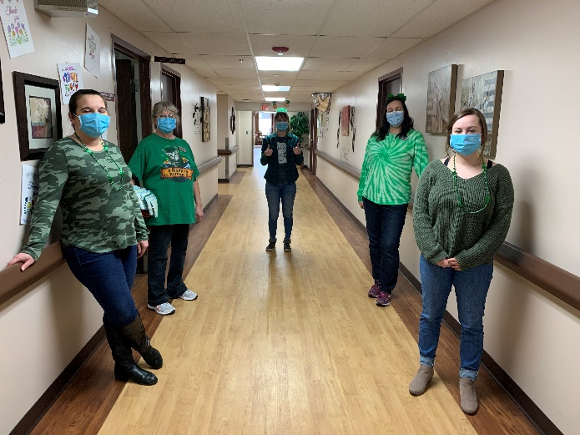

We are turning green!

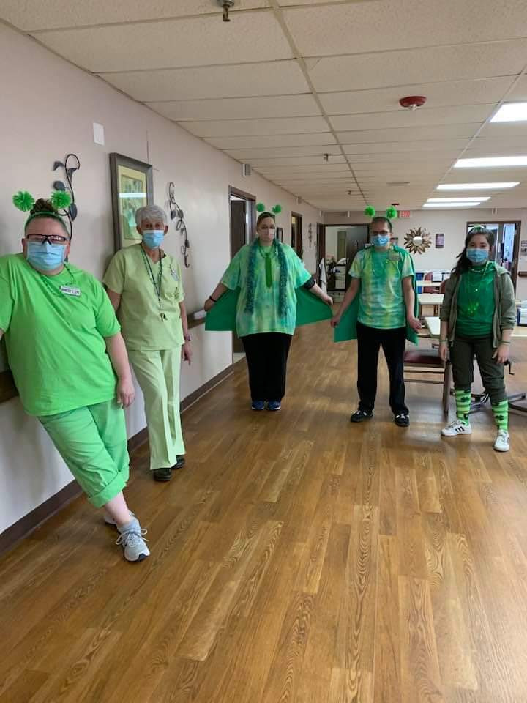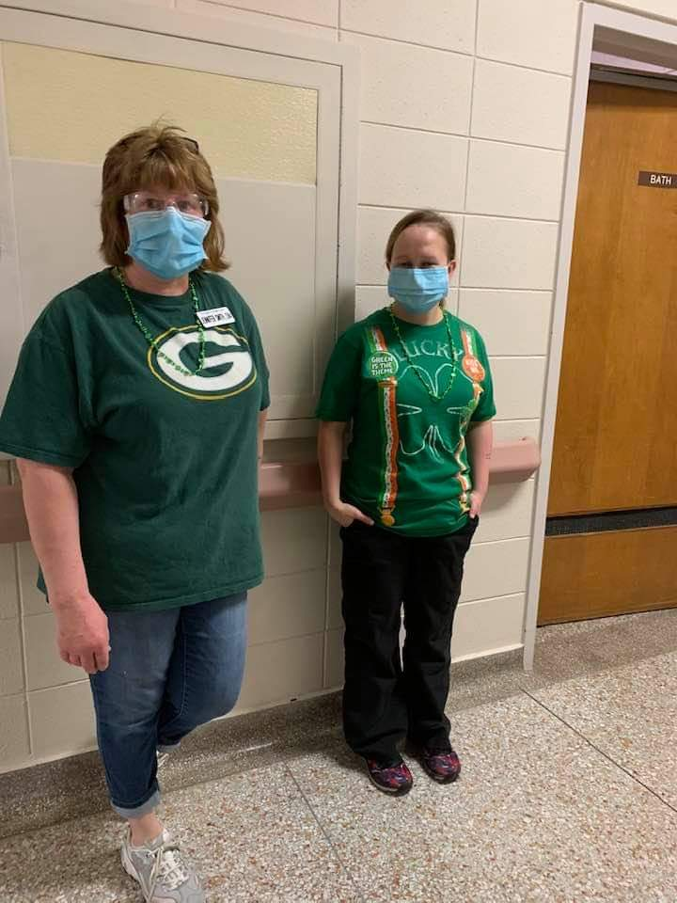

We completed our window art for St. Patrick’s Day this week:

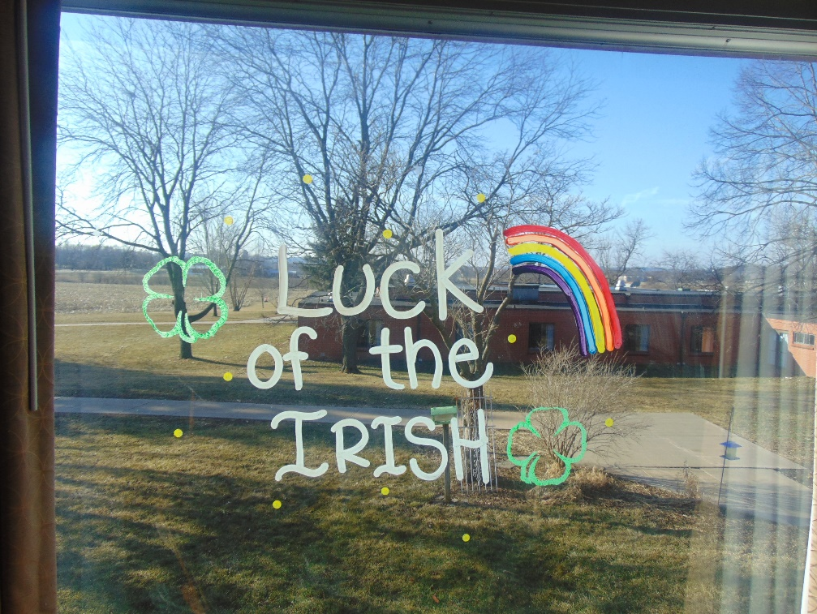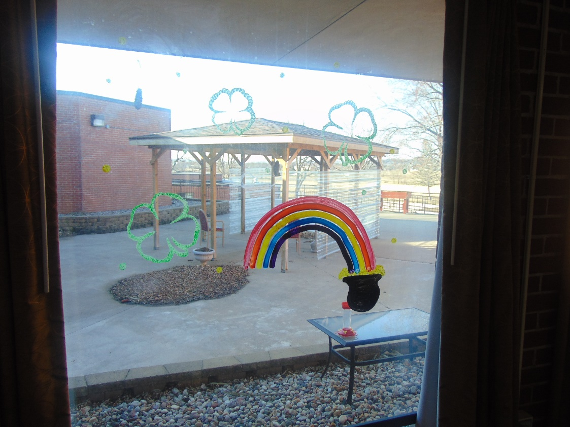

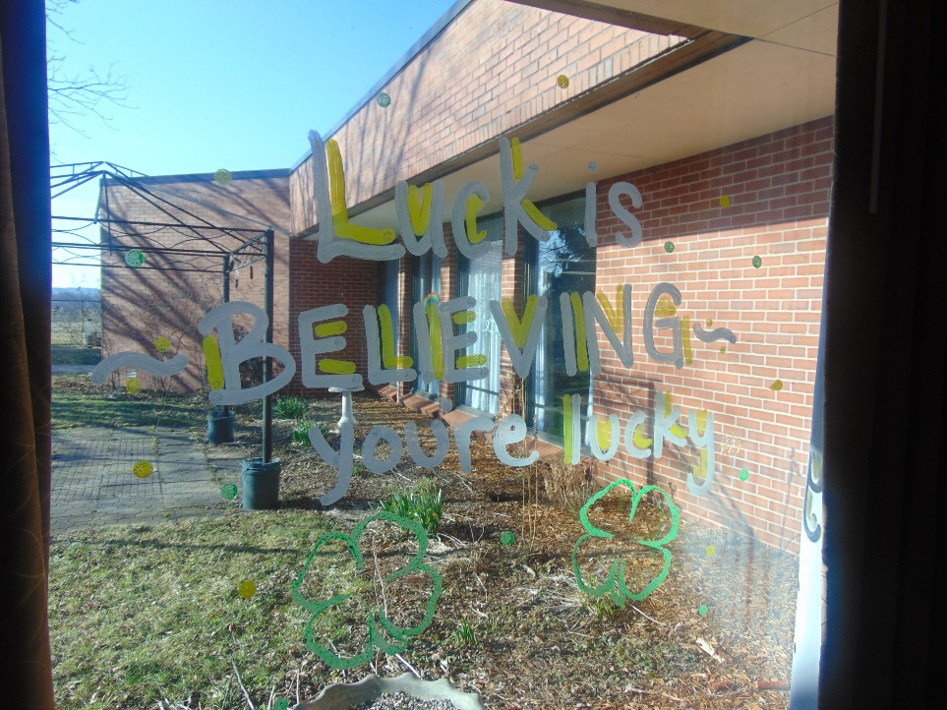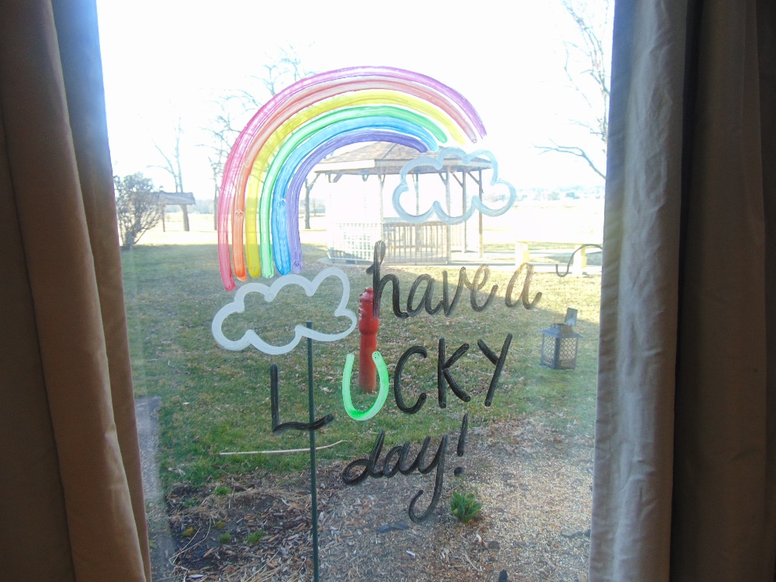

Our March Madness Cake vs. Pie bracket Piano music in the hallway:

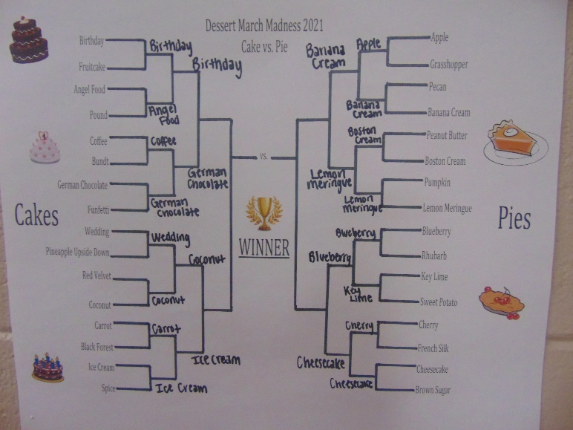 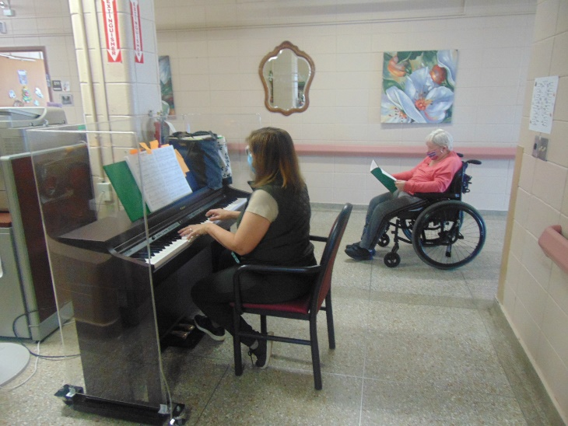

**Hello All,**

**This week we recognized March Madness by continuing our “March Madness – Pie vs Cake” voting to determine a favorite dessert. Women’s History Month was also recognized this week with facts/trivia and manicures. Our dress up day this week was “Green”, and we finished updating our window art throughout the home in preparation for St. Patrick’s Day. We enjoyed some delicious chocolate chip cookies, shared chocolate chip cookie facts, and played a chocolate chip word game. We concluded the week with listening to live piano music.**

**Wishing everyone a great weekend!**