1st week of March in Photos

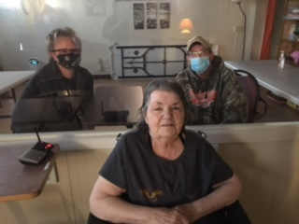 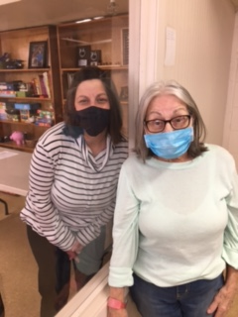

Family Visits are so fun!

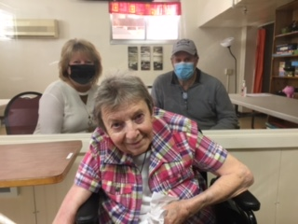

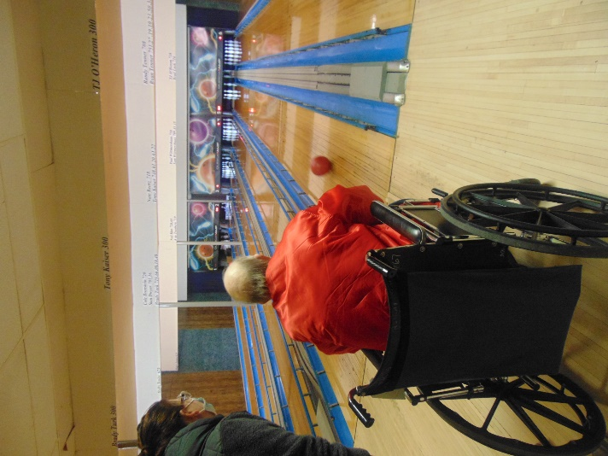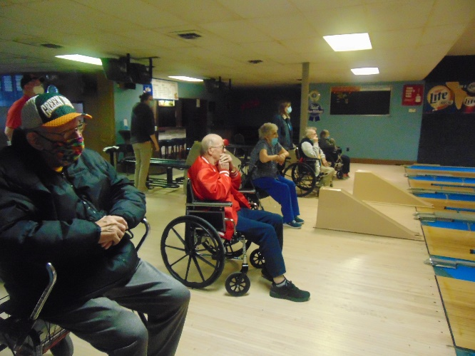

Bowling alley to ourselves for some great laughs, cheering and smiling!

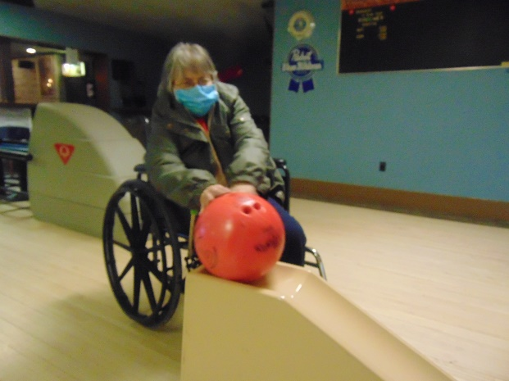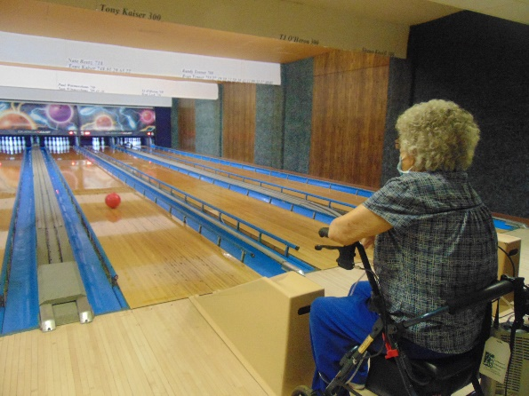

Learning about Johnny Cash, listening to some of his music and then a movie

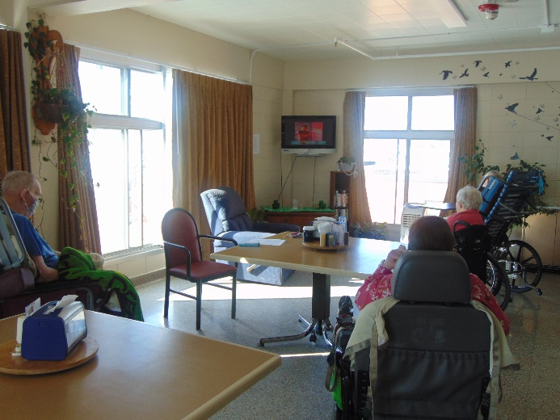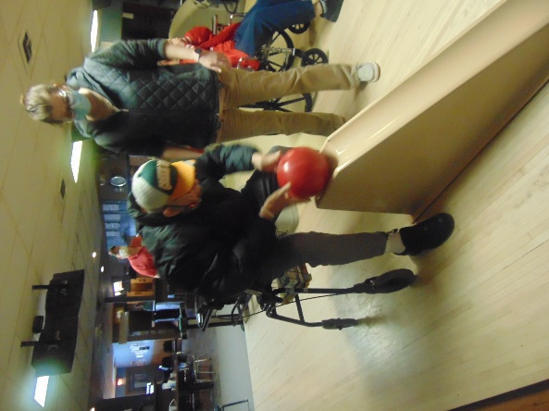

Another museum trip to ourselves

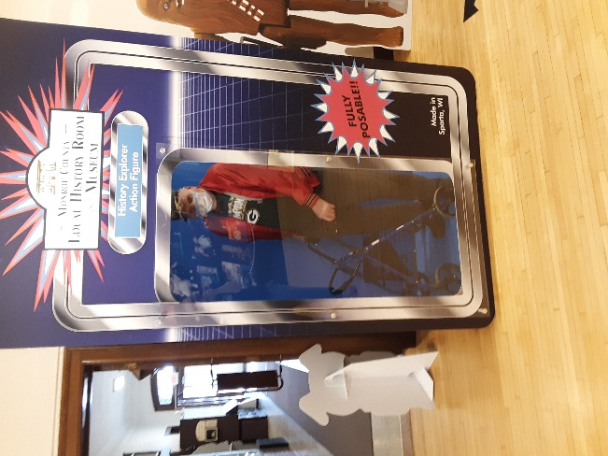

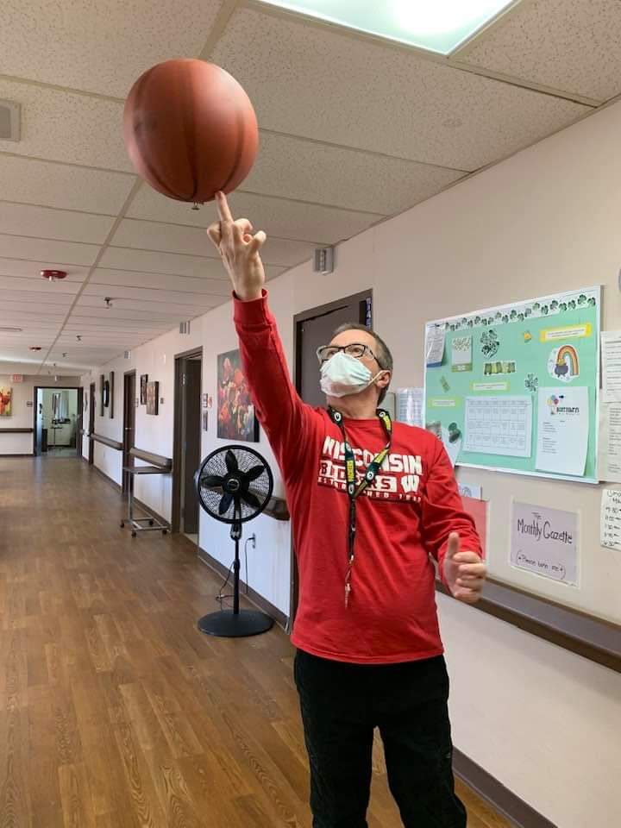Staff Dress Up Day – March Madness Theme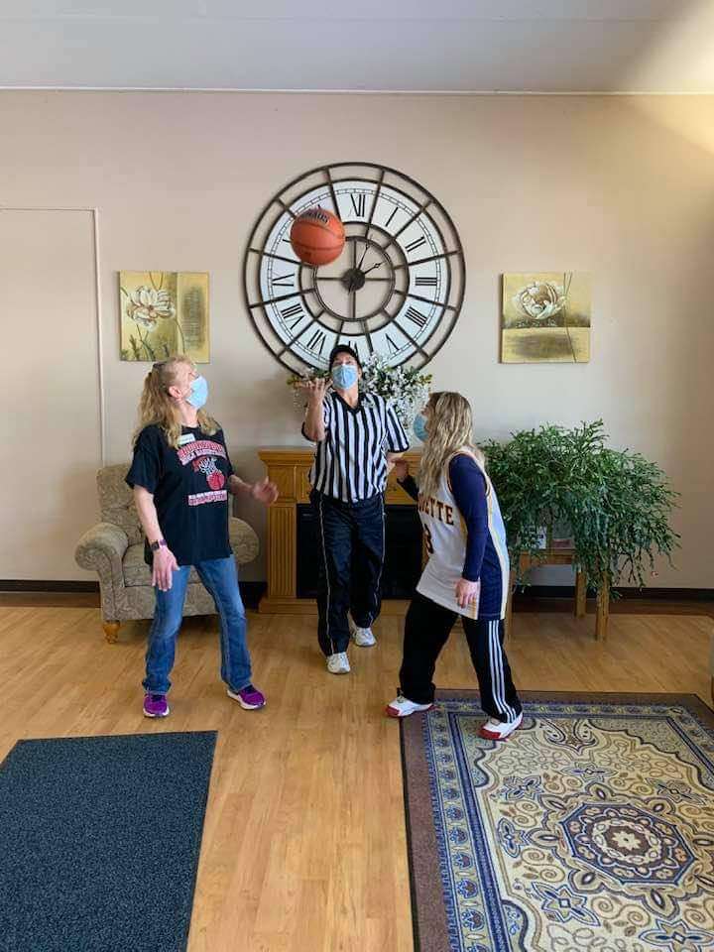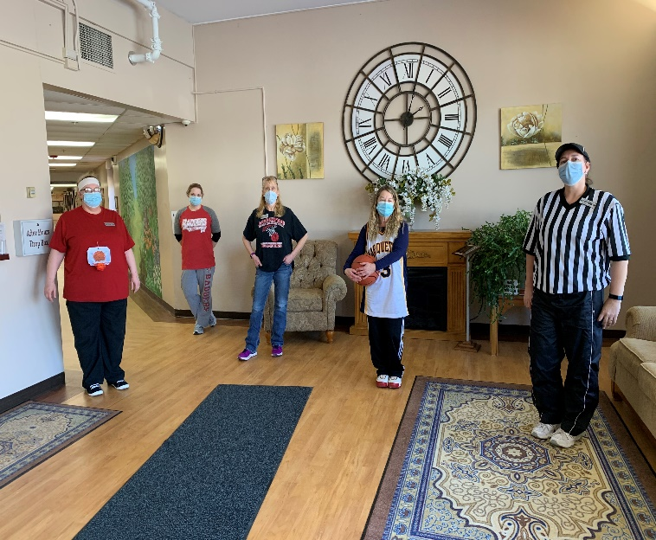

Happy Social Worker’s Month Christine and Sam!

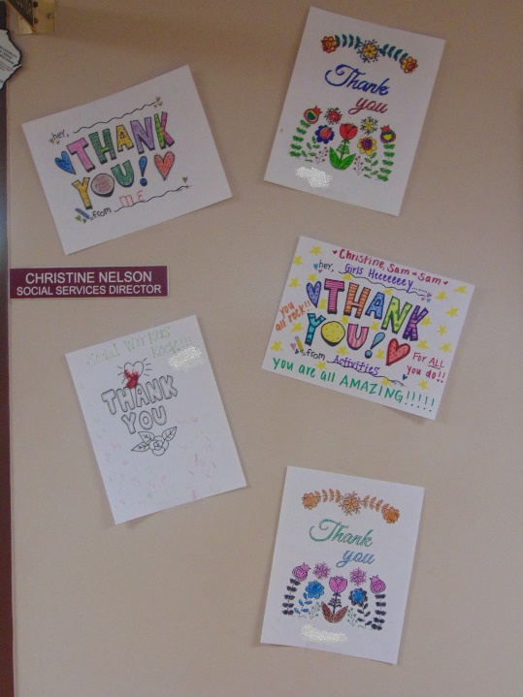 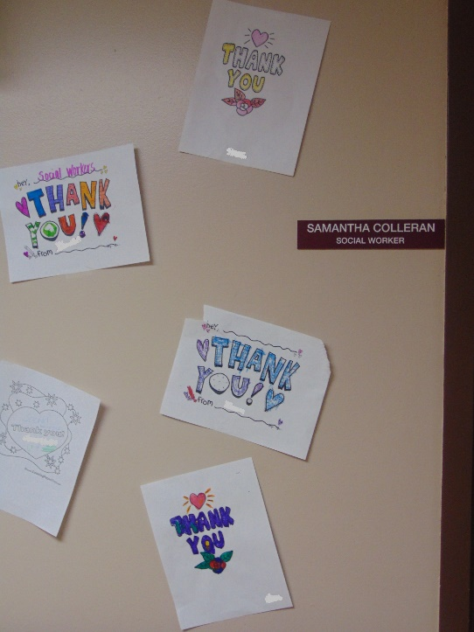

**Happy March everyone!**

**We hope everyone has been enjoying the mild weather. We are looking forward to more beautiful temps next week! With the nice weather, we were able to get out a couple times this week for some bowling at Bangor Lanes. They were kind enough to let us have the entire bowling alley to ourselves. A couple of us also got to make another trip to the museum in Sparta. Earlier this week, we celebrated Dr. Seuss with some facts/trivia and a few movies. It was World Wildlife Day on Wednesday, and we got to enjoy some facts and wildlife videos. Wishing everyone a wonderful weekend!**