Last week of February in Pictures

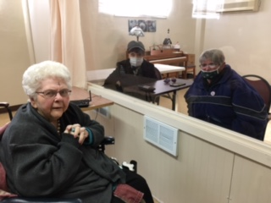 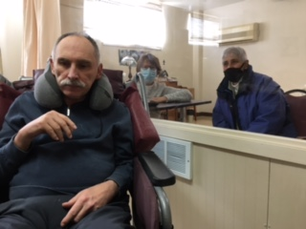

Family visits continue

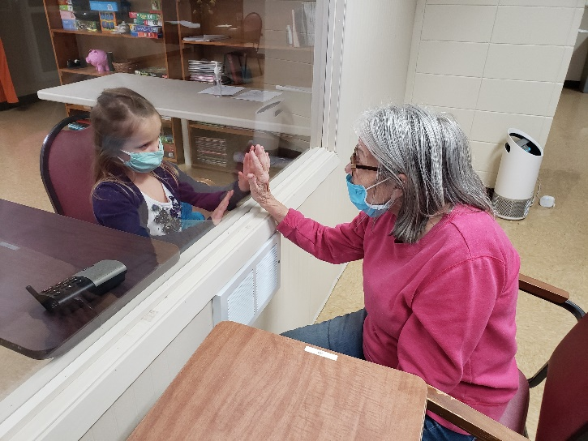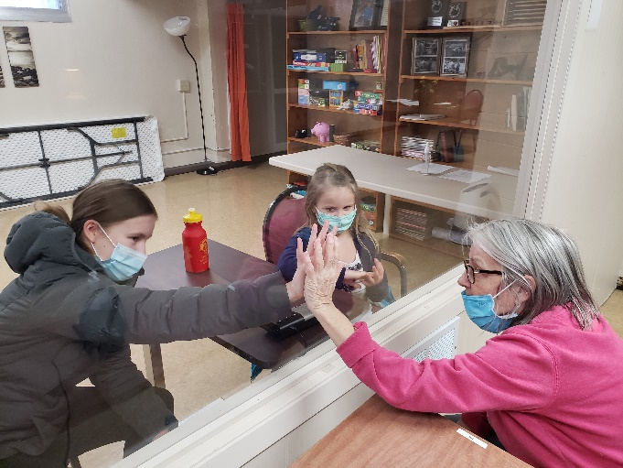

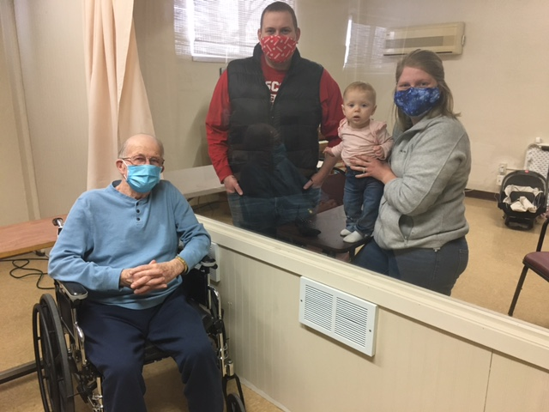

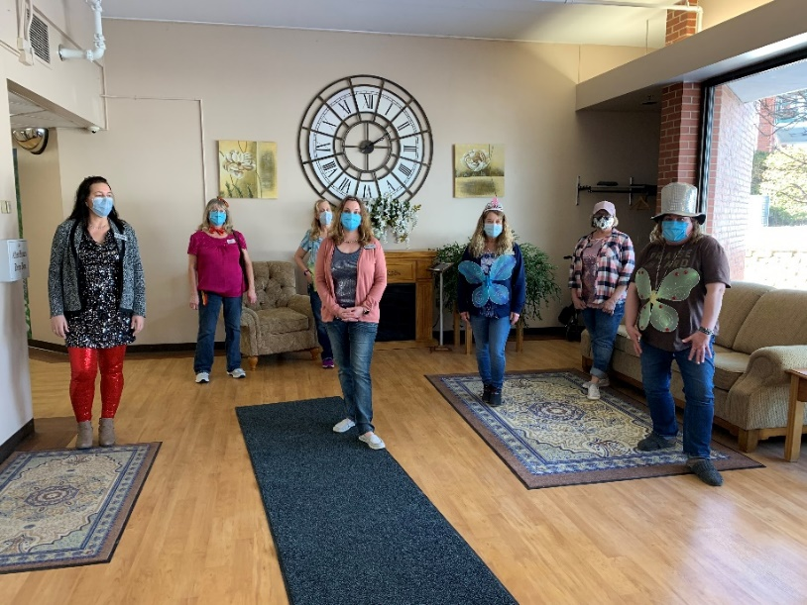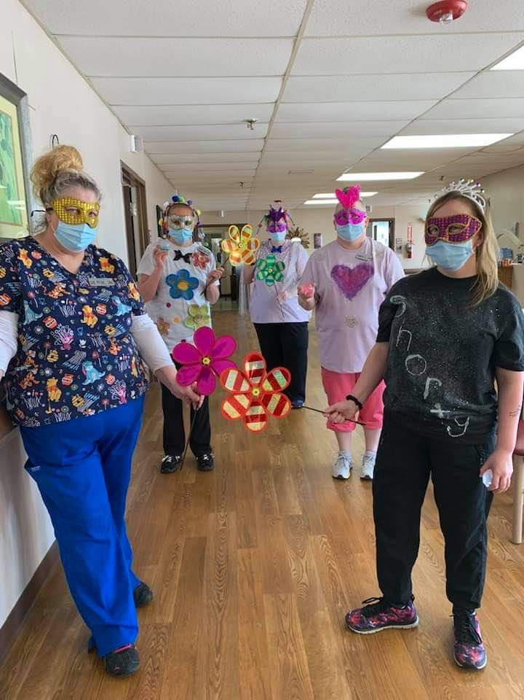

Glitter and Sparkle Day

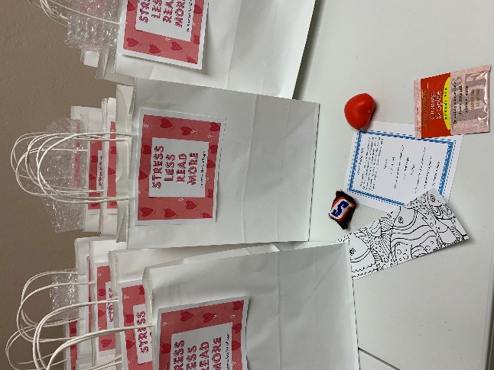 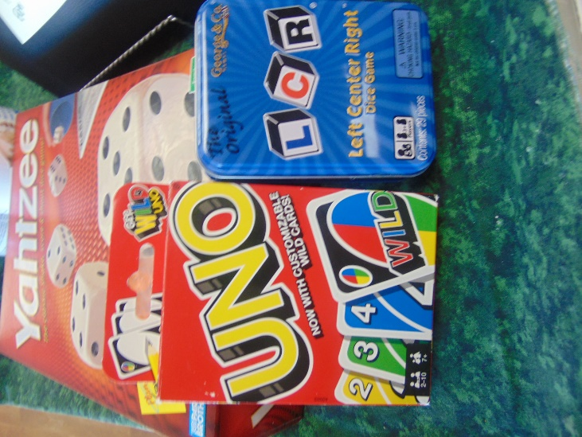

Stress kits from the library for the staff; what a nice surprise A Day of Games

The last Friday in February, man how time flies!

This past week we played a variety of games. Our intern Jess taught us a new spin on a card and dice bingo game that was a success. Then we played left/right/center and uno too. On Wednesday we had a no bake afternoon activity where we shared some interesting facts about deserts and then made our own! We had Nilla wafers, frosting and toppings to make out own concoctions. Lisa continues to play the piano in our halls throughout the month and we even sang along to Johnny Cash songs today. It is the birth anniversary of Johnny Cash so what better way to remember him then learn some facts, hear his songs and watch Walk the Line. Maybe this nice weather will stick around for a while, that sure would be nice!