1st Week of February in Pictures

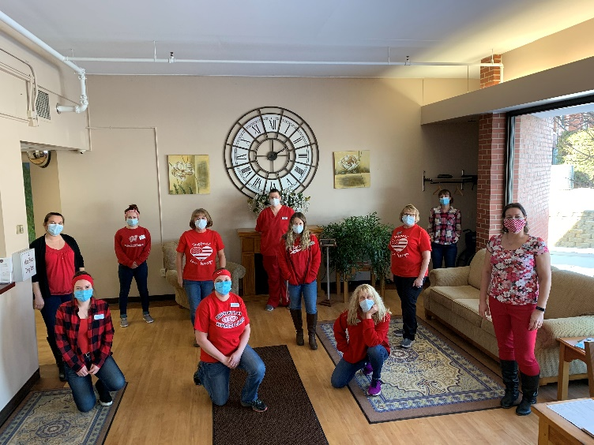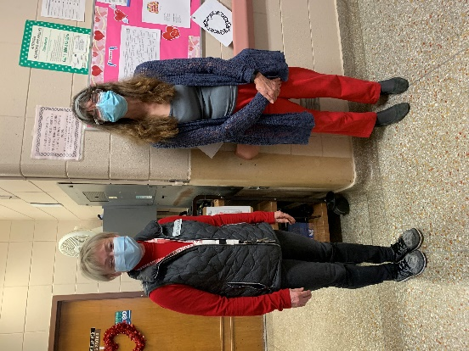

Wearing Red

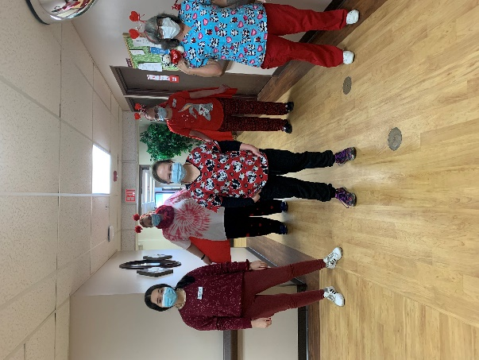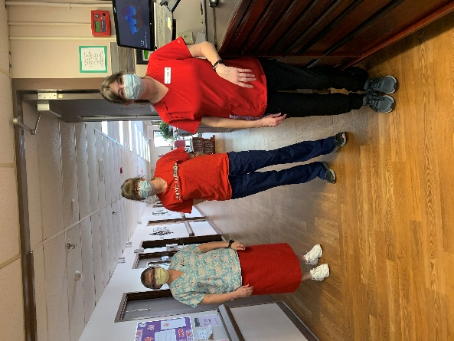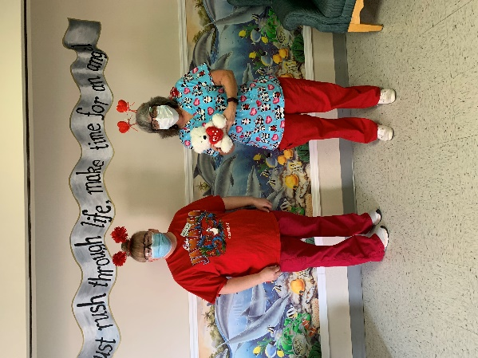

National Bird Feeder Day Activity

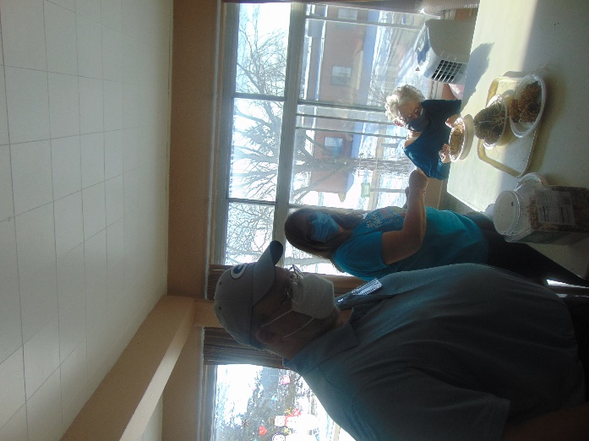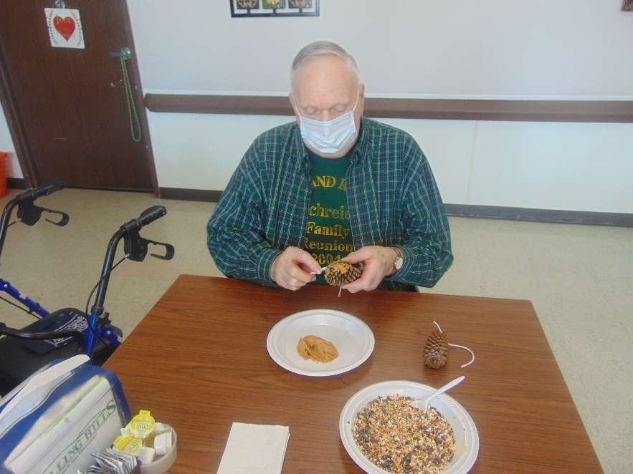

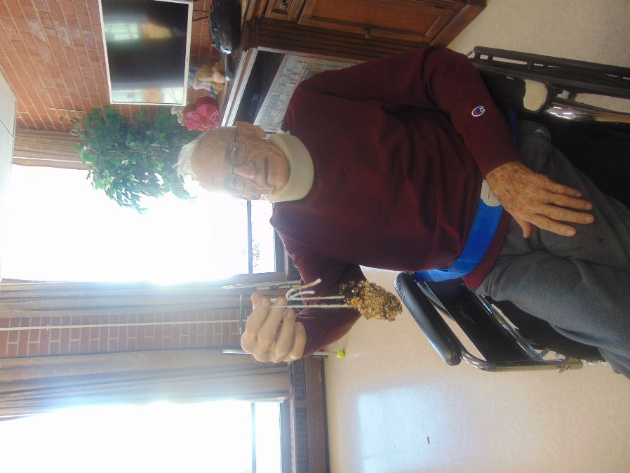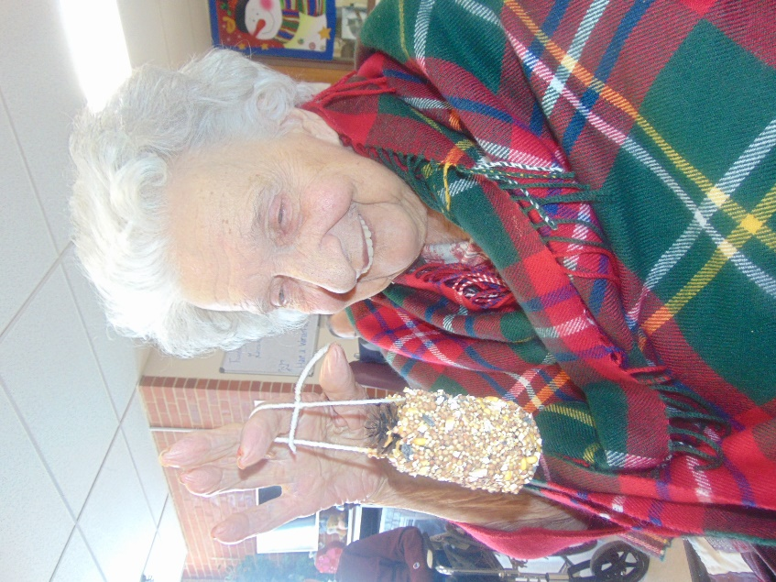

Learning about different birds and making them a feeder

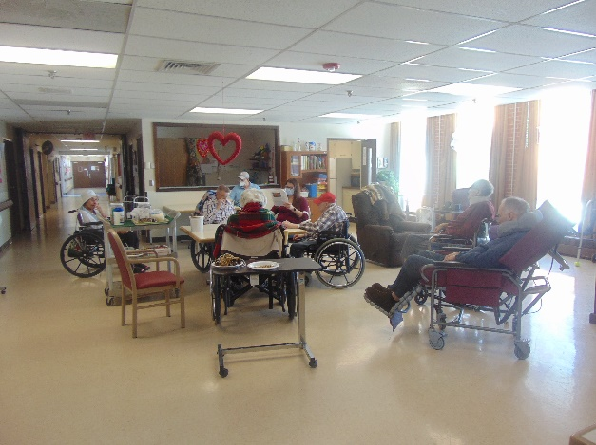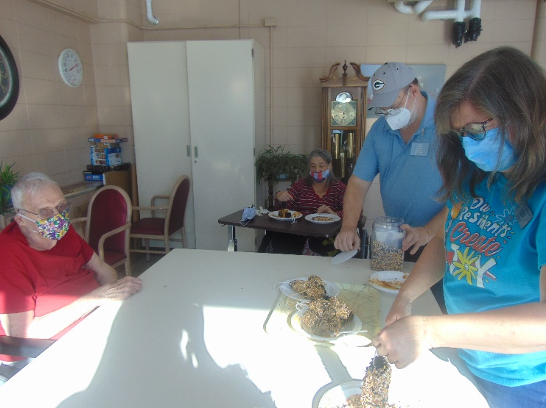

The 1st week of February is here and almost gone, and we get more winter too!

This past week we enjoyed some piano music with Lisa, exercised and talked about the news, watched some movies and church services and will be preparing for the Superbowl with a fun game and facts today. On Tuesday it was bird feeder day, so we shared fun facts about local birds and made homemade bird feeders for around our home with pinecones and peanut butter. Then on Thursday we celebrated muffin mania week with muffins and interesting facts about them because Muffin Compares to our Residents! If only you could all watch the in house channel, you would hear more of these horrible phrases and jokes!

Have a great weekend.

Linda