Last week of January 2021 in pictures

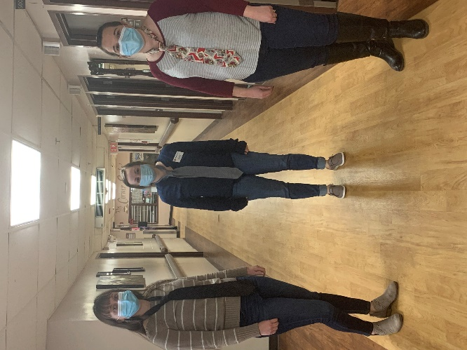 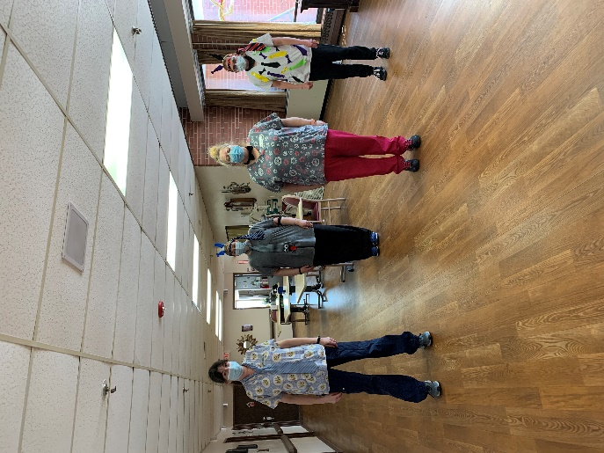

Wear a tie to work day!

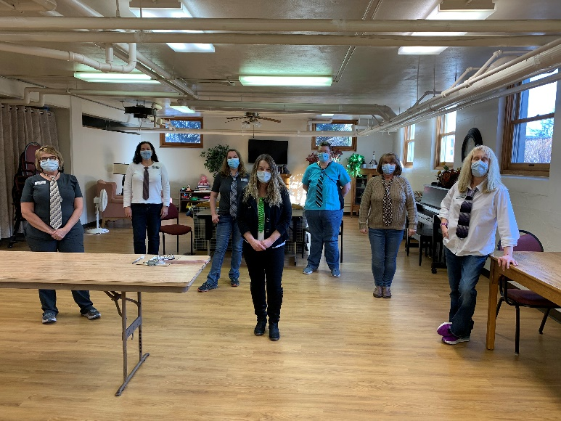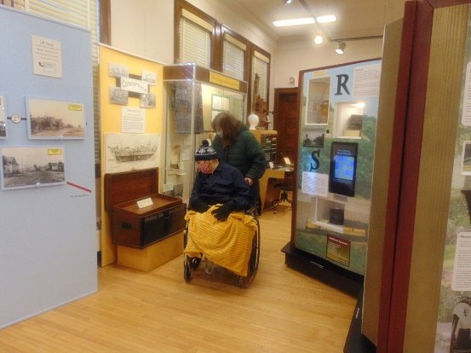

More trips to the museum

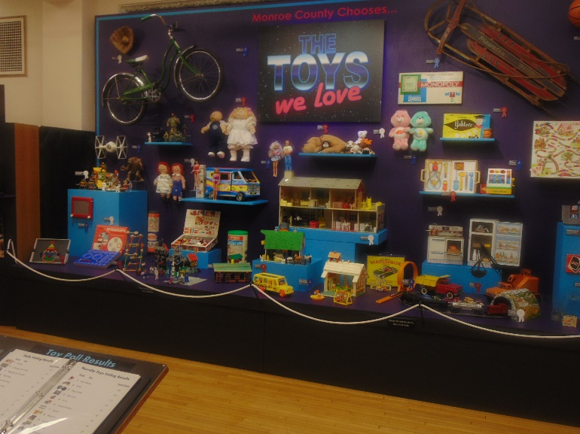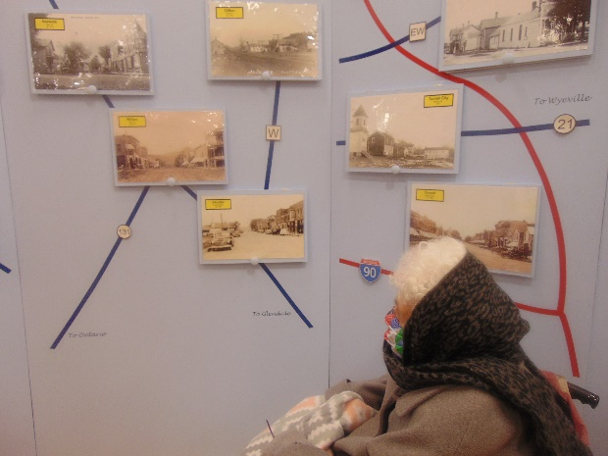

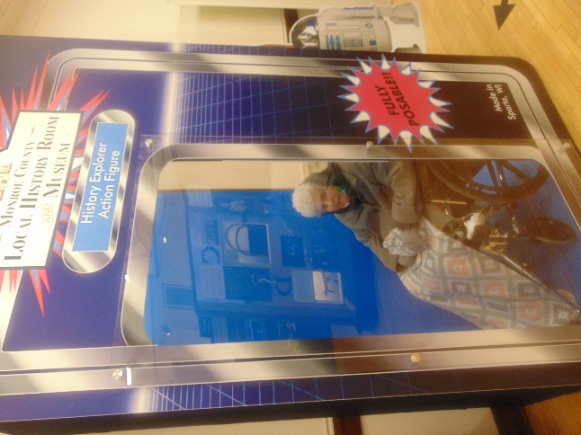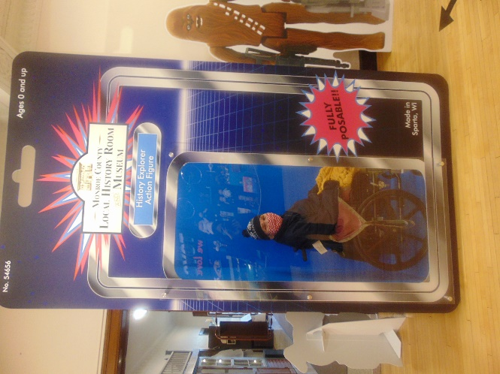

We can be action figures!

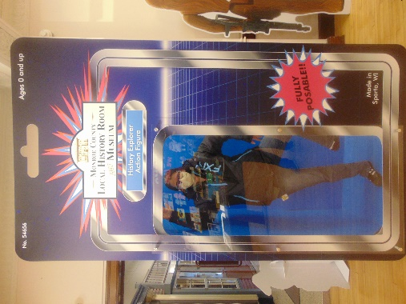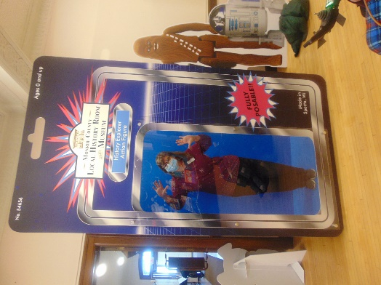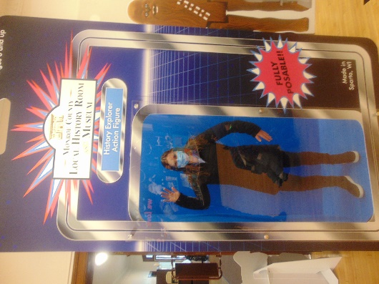

The last Friday of January is already here!

This week we continued to take advantage of having the museum to ourselves. It is a neat toy display and we venture into some of the everyday museum displays as well. Some of us on the 1st floor took a day to order in culvers and enjoy their food and custard. On channel 25 we watched church services and one of our old entertainers as well. Today we are doing a crossword puzzle in the halls to honor national puzzle day.

For anyone interested we are having a pre-sale only for our annual flower sale. We are selling gift cards in $20 increments to Sparta Floral. We also will have hanging mixed flower baskets with a plastic bottom for $25 and with a moss bottom for $28. Just in time to brighten your mom’s or neighbor’s day.

Please e mail or call Jessica Byom with what you would like (# of gift cards and/or which hanging plant and # wanted), by Wednesday, February 17th. She will then contact you and arrange for pick up on May 7th.

Please consider supporting us as this is our biggest fundraising effort. We continue to provide leisure supplies and special treats to keep everyone happy during these covid times.

Thanks in advance!

[Jessica.byom@co.monroe.wi.us](mailto:Jessica.byom@co.monroe.wi.us) 269-8804

Thanks and have a great weekend

Linda