3rd week of January in pictures

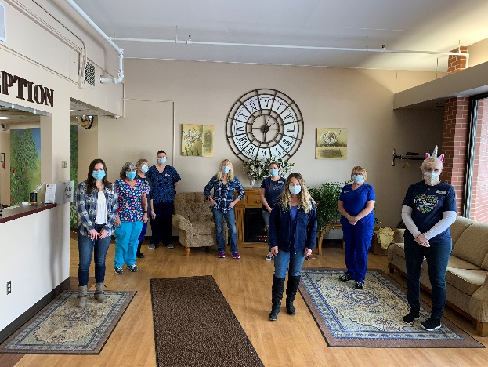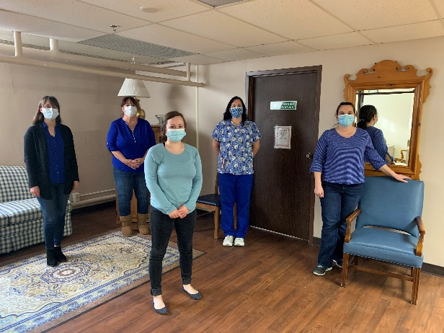

Winter Blues Day!

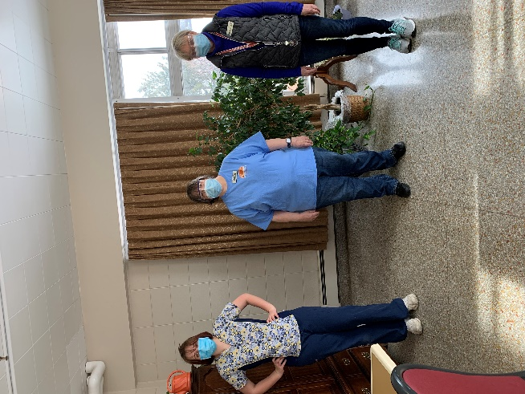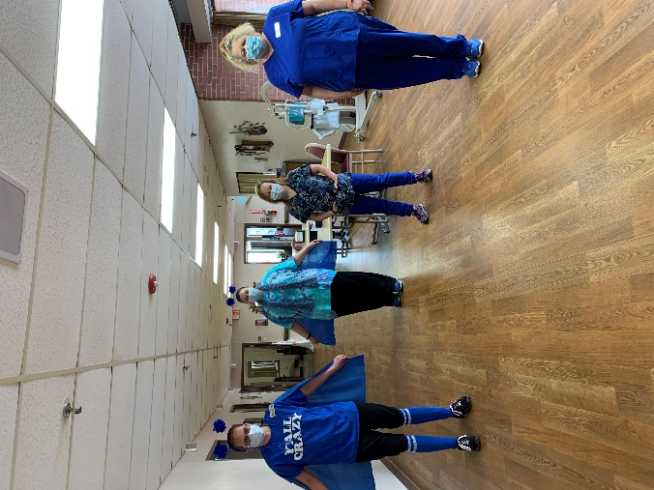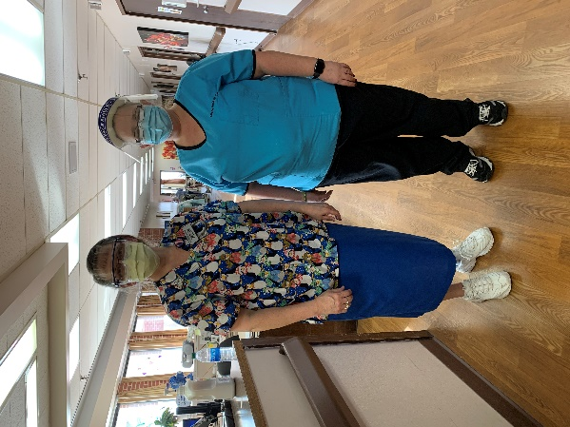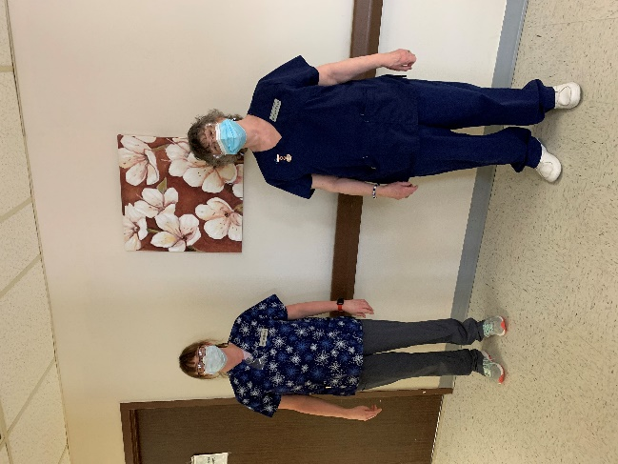

The Winter Blues visits consisted of blue cupcakes, blue facts and blue songs!

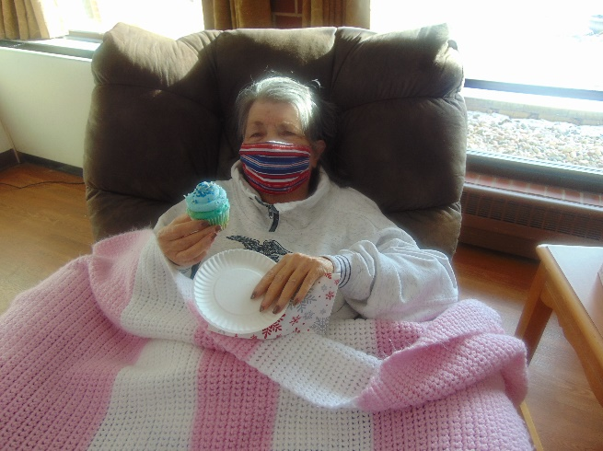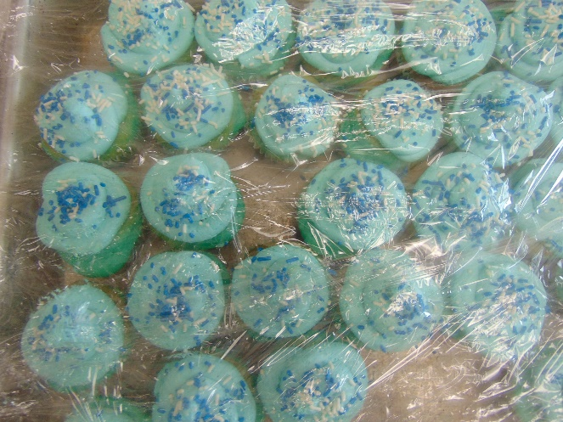

Making Hats in honor of national hat day after learning about the history of hats!

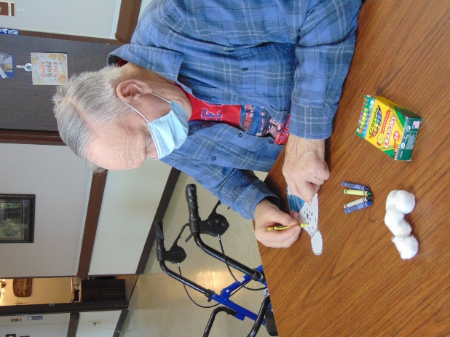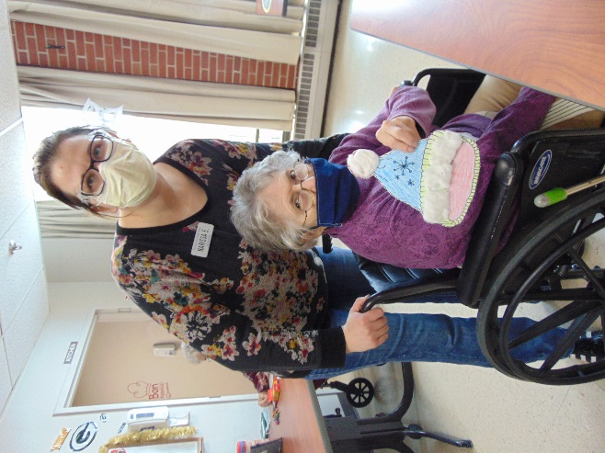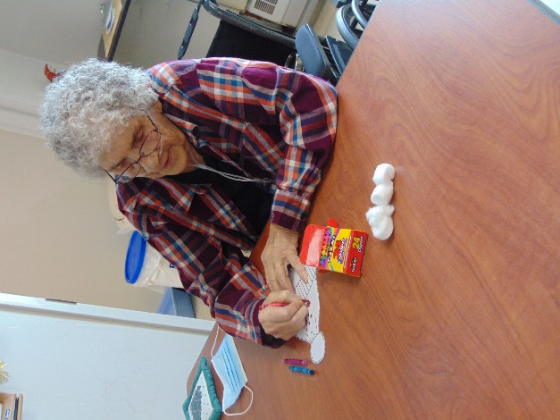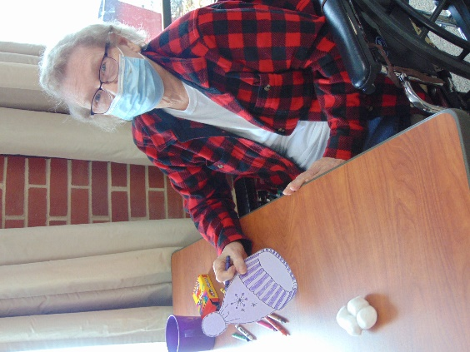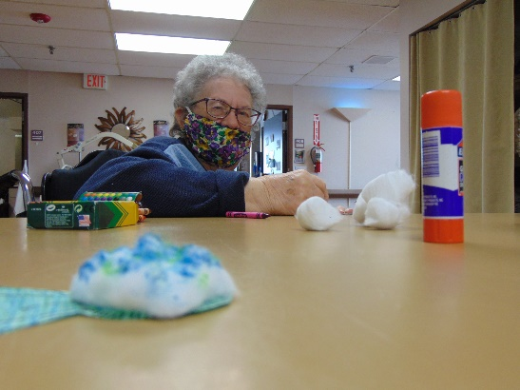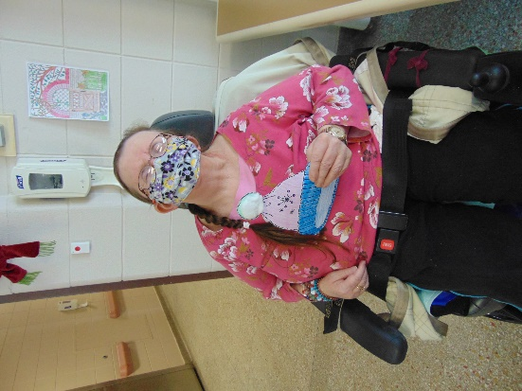

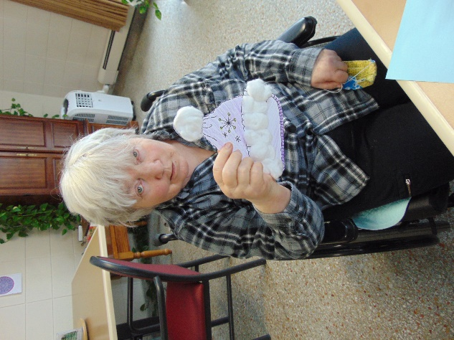

Happy Friday!

This week the staff had the sad task of removing all the Christmas decorations. But we did replace some joy with window paintings of snowman and hearts! On the 20th we had a winter blues party in the hall where we enjoyed blue cupcakes, heard songs with blue in it and some fun facts about the color. It is gourmet coffee month, so one afternoon we took around the Keurig and made fresh coffee to order. Today is the end of National Book Week, so we took the opportunity to hear some heartwarming Chicken Soup for the Soul stories.

Stay warm!

Linda