2021 1st Week in Pictures

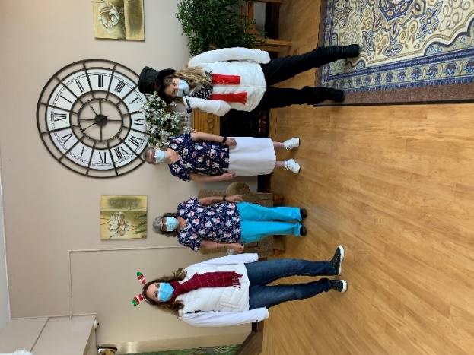 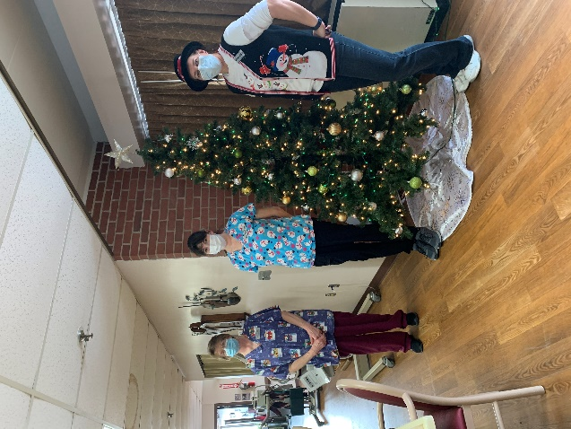

I spy Snowman!

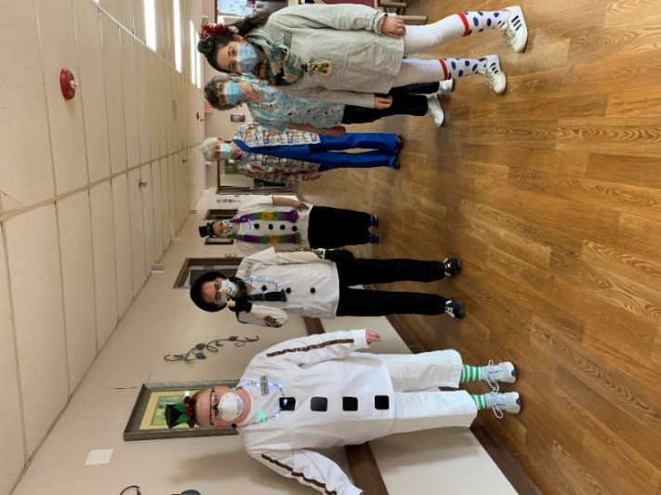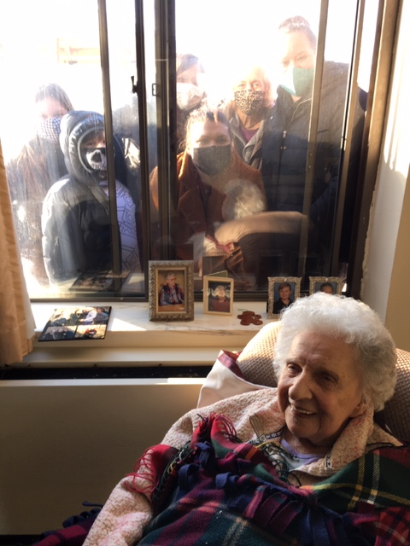

More snowman; and family dressed warm so they can do window visits too!

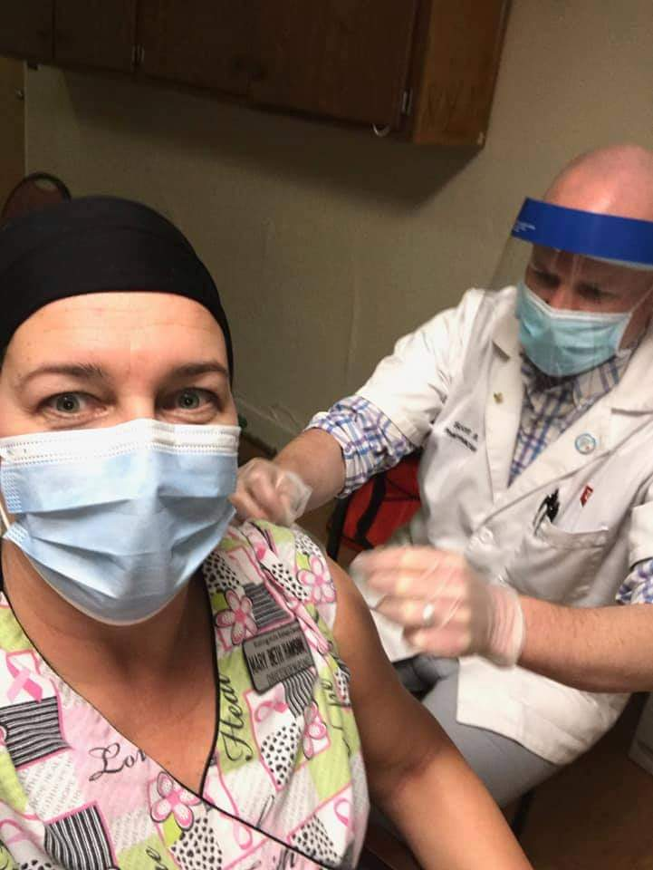 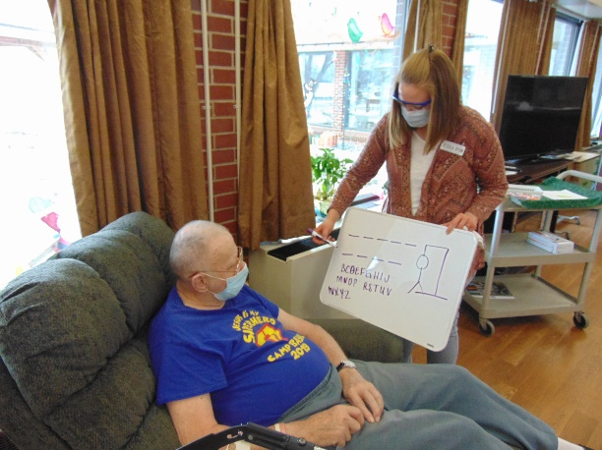

Covid Shots arrived Playing Hangman in the halls

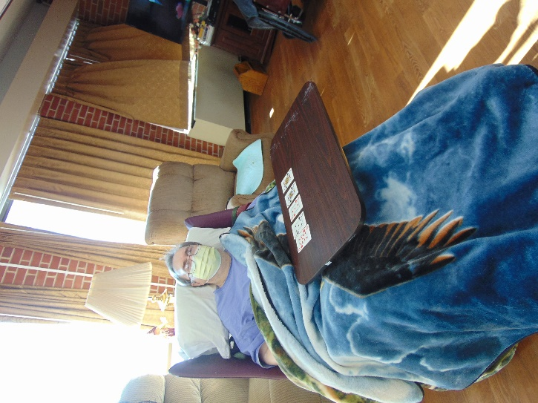 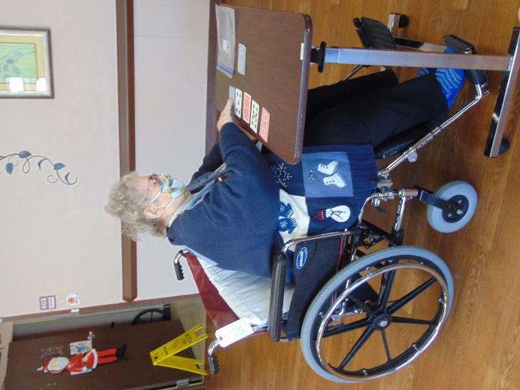

Playing Mystery Card Bingo; you never know what the prize will be if you win!

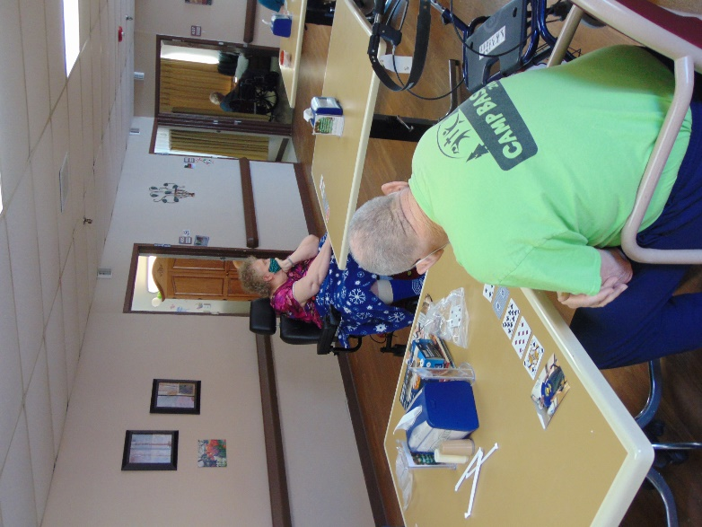 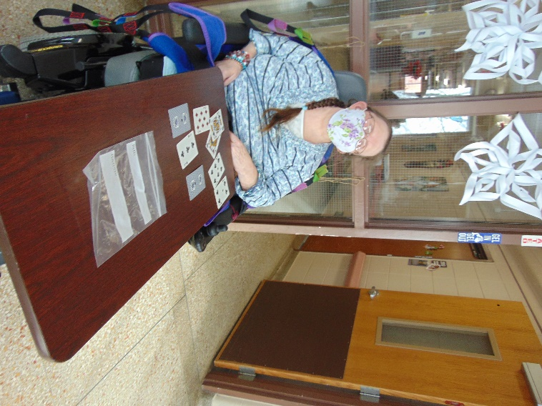

Happy New Year!

We have started out this year playing some games this week. One day we played mystery game, which is essentially card bingo where we surprise them with a different amount of money each win. Then we had some fun with word games by playing Pictionary. On channel 25 Linda led us in some trivia questions and song. Keota was able to come by our windows too, along with family members, since the Wisconsin weather has allowed for this. As this is being written, Lisa is brightening the hallways with music on the piano and later we will be getting updates during resident council on the building project process and the covid vaccinations that were started yesterday.

Have a great week!

Linda