Last week of 2020 in pictures

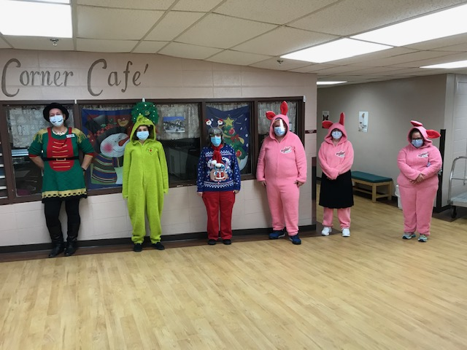 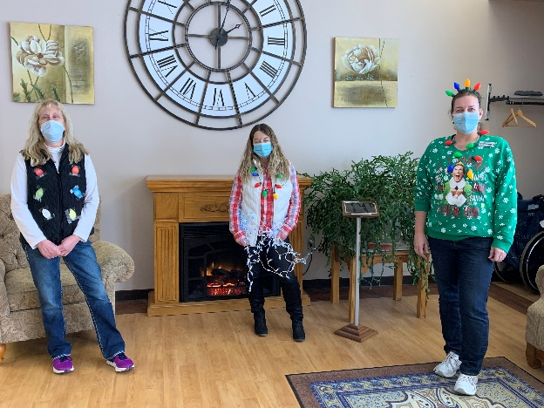

Christmas Characters seen around the home! Covered in Christmas lights too!

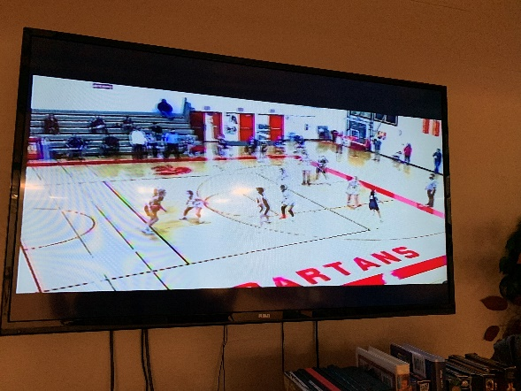 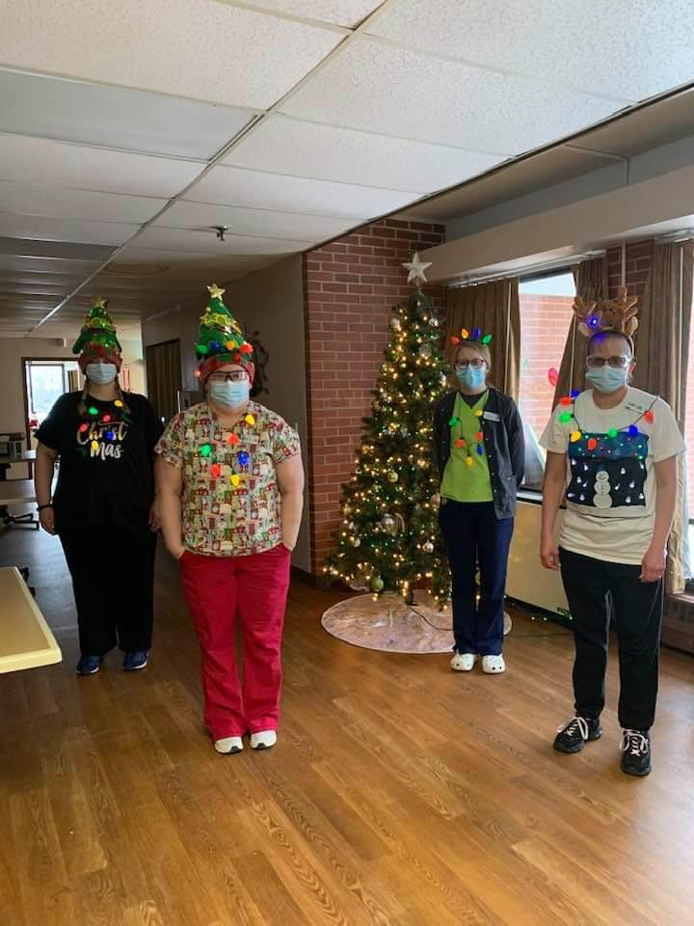

On Channel 25 we watched the Sparta Varsity Girls Basketball game

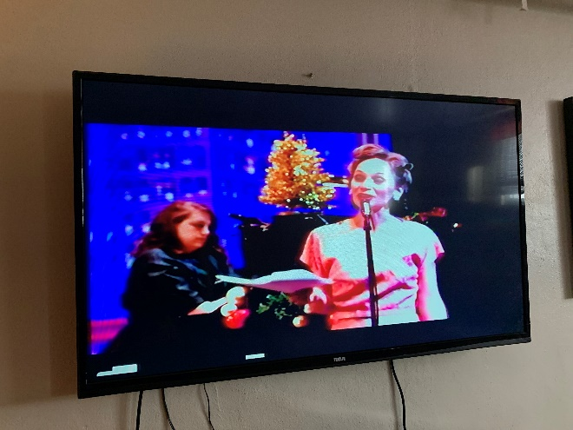 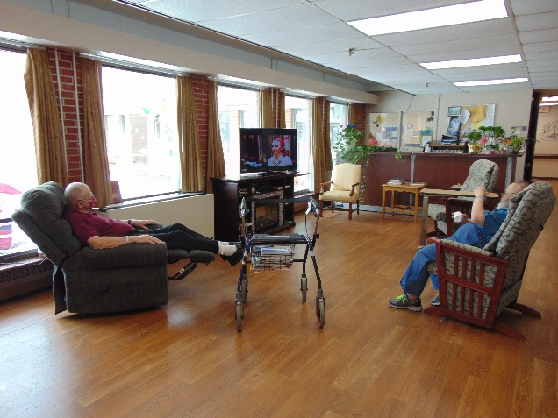

On Channel 25 we watched a radio show: Miracle on 34th Street, put on by the La Crosse Theatre Company, donated by a community member

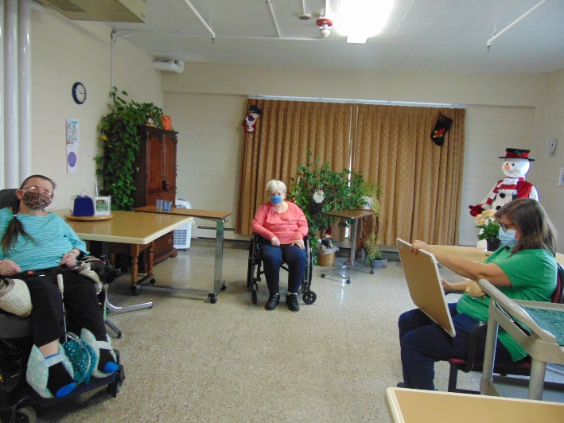 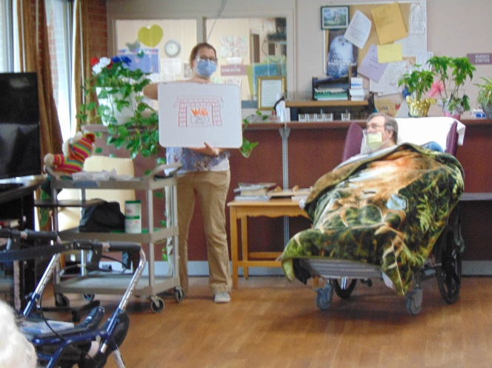

Holiday Pictionary

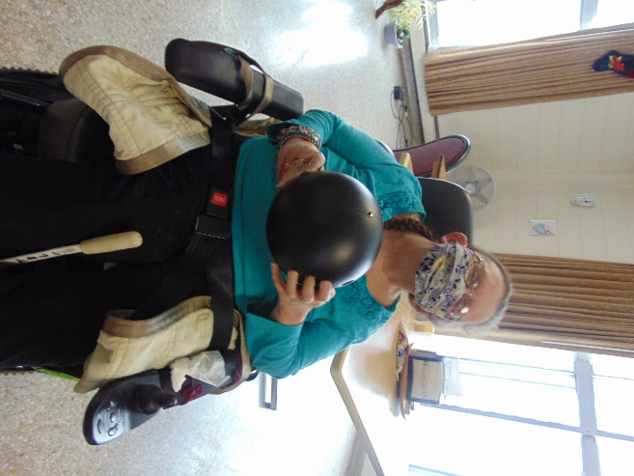 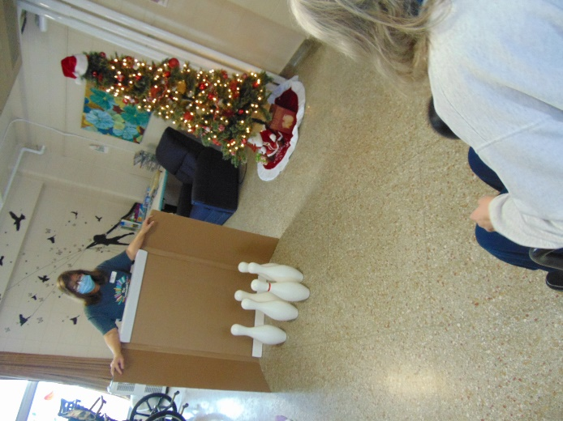

Bowling Fun

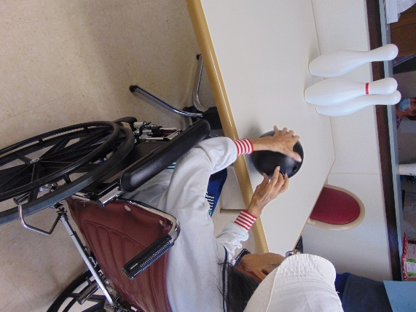 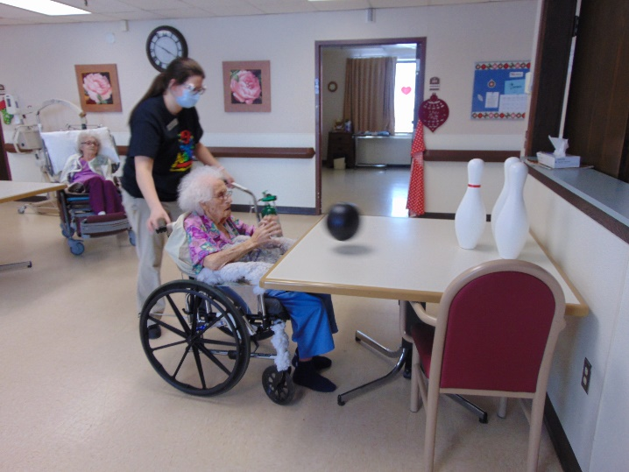

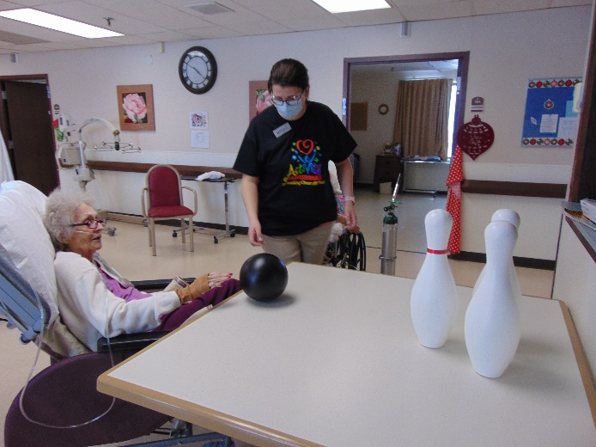 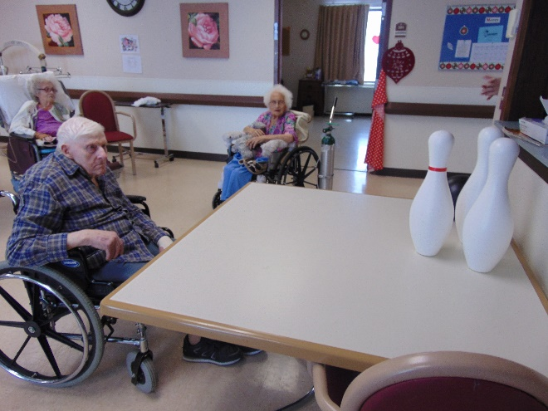

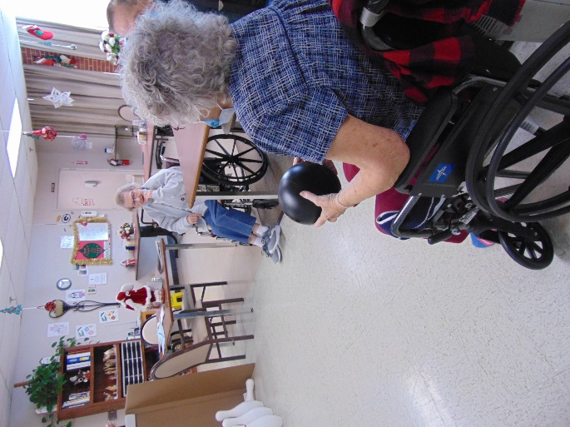 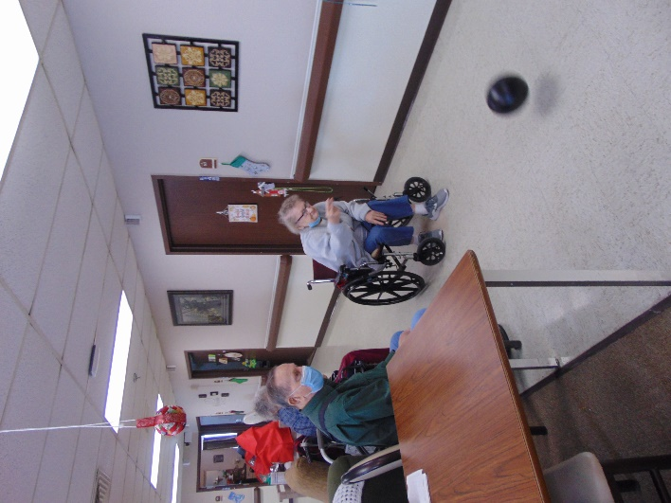 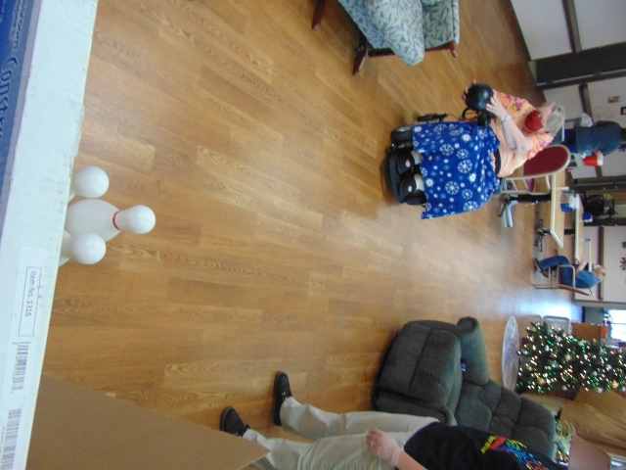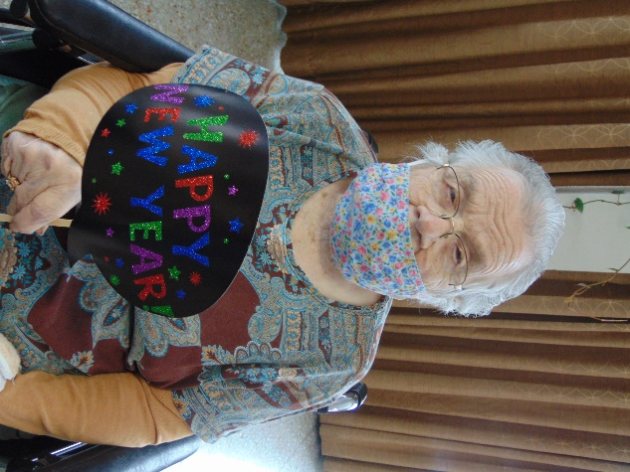

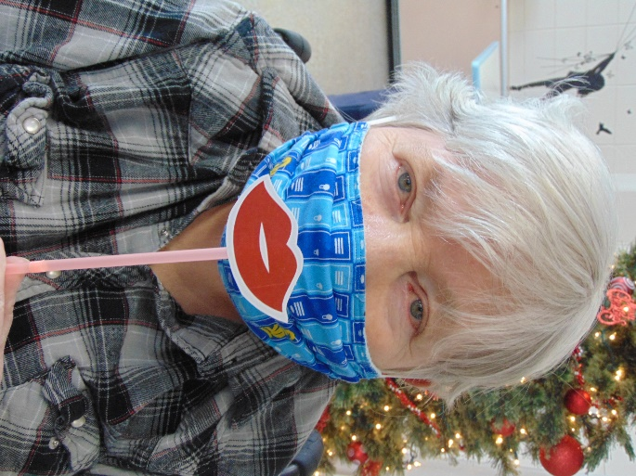 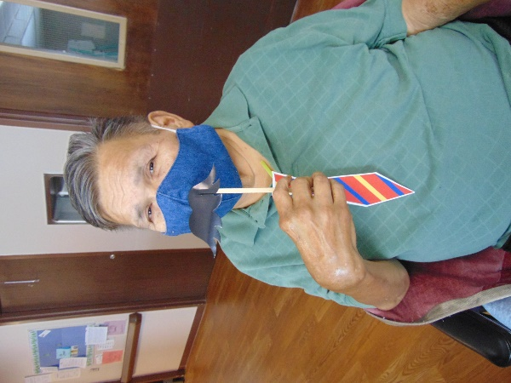

New Years Fun!

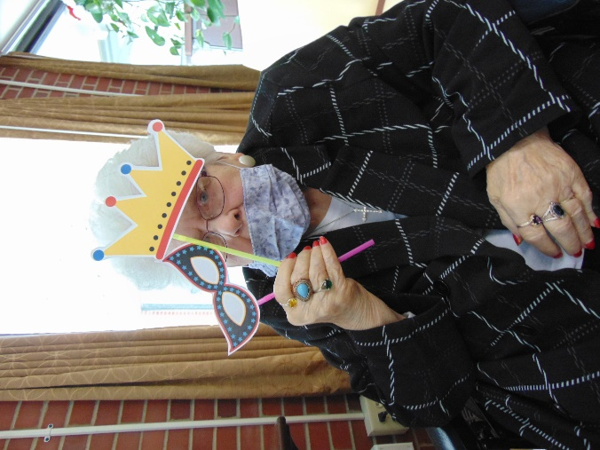 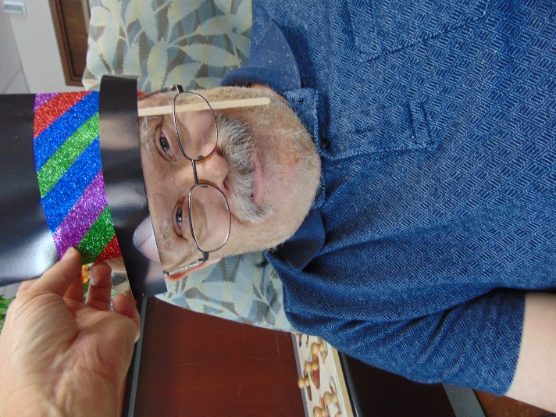

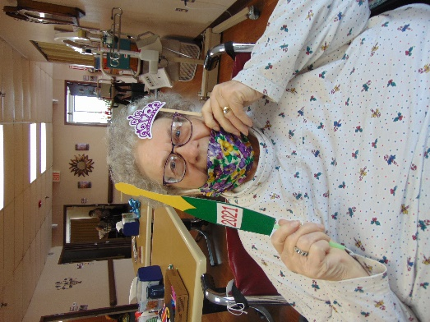 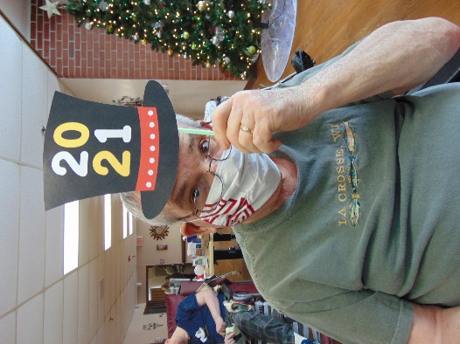 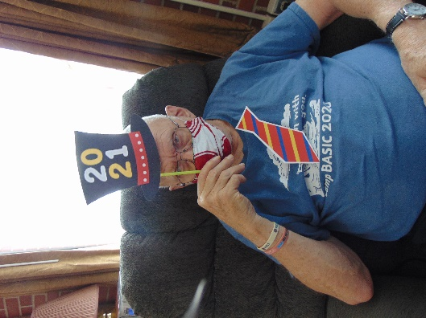

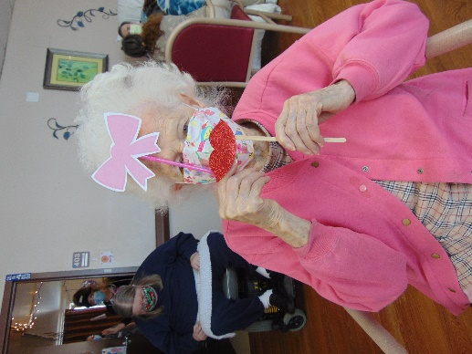 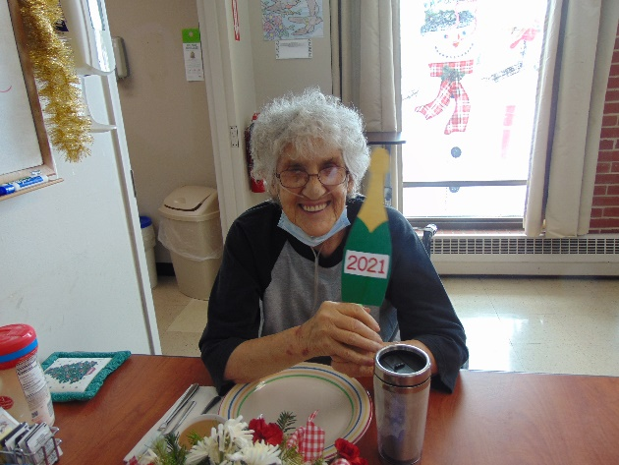

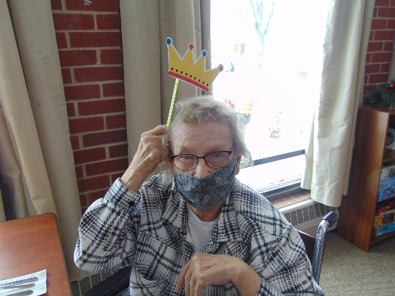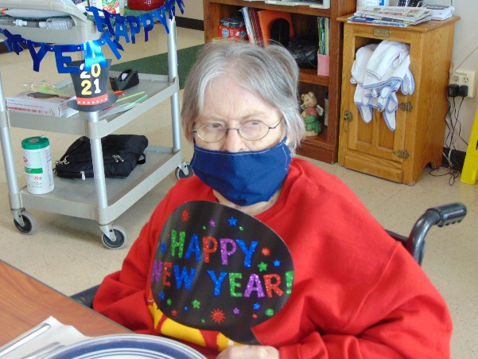

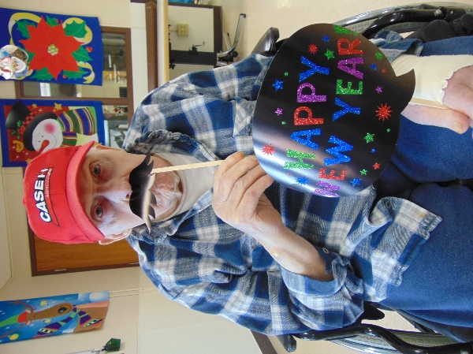 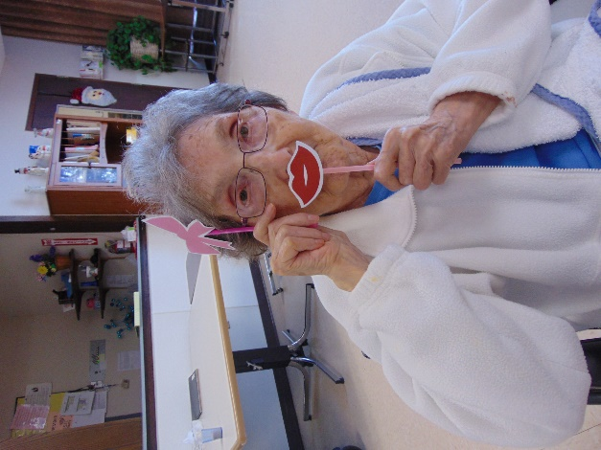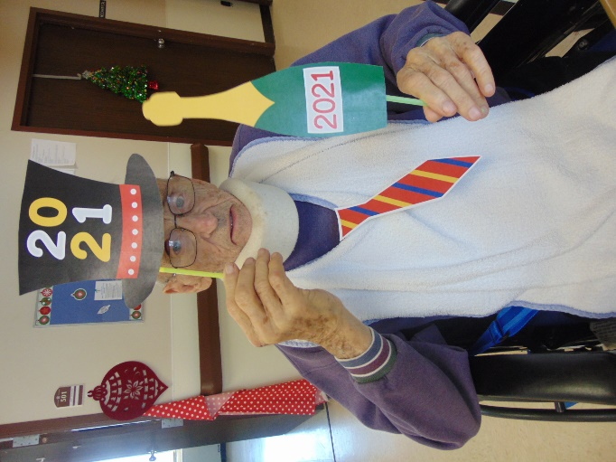 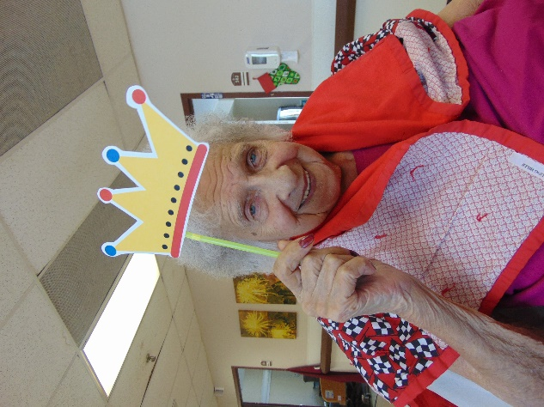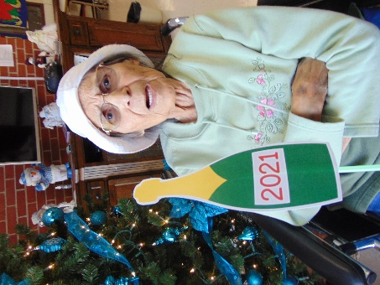

Wow, unbelievable that 2021 is almost here!

This past year sure has been a year of ups and downs and so many changes. We at Rolling Hills sure hope for a great 2021 for all of us. We continue to rise up to all the challenges and changes we face and hope we are offering a variety of leisure that all the residents have been enjoying!

This last week of December we have had a great time. We celebrated bowling balls birthday with some games of bowling in the hall! We were treated to a radio show performance by the La Crosse Community Theatre of Miracle on 34th Street on our in house channel 25. This was thanks to a community members Christmas gift to us. Lisa’s music helps bring joy, smiles and dancing feet as always. We also continue to keep up all the virtual visits and appreciate your patience if we are late or run into technological difficulties. The last day of 2020 we will join in some New Years fun by doing a count down, having some snacks, taking some pictures, listening to some facts and maybe even asking a few trivia questions too.

Happy New Year!

Linda