3rd week of December in Pictures

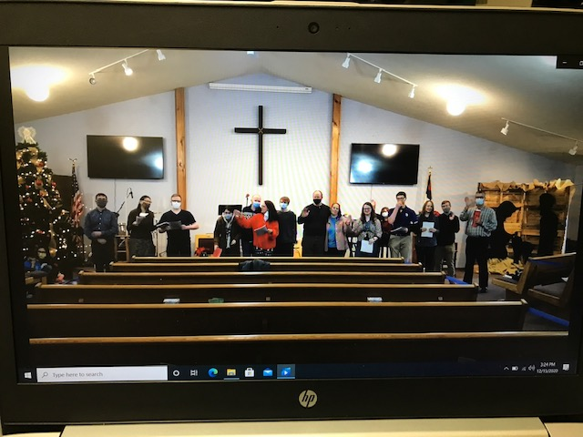

One Church group that sang carols for our residents to played for them

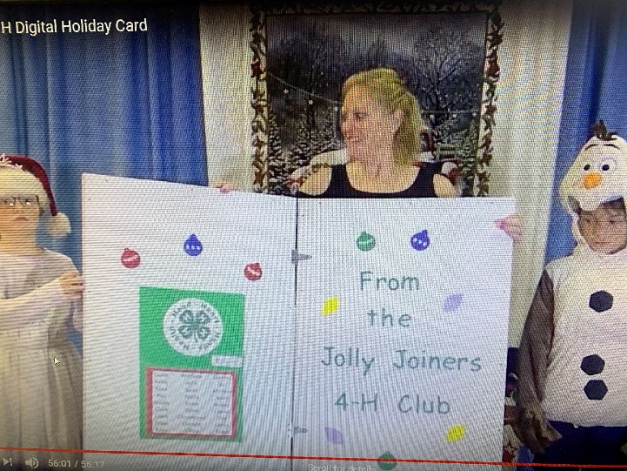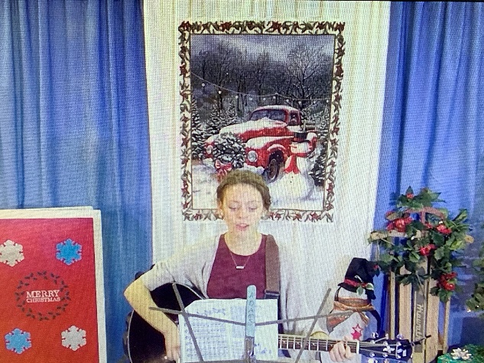

Jolly Joiners 4H put on a Christmas presentation filled with stories, song and dance!

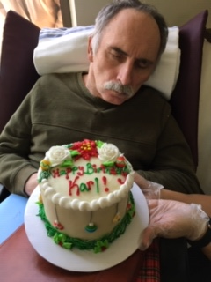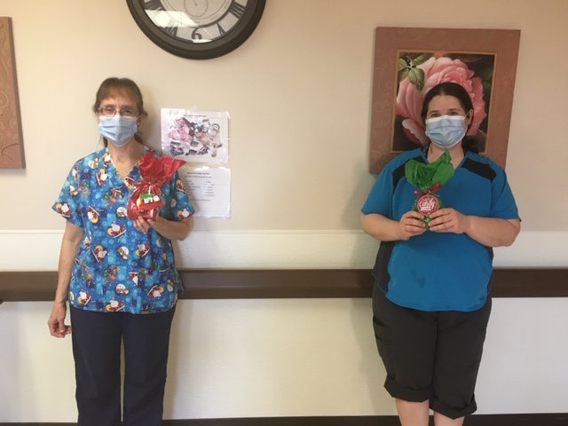

Birthday in quarantine The staff are appreciative of all the gestures of kindness

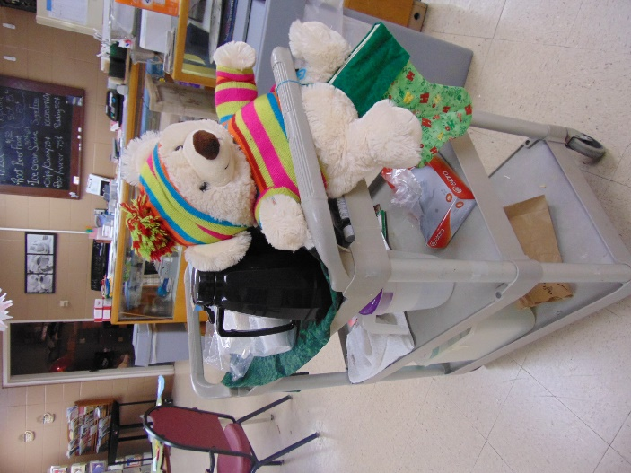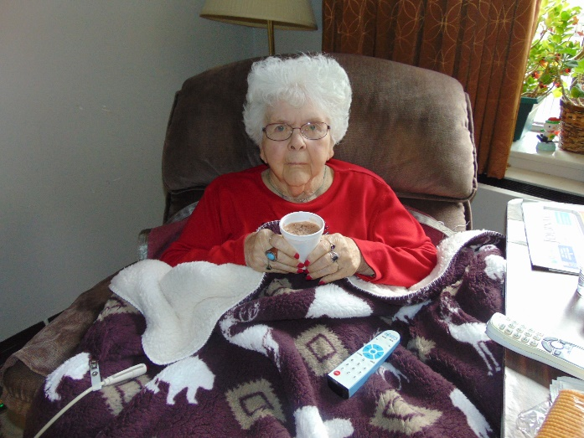

Hot Cocoa visits

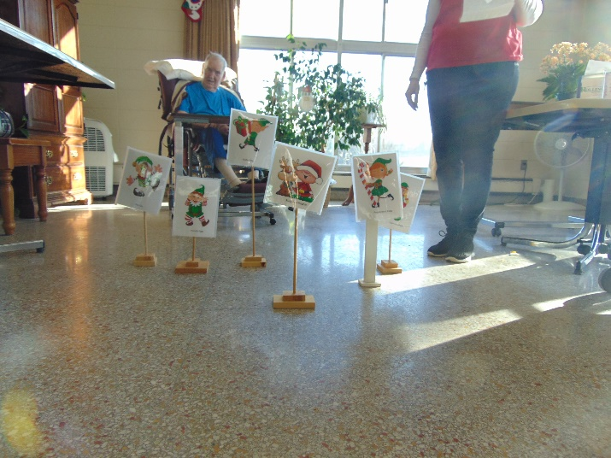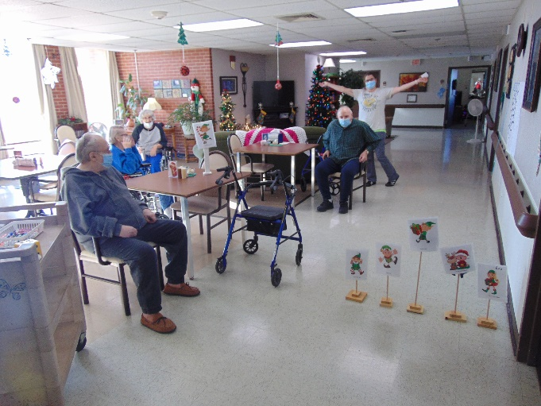

Elf Races were a hit!

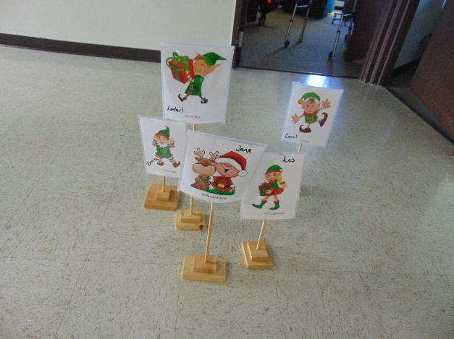 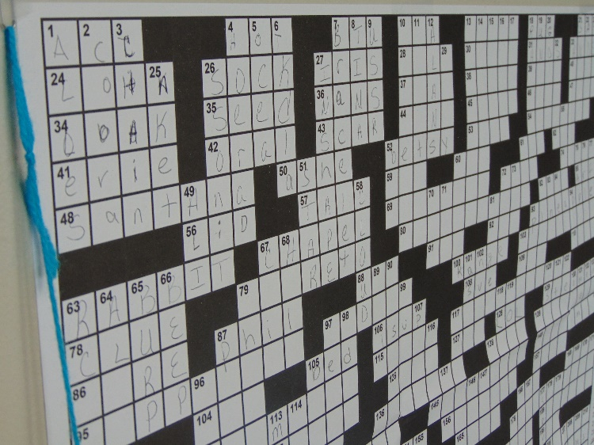

Our Elves and Crossword wall

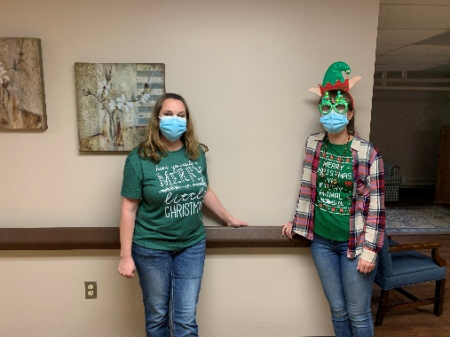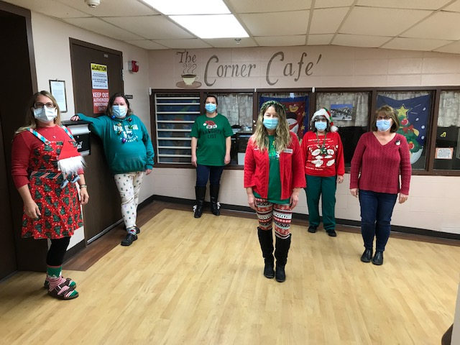

Green & Red Day to get into the Spirit!

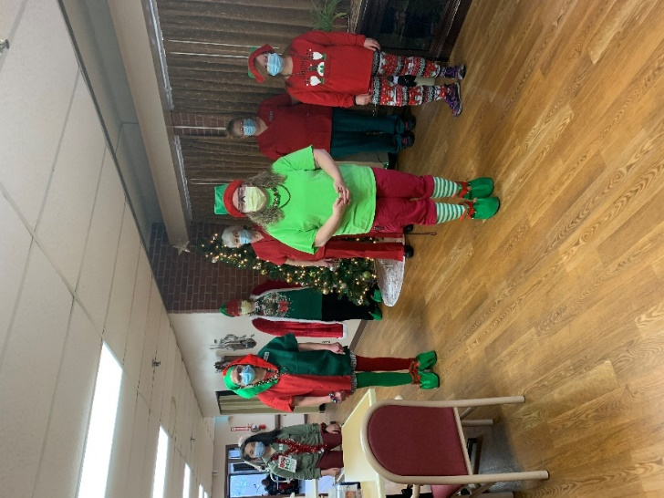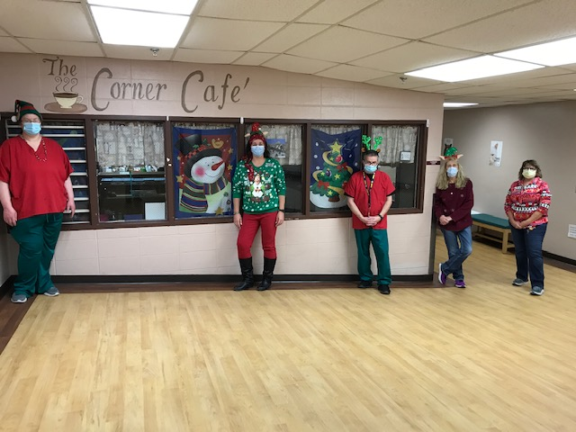

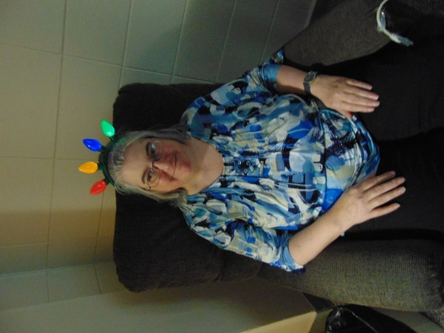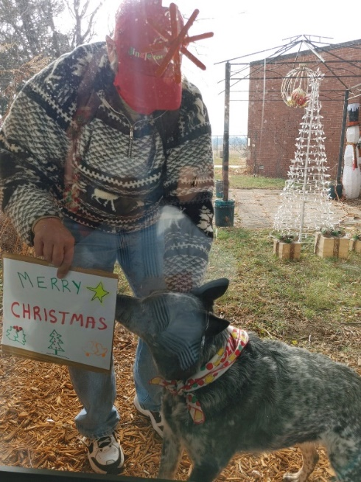

Christmas is almost here, we can feel it in the air and maybe our waistlines too!

This week the residents had the chance to watch some Christmas programs from outside organizations and groups on channel 25. Some more groups are sending us jump drives and/or links next week as well, so the Christmas spirit is alive but different this year. The employees always wish a Merry Christmas to our residents by putting on a pageant, so we could not disappoint them this year. We videotaped and created our own “movie pageant” that brought lots of smiles to everyone. At the conclusion of the first showing, the kitchen had made some goodies for the residents to enjoy that the activity staff passed out. We did make sure to show this a few times to ensure everyone had a chance to watch it!

We are overwhelmed by the generosity of the community this year. All our residents will be getting some great gifts for Christmas! Wrapping will be next week and our elf employees cannot wait! Speaking of elves, this week we enjoyed some elf races in the halls. There was also lots of Christmas facts, trivia and even a Christmas Themed game of Pictionary to fill our days. Christmas music and movies are also a weekly, if not daily, occurrence around here.

Until next week,

Linda