2nd week of December in Photos

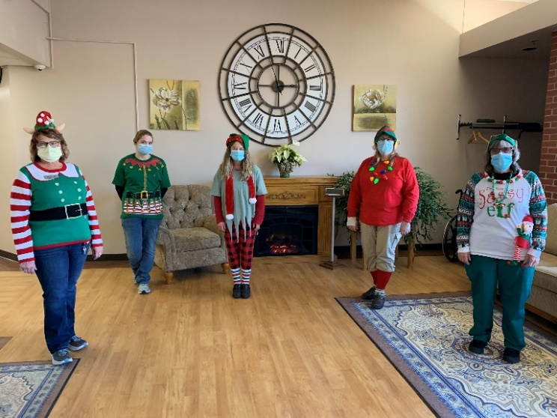 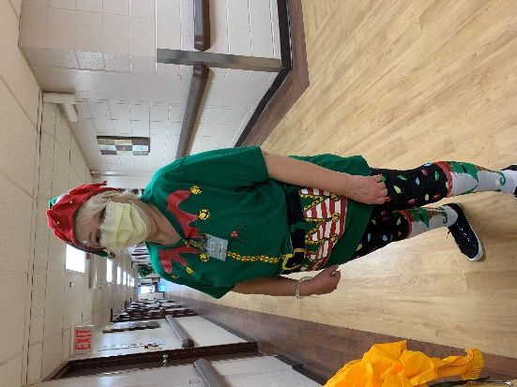

The Elves were working around the home this week!

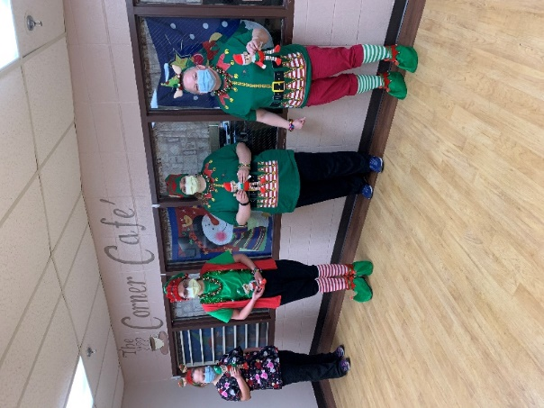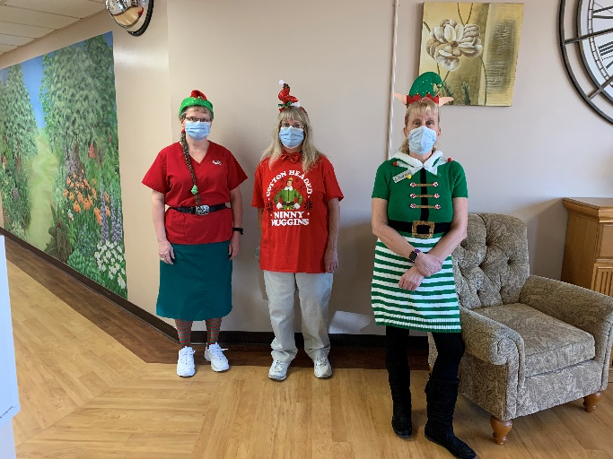

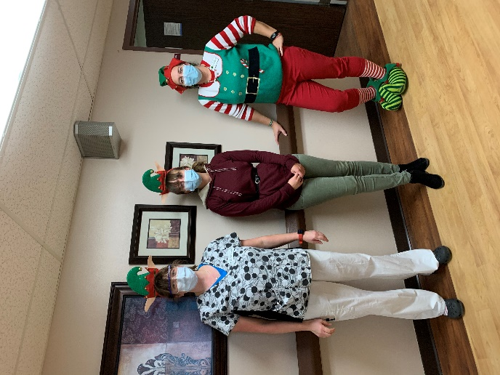 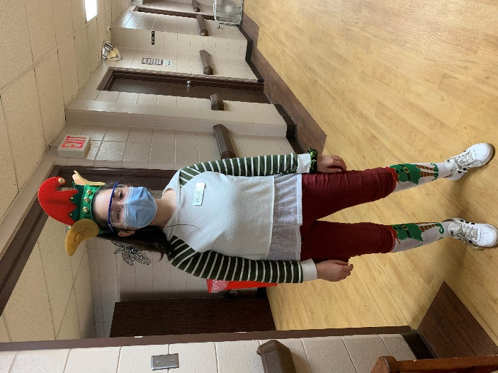

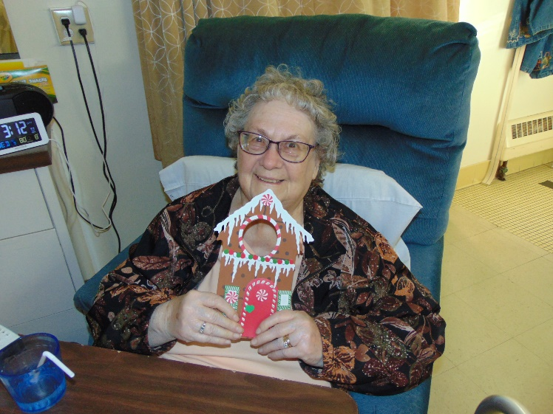 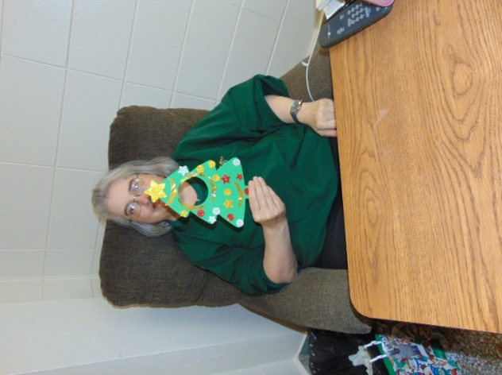

Having fun making our own Christmas door decorations

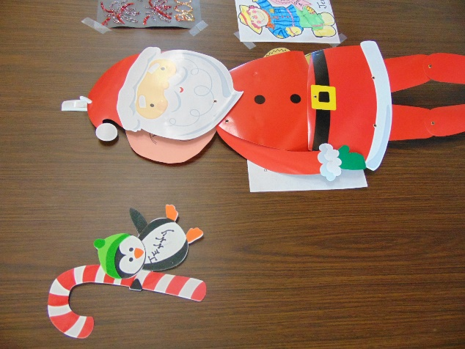 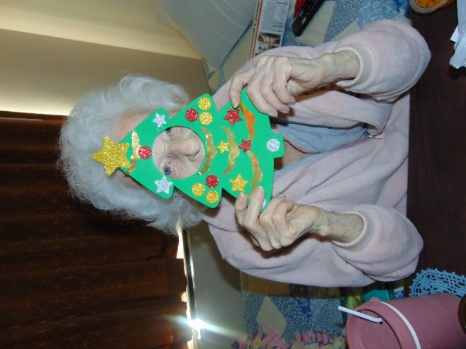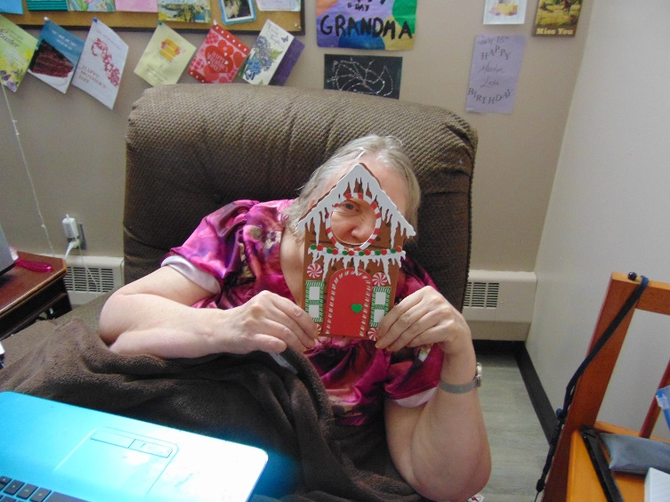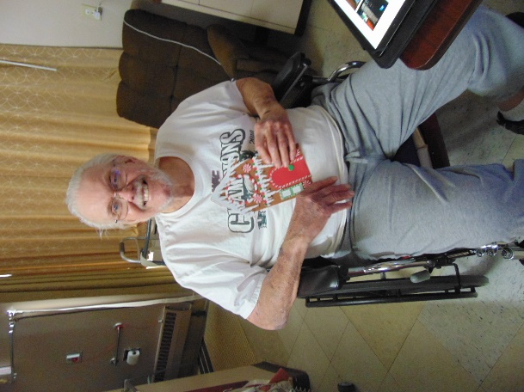

Still decorating the windows too!

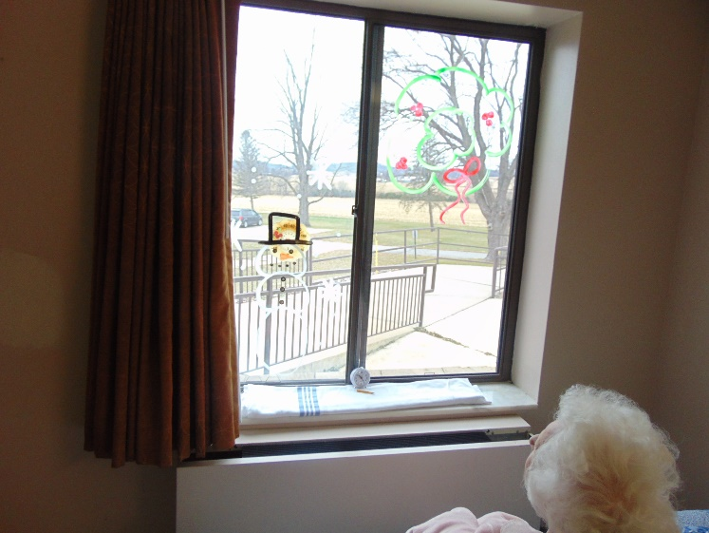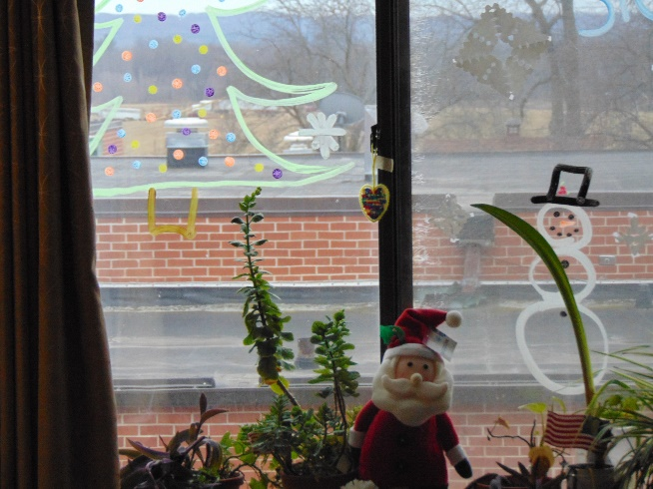

We also started taking residents to see the Sparta Park Lights

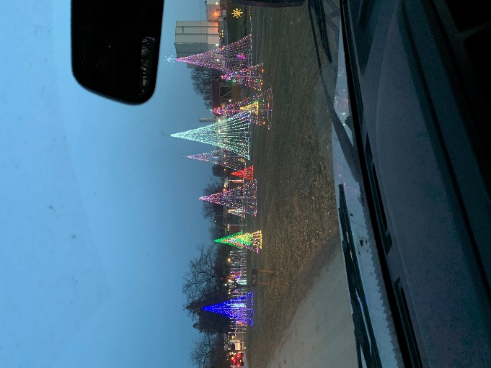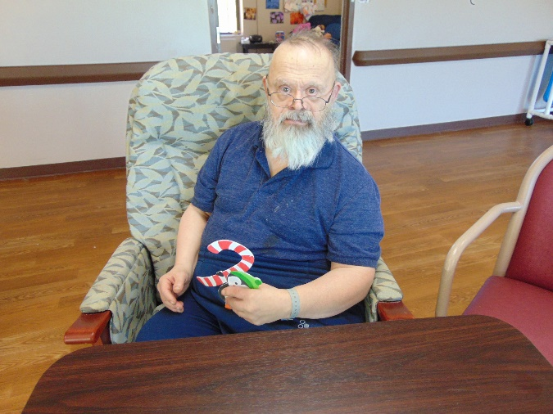

We cannot believe it is already the 2nd week of December around here. Our dress up theme this week was Elves, and we have been busy around here! Lisa continues to play Christmas music in the halls on the piano and Elaine and Narissa were finishing up Christmas Window Painting in resident rooms to brighten their day. One day everyone was treated to 2 cupcakes to sweeten them up!! Actually it was to celebrate a resident’s birthday and the activity staff was celebrating Bingo’s Birthday so we played and then ate. We had a church group, Hands & Feet, send us some neat Christmas door decoration crafts, so we took time to listen to Christmas music and put these together. This weekend Lisa will celebrate National Hot Cocoa day with facts and a cup of it too. On Thursday we began our trips to the Sparta Park Christmas lights. We also stopped over at the courthouse to see the decorations outside there too. We gave a guided tour as we drove, showing off all the things like the lights and Kriskindlmarkt. Until next week, take care and stay healthy!

Linda