1st week of December in photos

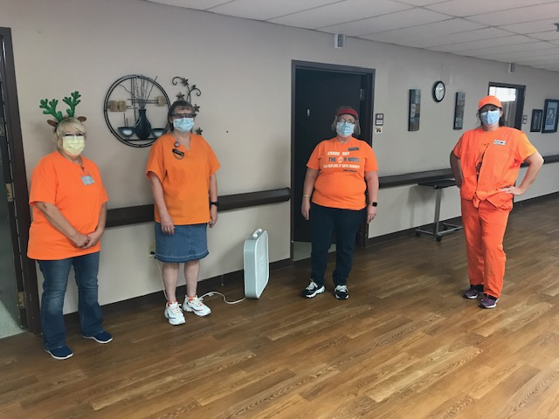 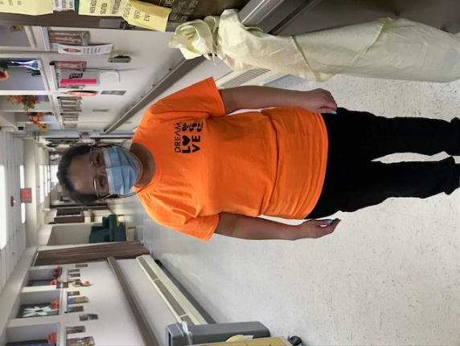

Wearing Orange!

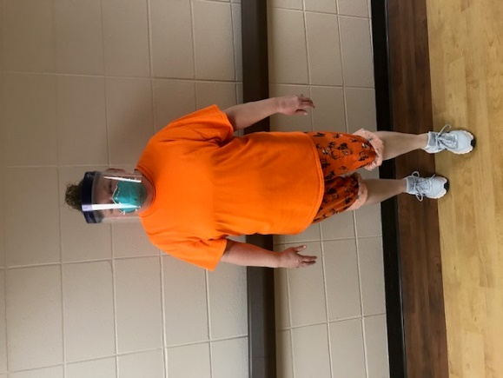 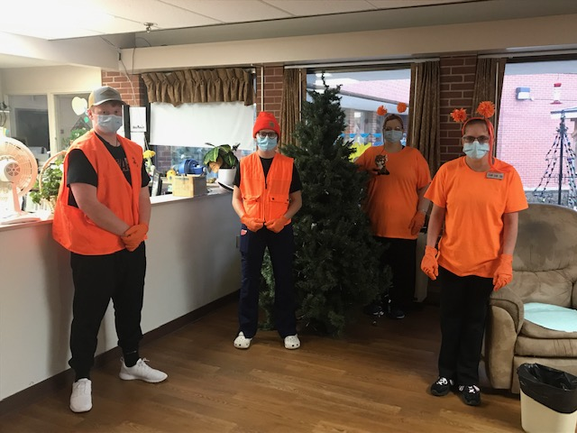

Racing Deer:

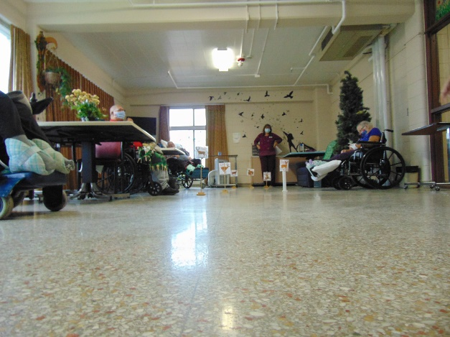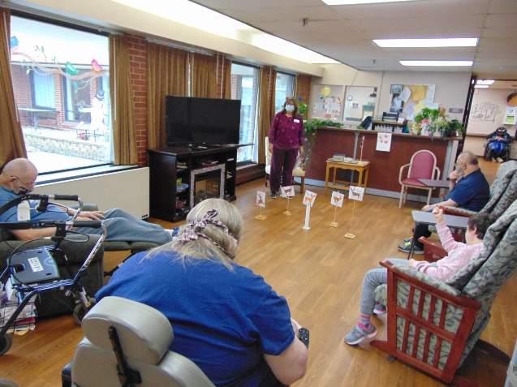

Wearing ugly sweaters:

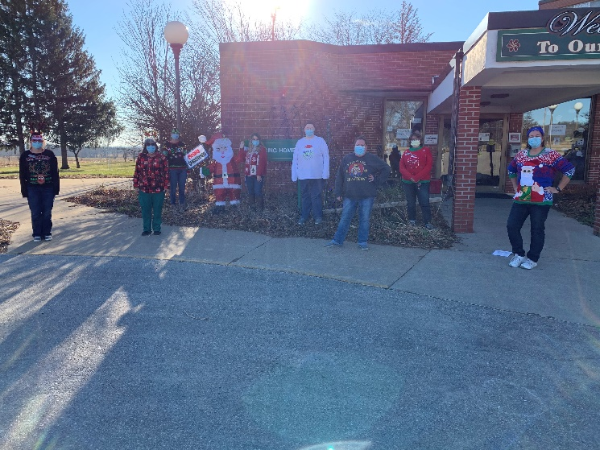 

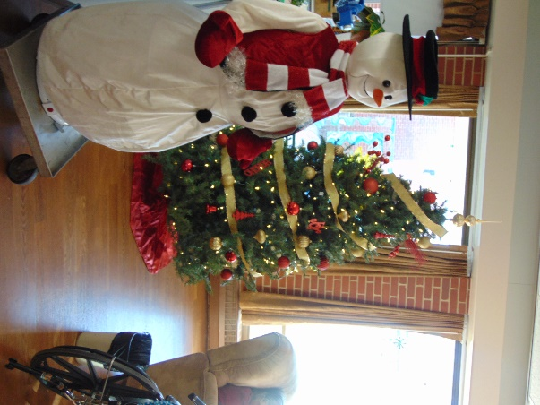 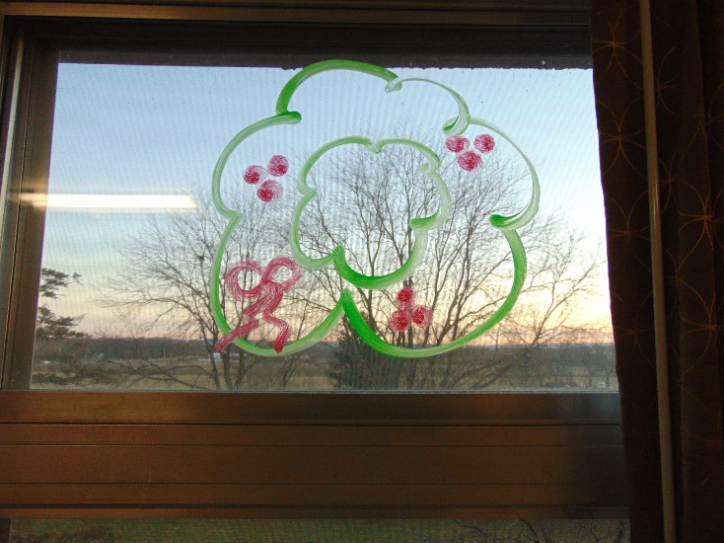

Some of the decorations being put up around the home

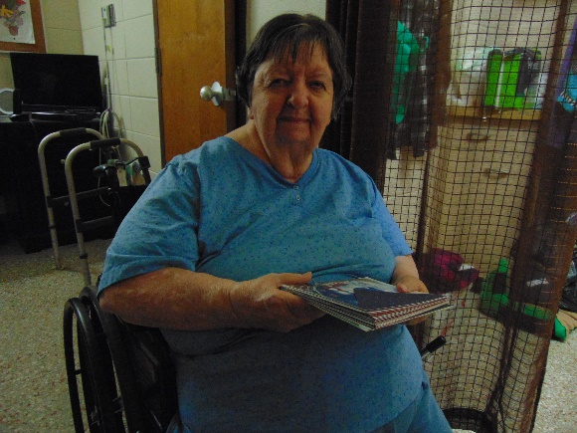 Taking advantage of the Christmas cards

This photographer has not kept up with her duties this week, but I assure you, we continue to find joy in our days here at Rolling Hills. Lots of indoor decorating happened this week and as this is being written, our outdoor lights are going up. We can’t wait to see them all lit up and bring some smiles to those indoors and that drive by! We have window writing paint and some have joined in putting winter phrases and pictures on their windows. The support aides decorated one tree with a Packer theme to bring some added smiles. Lisa has been playing some Chrismas music in the halls and even Laurel sang Christmas songs on our in house channel Thursday program too. We changed up Bible study at the beginning of the week to do an Advent program, followed by some tea and lemon bars distributed to the units. With the nicer weather still hanging on, we also get to see Keota outside our windows too. This holiday season will sure be different, but we plan on making it as special as possible. We already have groups recording programs to show our residents and we also have been receiving lots of presents to pass out to everyone!