Snapshots from the 2nd week of November—Check Roger Friday!!!!!

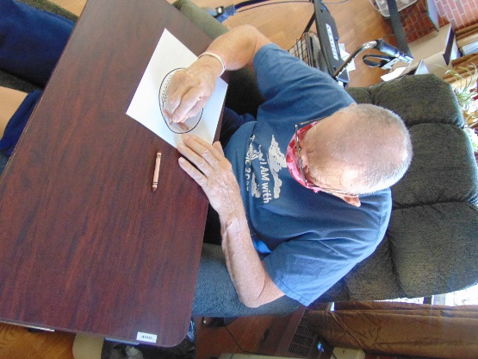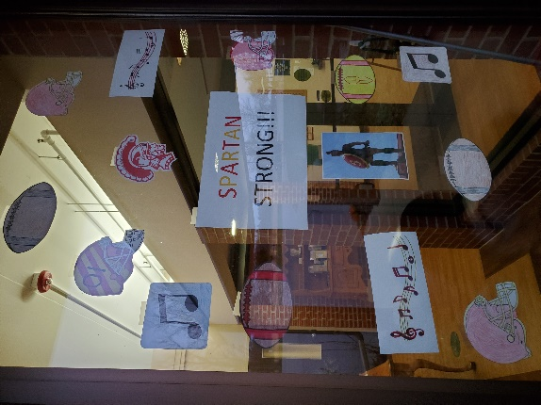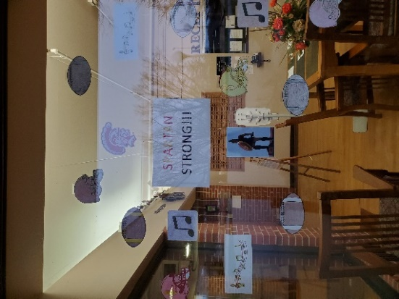

Getting into the Homecoming Sprit for Sparta by decorating our entrance windows

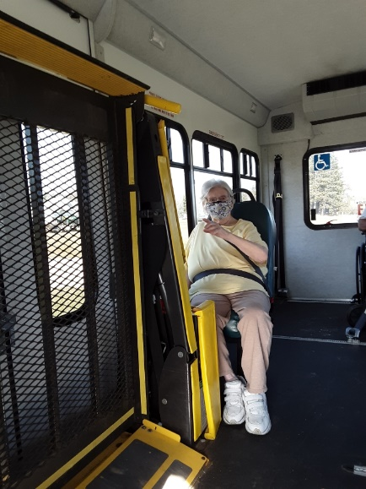 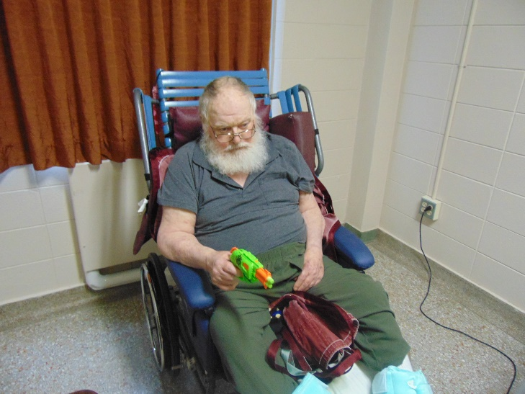

From lastFriday afternoon enjoying the weather; Getting ready for hunting with some target practice

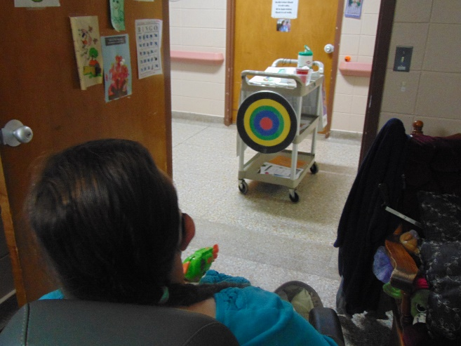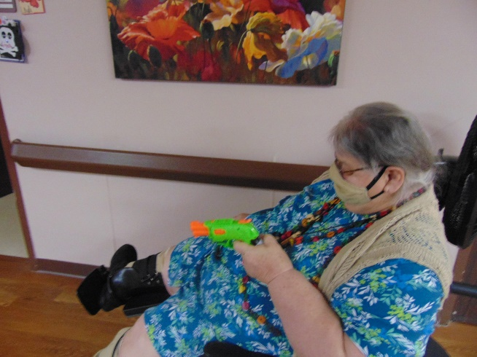

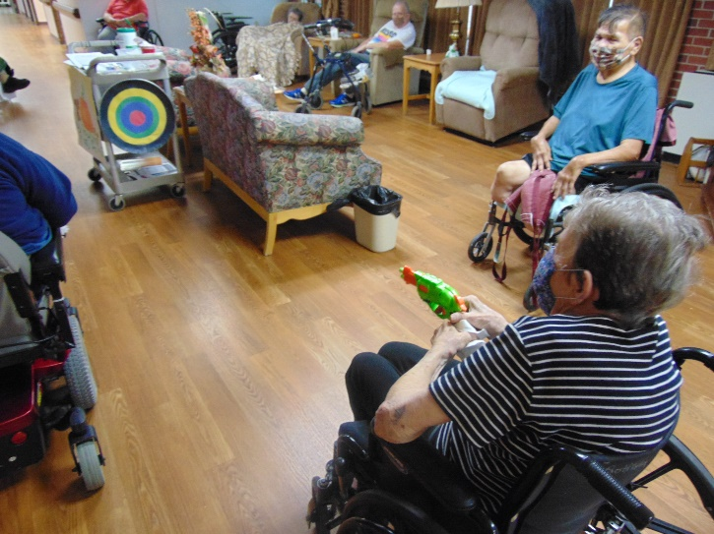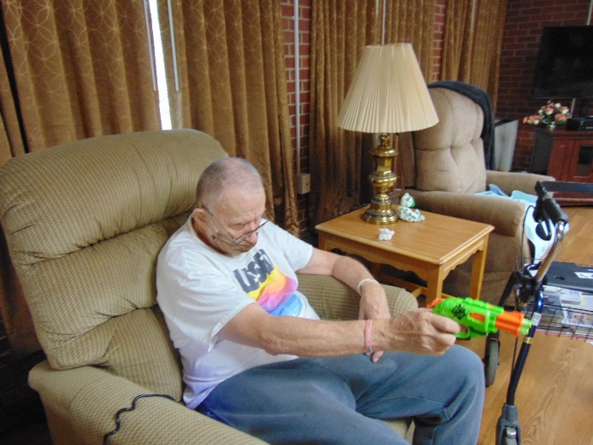

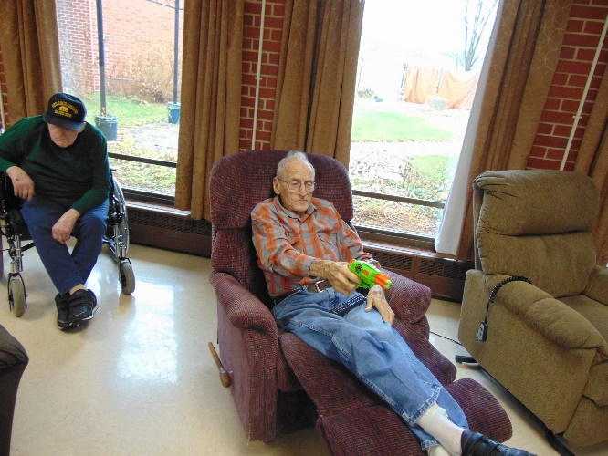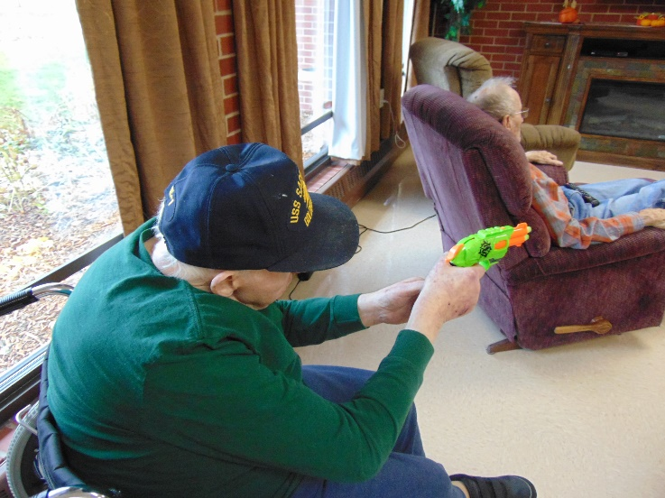

Red, White & Blue Day for November 11th

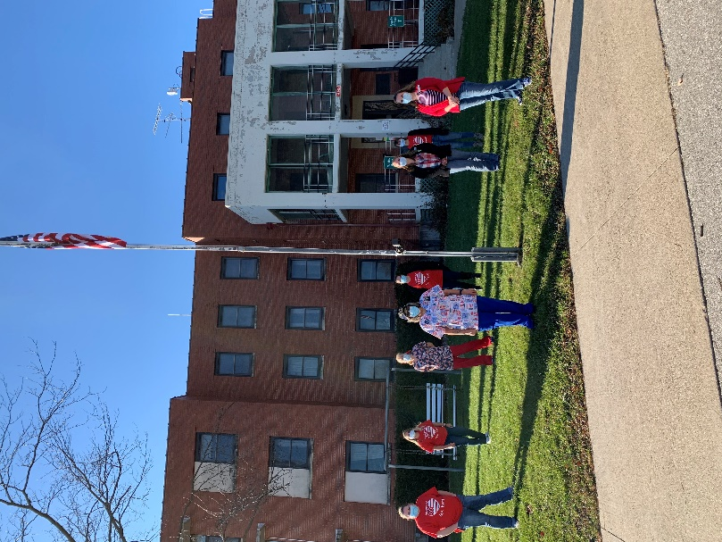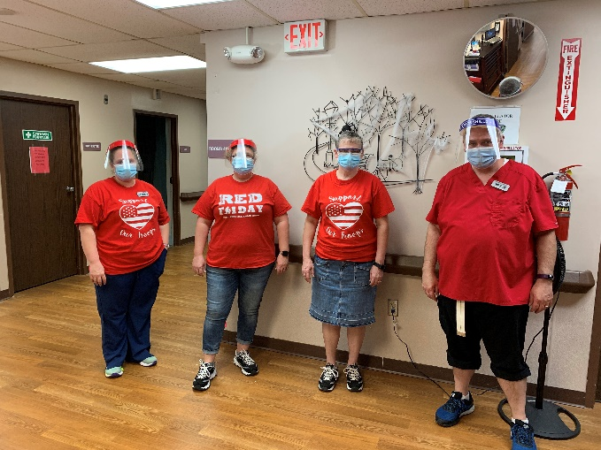

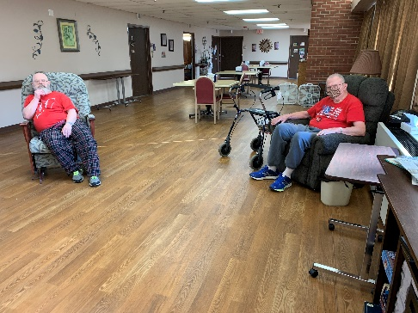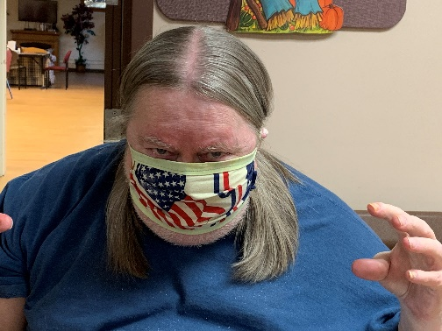

Residents got involved too!

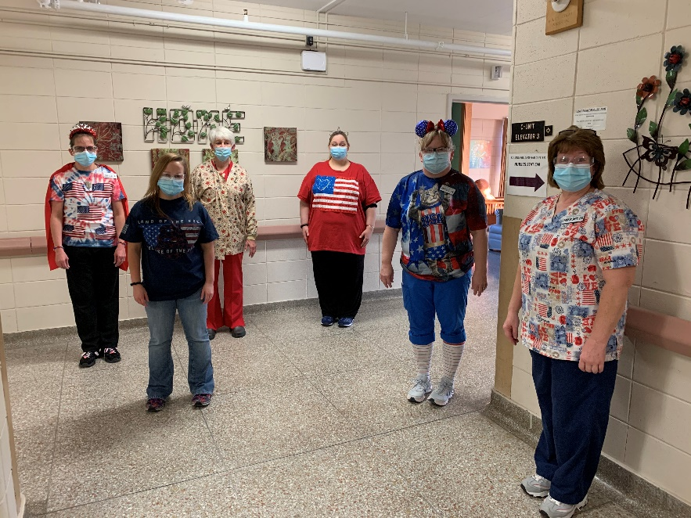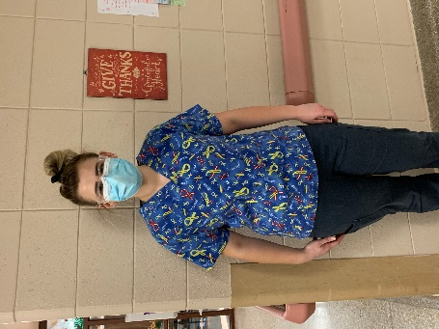

Some of our Veteran’s receiving their gifts from the community; we thank all our Veteran’s for their service!

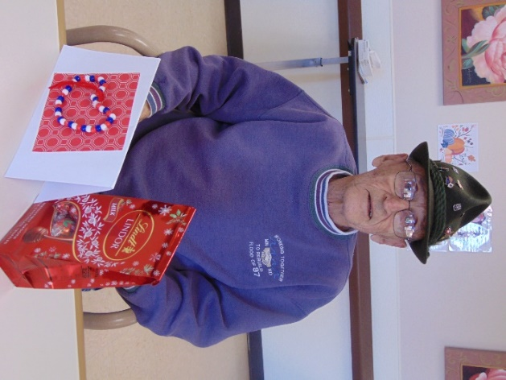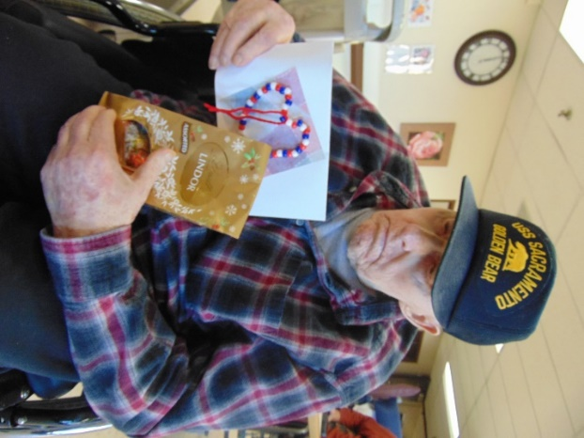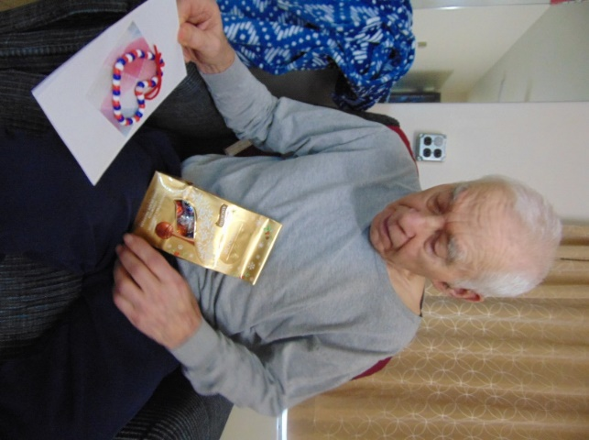

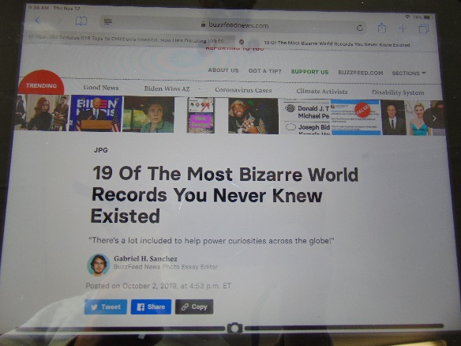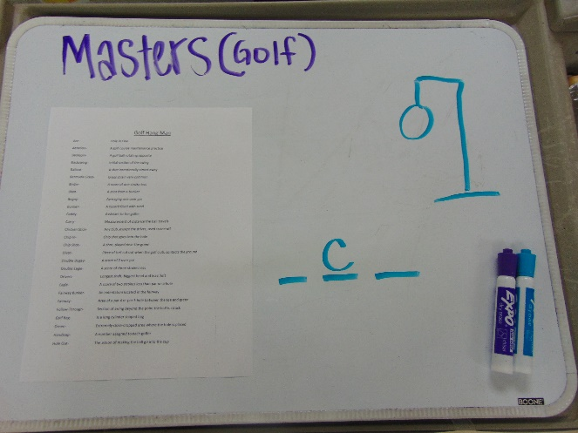

Hearing World Records and playing a golf themed hangman game

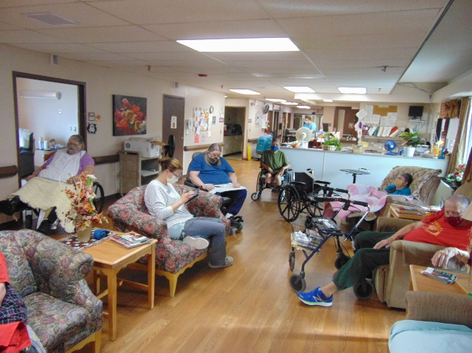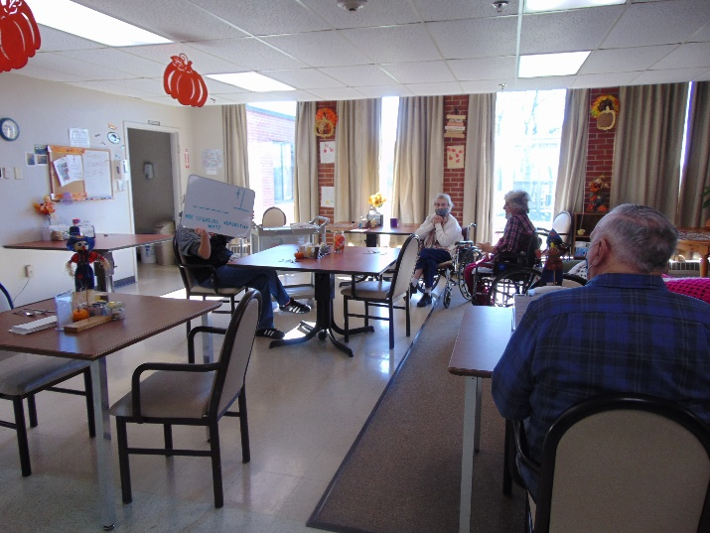

Friday the 13th is upon us and we hope it finds you doing well.

We continue to stay as active as we can here at Rolling Hills. This past week we decided to deliver some Hugs (the candy version) to brighten their day. Then we enjoyed learning some hunting facts and getting a chance to do some target shooting too! On Veteran’s Day Linda did a program on channel 25 with some history, poems and thanking the Veteran’s that live at Rolling Hills. Then everyone enjoyed Patriotic music all day on this channel as well. On the 12th it was the Guinness World Record day, so we used Ipads and shared the top 19 records with pictures to everyone. Lisa also played music in the hallways, and we will continue to use her talents weekly. To celebrate the Masters beginning today, we played a hangman game with golf themed puzzles. We also enjoyed a recital of a grandchild who plays the violin and attends Victoria College in Canada.

Until next week, stay safe and healthy!