Snapshots for first week in November

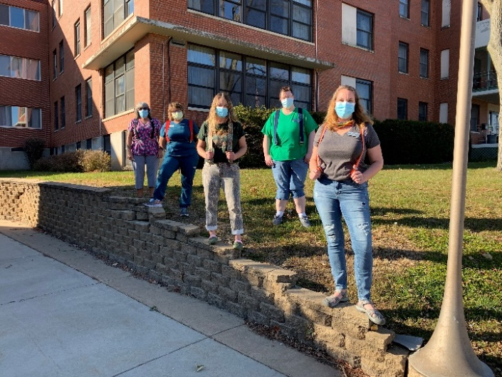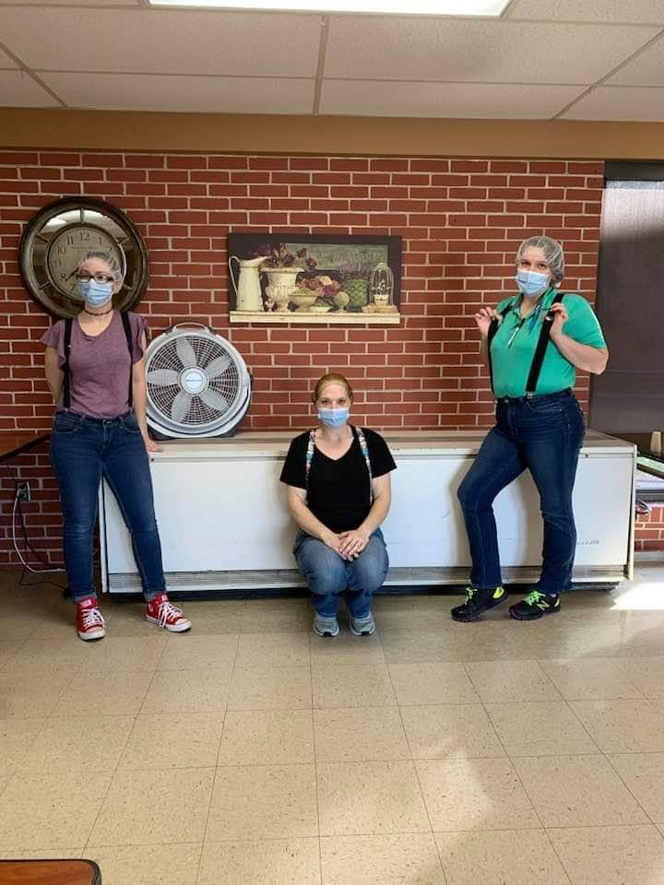

Suspender Day!

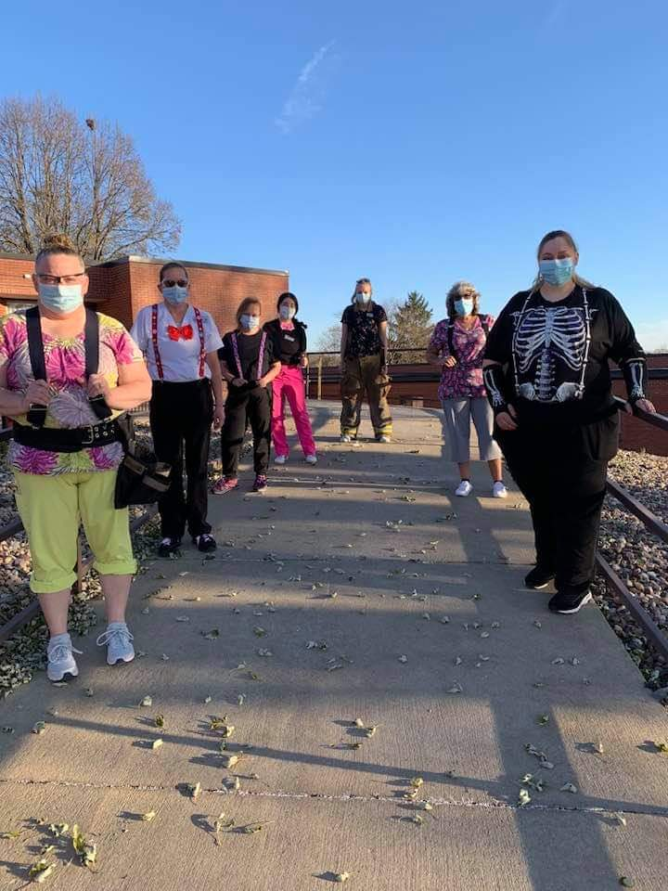 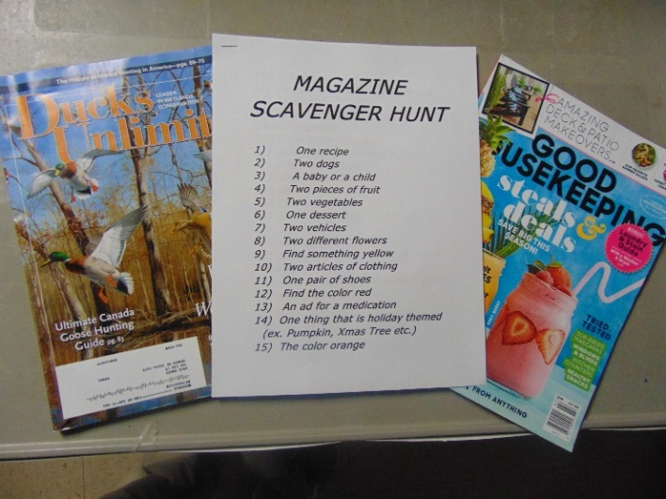

Magazine scavenger hunts for fun

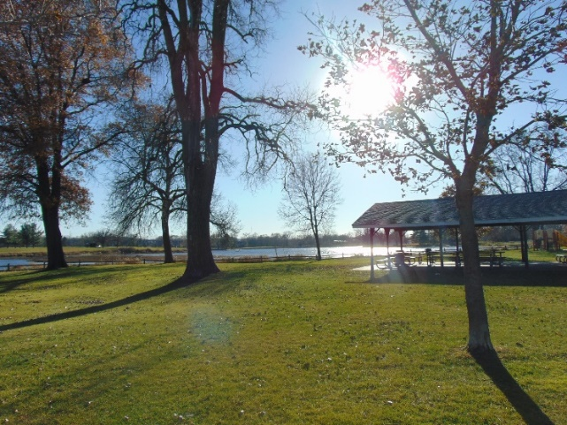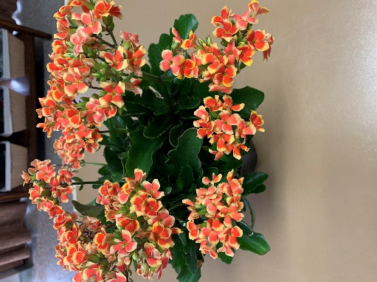

Scenic drives around our community. Thanks to Sparta Floral for the pick me up flowers ☺

Happy 1st Friday in November!

We hope the sunshine finds you doing well. We continue to fill the days around here with smiles and activities. This week the weather allowed us to get outside and go for some scenic drives. Some of us had our spirits brightened from flowers from Sparta Floral. Linda had us tapping to our feet to 50s and 60s music again (thanks for the suggestion from family) on channel 25. Then she continued the music theme and did an educational program on campaign songs on Election Day. Interesting song choices through the years and many we sang along to. Lisa also played some music in the halls around the home as well.

Going to put this request out there now and again in a few weeks, but if you have deer hunting pictures, please e mail them to our Jessica in activities. Her e mail is [Jessica.Byom@co.monroe.wi.us](mailto:Jessica.Byom@co.monroe.wi.us)

She will be putting together a slide show of pictures for our hunters to enjoy during the hunting season.

Have a great and safe weekend.

Linda