Snapshots from October 12th to the 16th
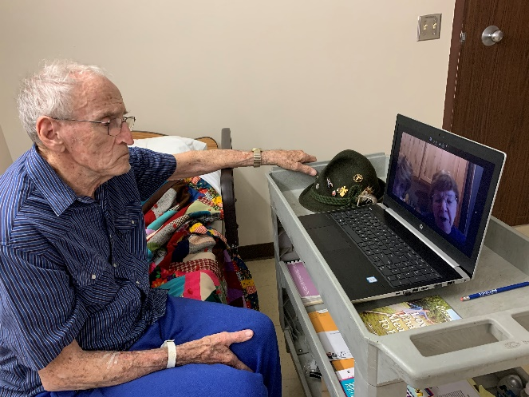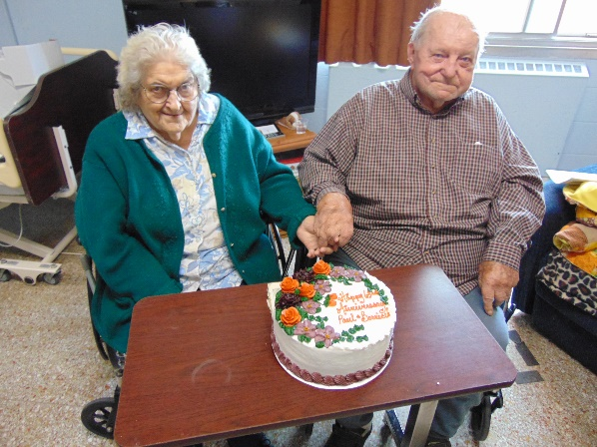
Virtual Visits still going well Celebrating a 63rd anniversary during covid
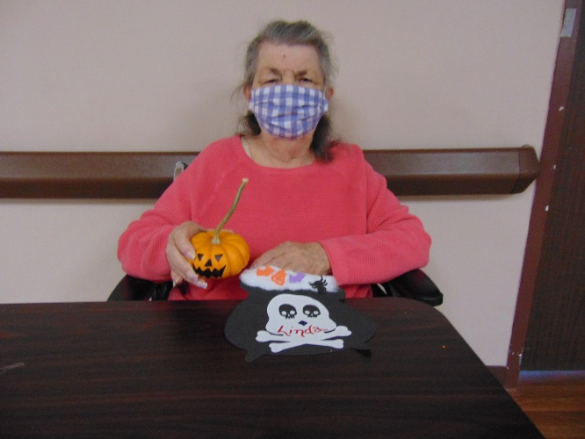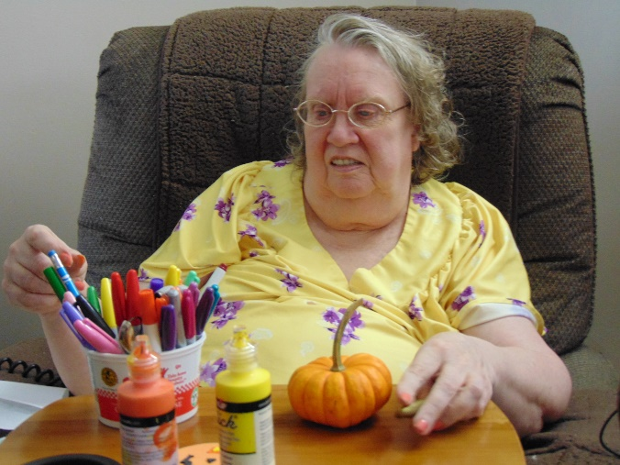
Making use of our mini pumpkins donated to us to get creative and decorate
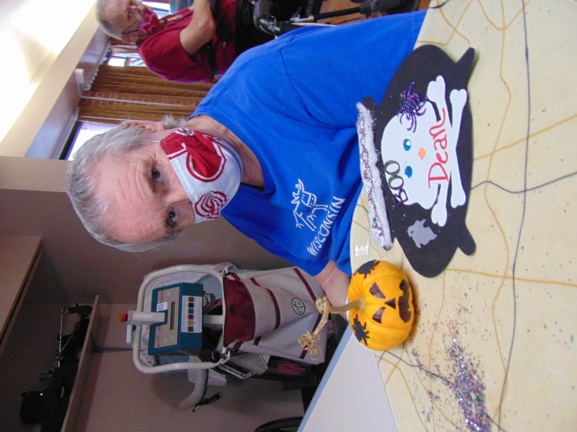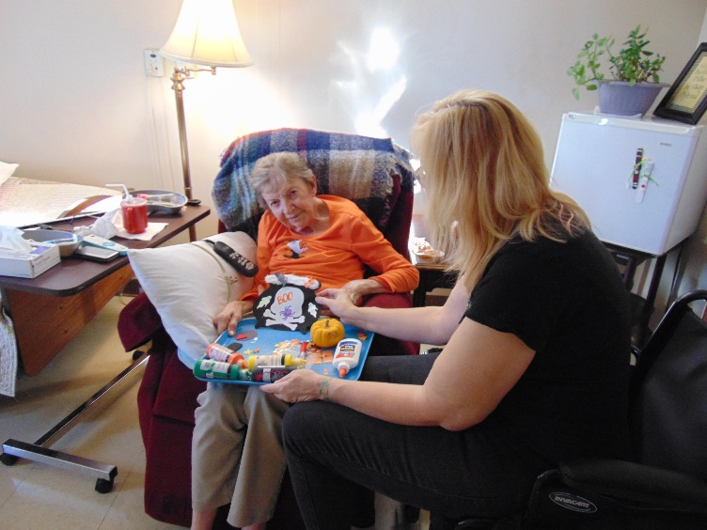
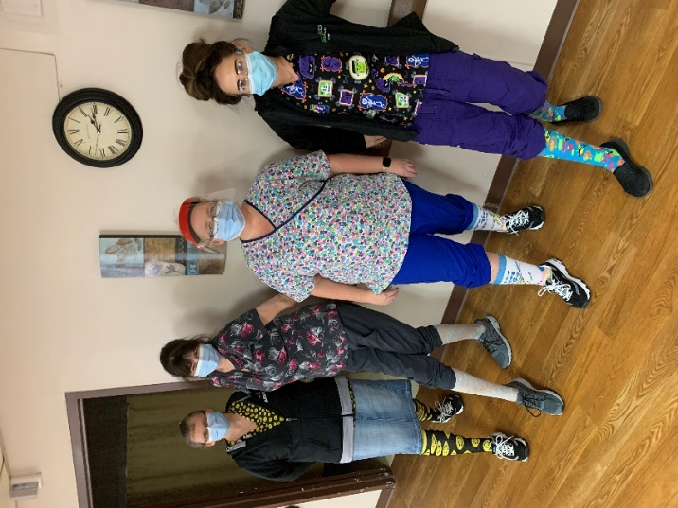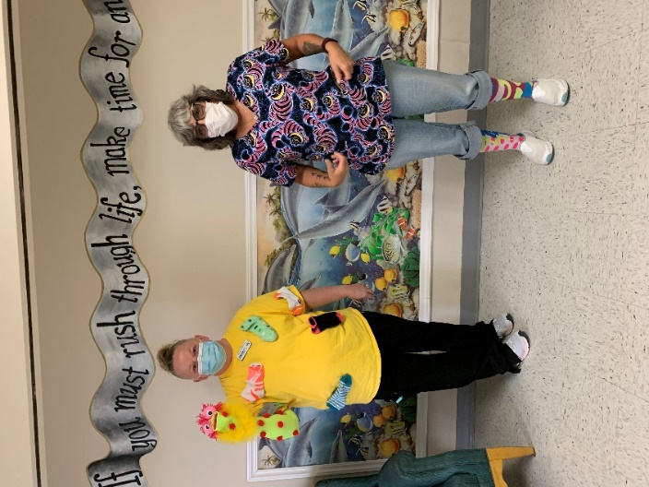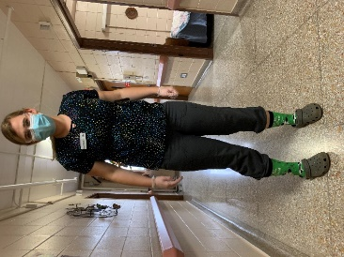
Crazy Socks was the theme to bring smiles around the home!
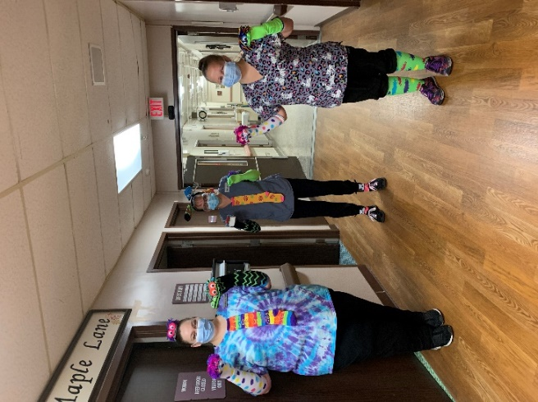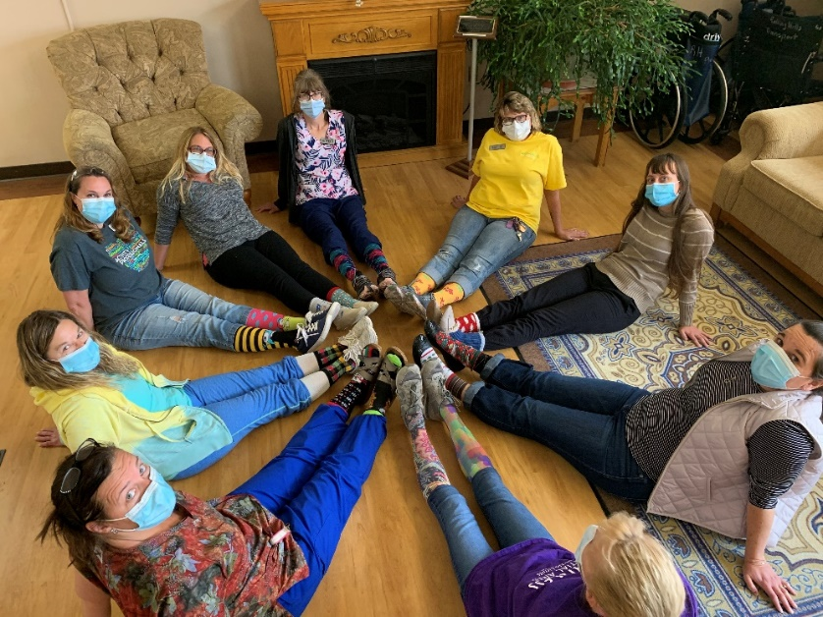

It’s Friday again!
We have kept busy here and there with social visits one on one, Bible study and music on channel 25, laughter is the best medicine in the hall as well as traveling around with a craft cart. We were donated some pumpkins and gourds for around our home. The mini pumpkins we used for a craft that could then decorate their rooms. Next week we are thinking about doing some carving and facts.
This past week on Monday we delivered a Hershey “hug” with an encouraging phrase to brighten everyone’s day. Here is our hug message we shared:
Hugs
Are non-fattening
Don’t cause cavities
Contain no preservatives or artificial ingredients
Are cholesterol-free and naturally sweet
Are a completely, renewable resource
Don’t require batteries, tune-ups or X-rays
Are non-taxable, fully returnable and energy efficient
Are safe in all kinds of weather
Are especially good for cold, rainy days
Are exceptionally effective in treating the Monday Blues

Enjoy this hug to keep you encouraged during these Covid times from the activity staff!

