October 19th to the 23rd snapshots
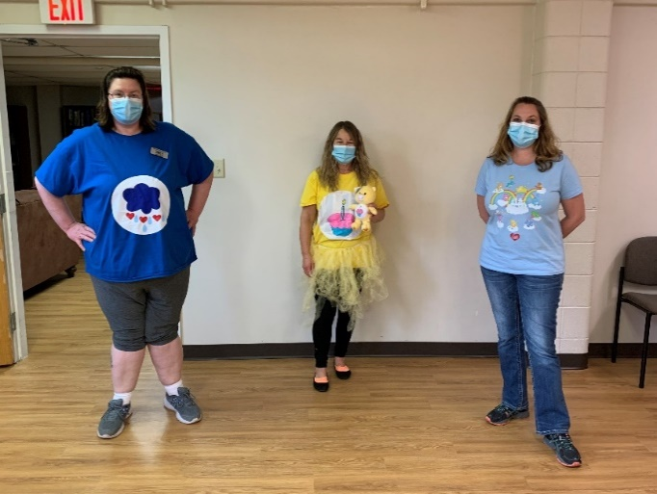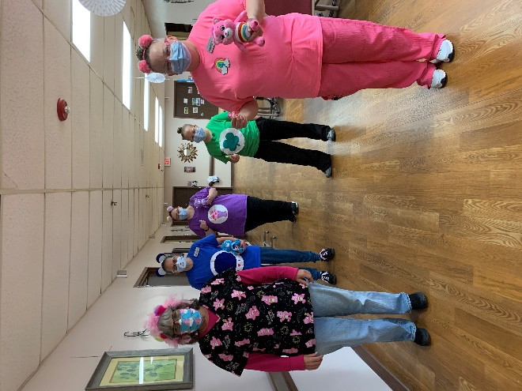
Care Bear theme
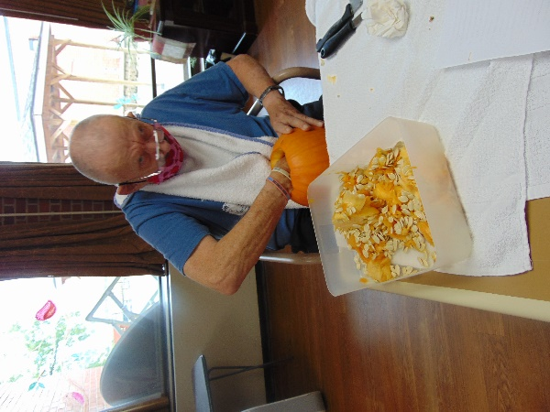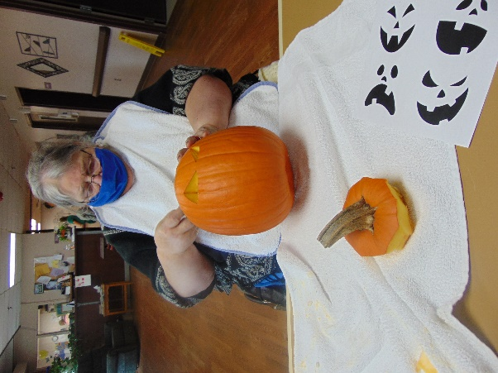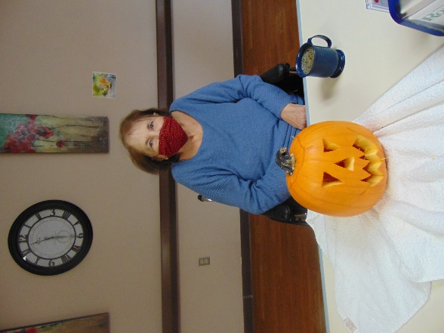
Pumpkin smells were free while we carved a few pumpkins
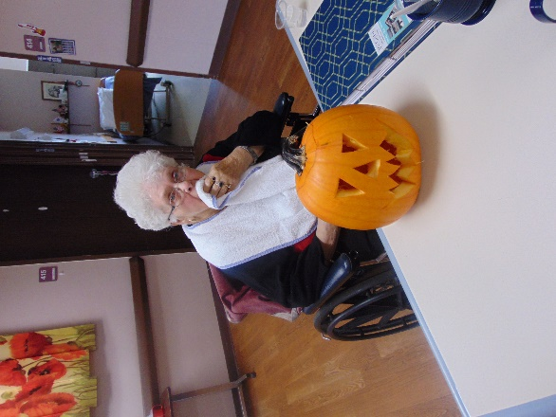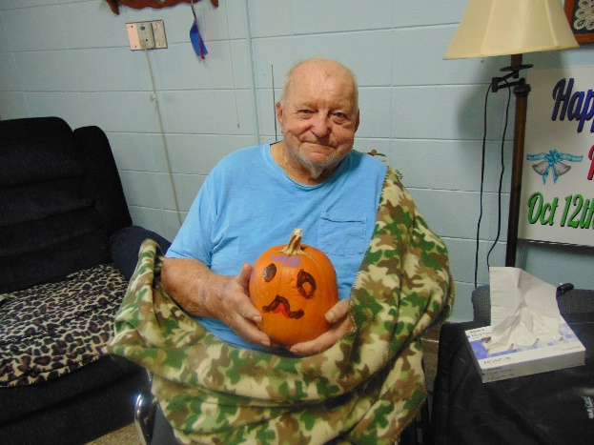

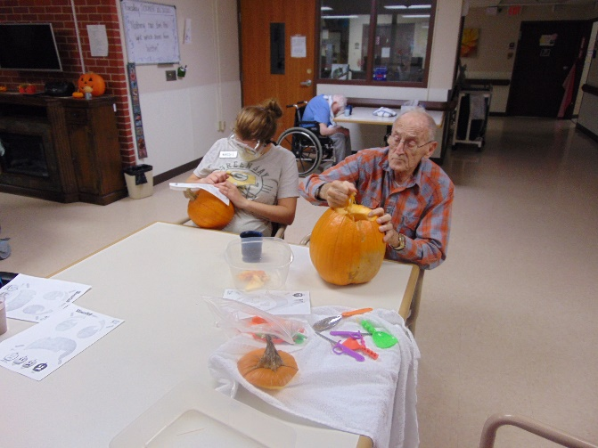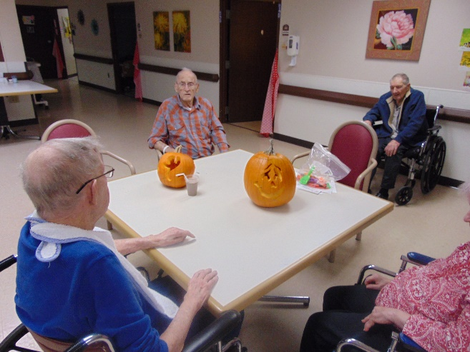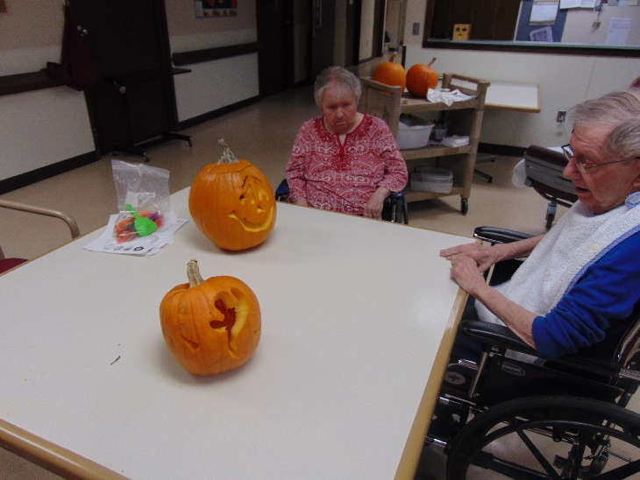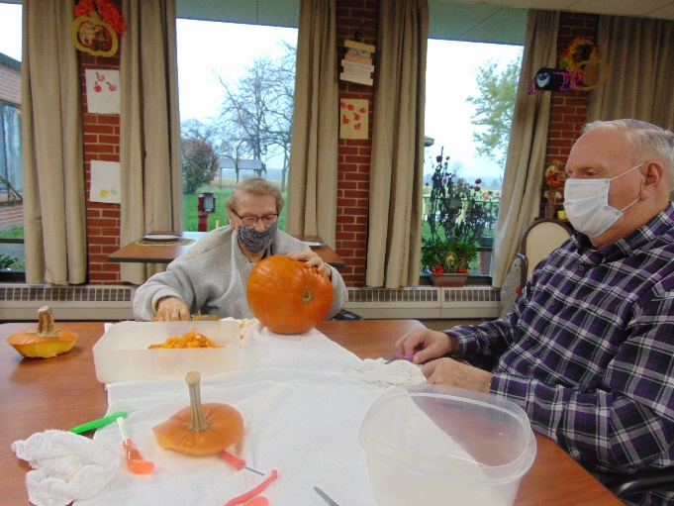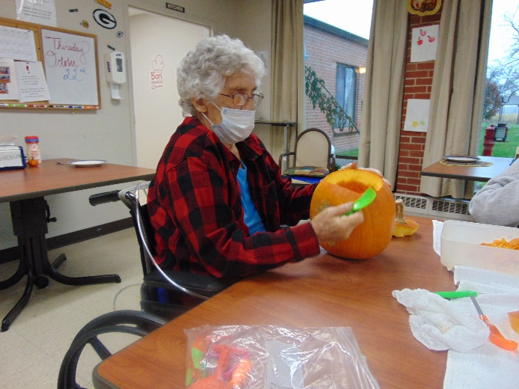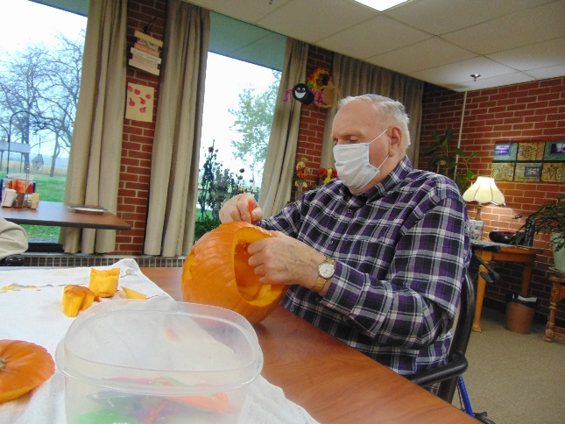

Halloween is so close, we can taste the candy!
This week we began decorating our outside of the home with donated pumpkins, gourds and corn. So even though we have seen some gloomy days, they are brightened with the orange pumpkins sitting outside. We had our memorial service recognition this week on channel 25, remembering our friends that have passed away in the past couple of months. We also had fun playing Mystery game, carving pumpkins and playing hangman in the halls. We have been working on some great pictures for our family and friends to share next Friday, so we hope you will enjoy those as well.
As always, stay safe and healthy.
Linda

