Snapshots from first week of September

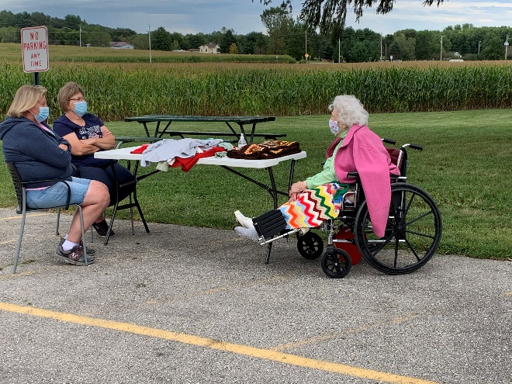

Outside visits continue

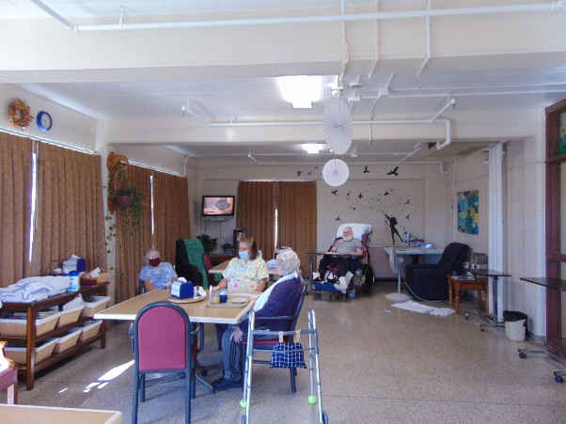 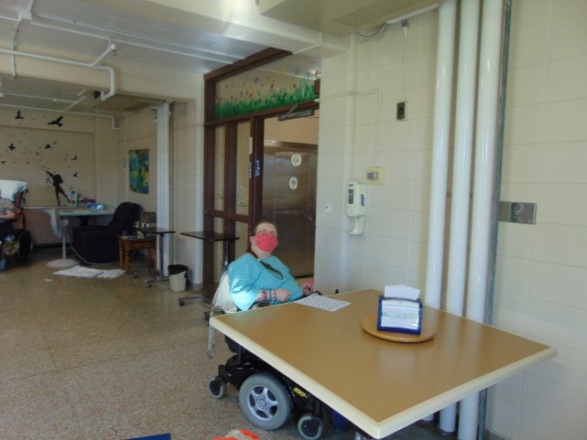

Still playing bingo

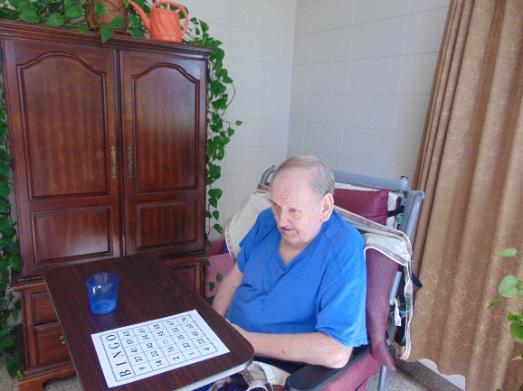 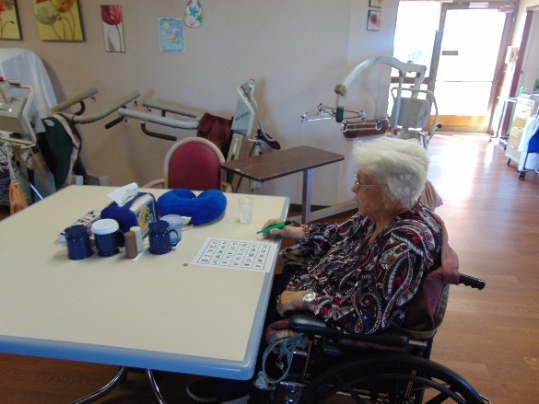

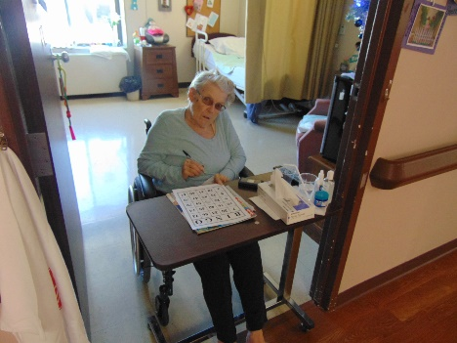 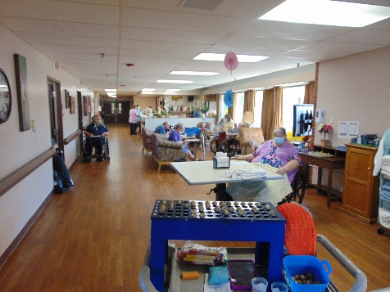

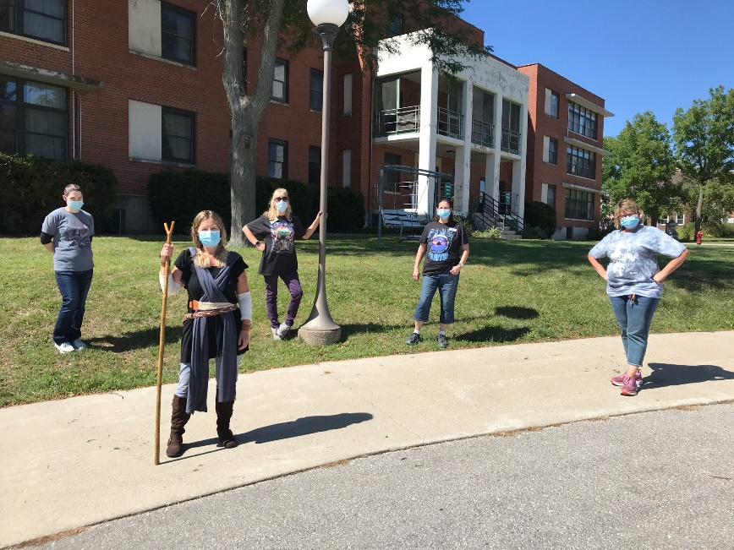

Star Wars/Space Day

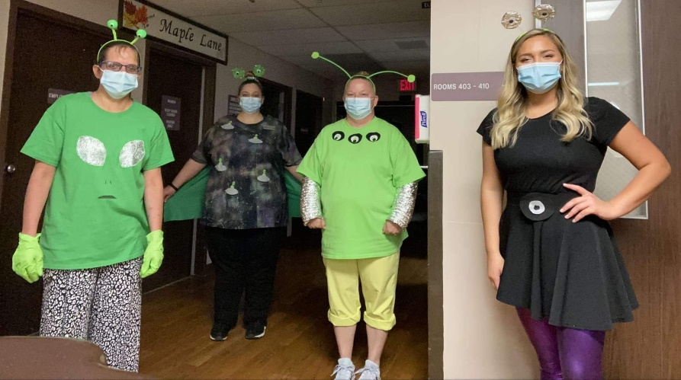

Keota visited outside the windows again

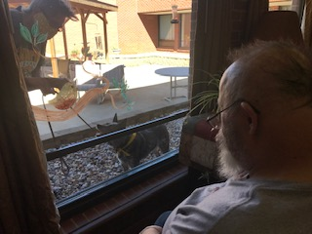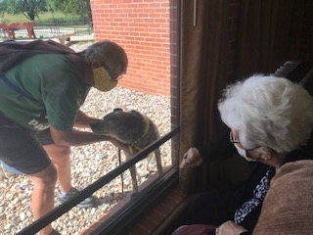

We had so much fun “bobbing” for apples too!

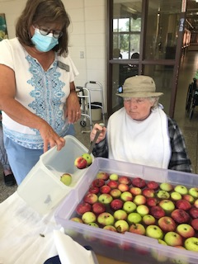 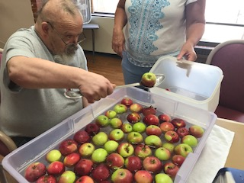 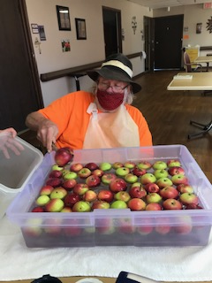

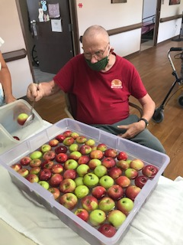 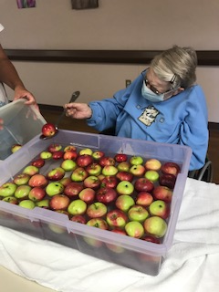 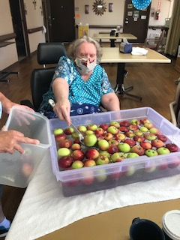

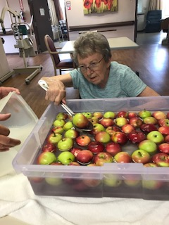

The first Friday in September is upon us! I cannot believe how fast time is going by this year. We have been trying to stay busy around here. This week it was with exercise, scenic drives, “bobbing for apples” and watching Keota do her tricks from afar. Lisa continues to play piano music now and again too. Activity staff work hard trying to spend time with everyone, offering assistance sending mail, doing a craft, organizing their rooms, repotting plants, playing cards and much more. This week we began our new theme, apples. Each week we will be incorporating some apple fun with crafts, games, facts and more. All staff continue to ensure the outdoor scheduled visits are safe and activity staff continue to ensure virtual visit requests are met to the best of their ability. Until next week! Linda