Snapshots from September 8th to the 11th
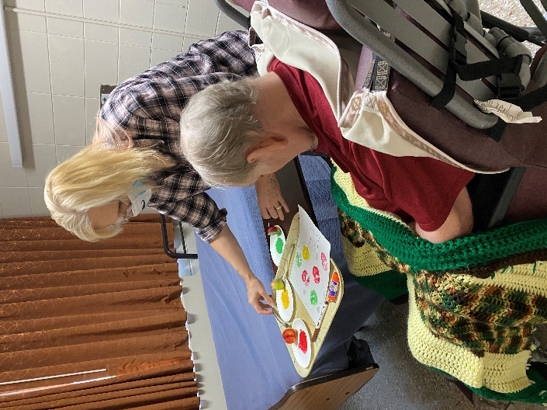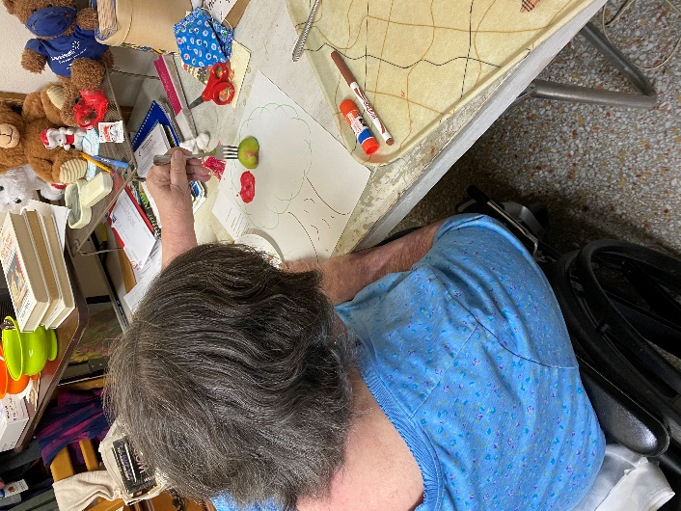
The apple theme continues with an apple craft
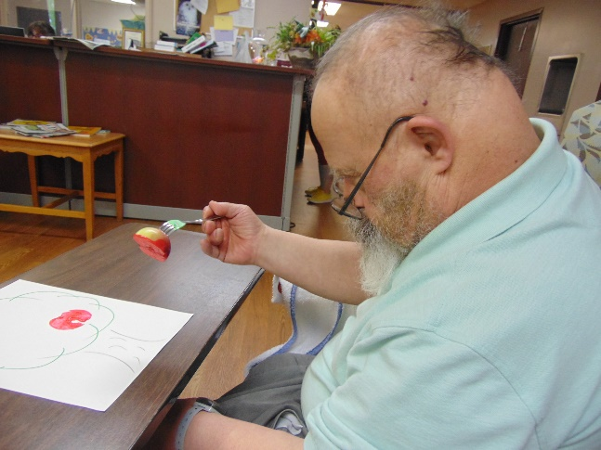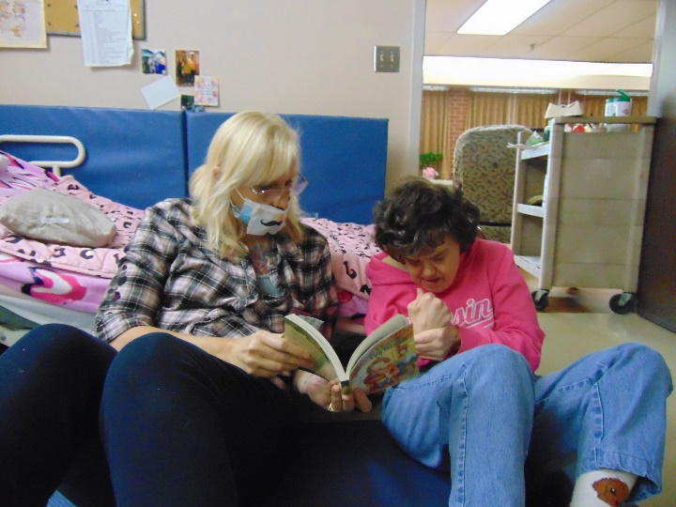
Apple craft and reading time
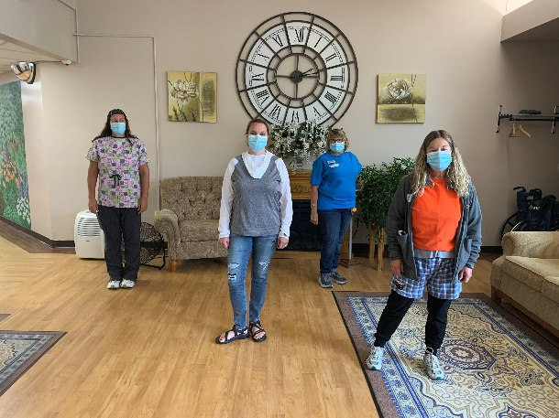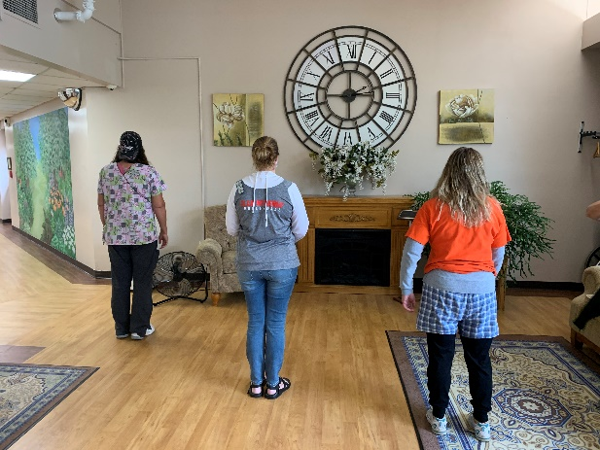
Inside out and Backwards Day

Well, this is a colder Friday than I would like, but I hope it finds you all doing well. We continued our apple theme and had a craft this week along with hearing all about apple facts. Linda has been using channel 25 this week to keep us laughing with school jokes and humor, along with singing some familiar tunes. Lisa was back in the halls, bringing some live piano music to listen to and sing along with songs residents have been requesting. Then we have been trying to visit everyone, keep up with the virtual visits and of course offer assurance during these difficult times. Next week we will finish our apple theme with some applesauce and apple bingo.
Our department is always looking for ideas, so if you have a great theme to try here, please let us know. We always try to have a game, a craft, some facts or trivia and food with each theme we bring forward.
Have a great and safe week and we will send more pictures next Friday.
Linda

