Snapshots from August 10th to the 14th

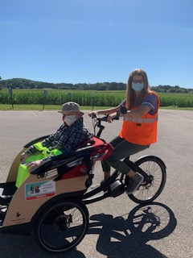 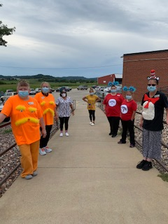

More bike rides

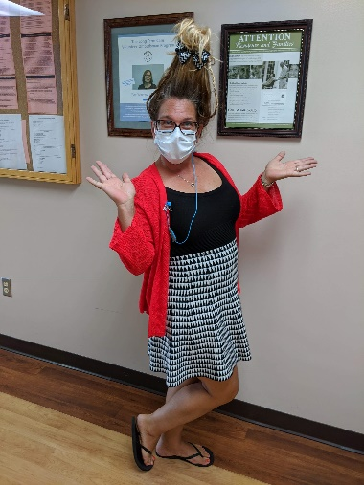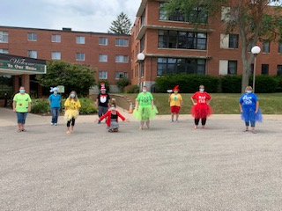

Dr Seuss Day at Rolling Hills

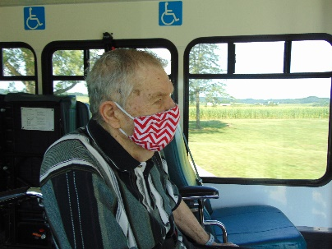 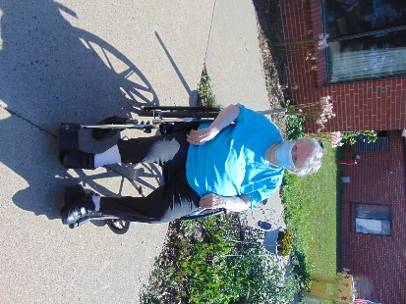 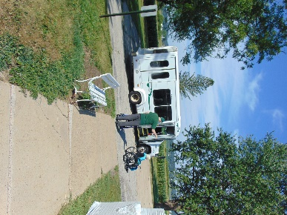

Scenic Drives are great to do!

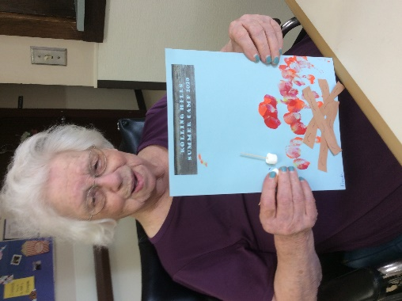 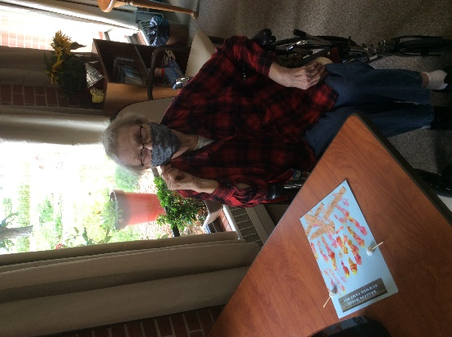 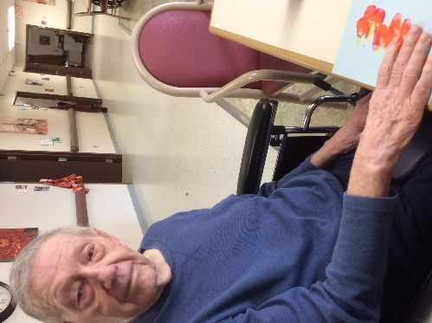

Rolling Hills Summer Camp 2020 began with a craft!

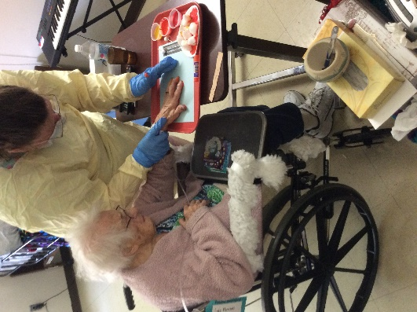 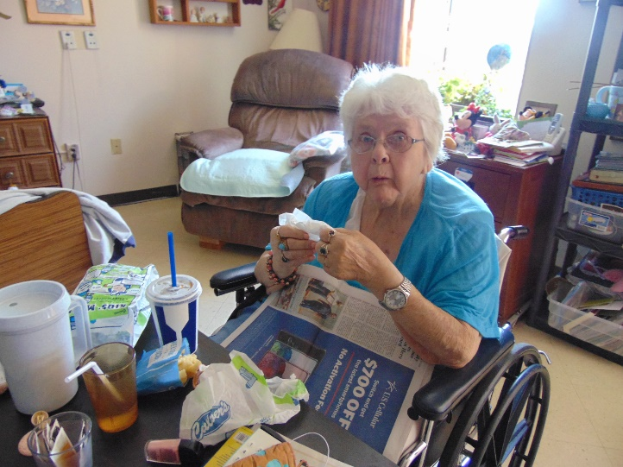

We even decided to do an order-in Culvers lunch beginning with one area and will work our way through

We decided to have a little more fun with Dr Seuss Wednesday this past week. Staff dressed up and residents got to watch The Cat in the Hat, listen to a few stories (Green Eggs & Ham, Oh The Place’s You’ll Go) and learn some fun facts about Dr Seuss himself. We continue to take advantage of the nice weather for sitting on the patio, going for walks on our walking path or going for bike rides. We began our summer camp activities this week with a craft. It was definitely a hands on fun time! Next week we think our camp fun will bring some laughs and fill their bellies! We even tried an order-in Culvers meal. We still can’t eat together, but it was a nice change of pace and we plan to go hall by hall for this opportunity.

Have a great weekend.

Linda