Snapshots for August 24th to 28th

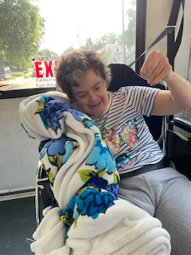 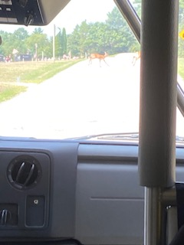

Car rides to check out nature continue-geese and deer were seen on one drive!

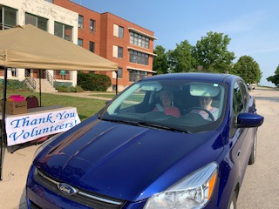 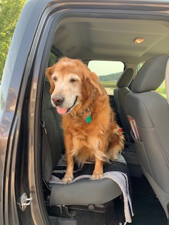

We held a Drive By Volunteer appreciation. We miss our many volunteers and never had the chance to have their appreciation party due to Covid, so this was our way to say thanks in 2020!

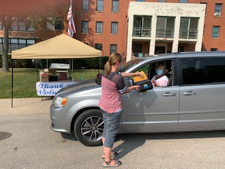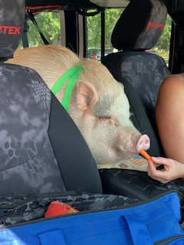

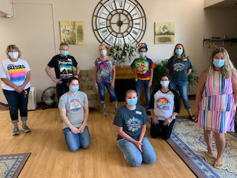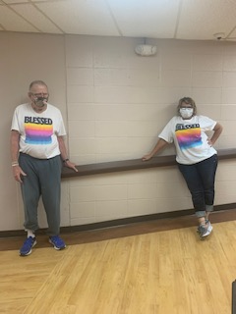

Rainbow was the theme this week!

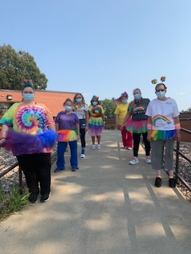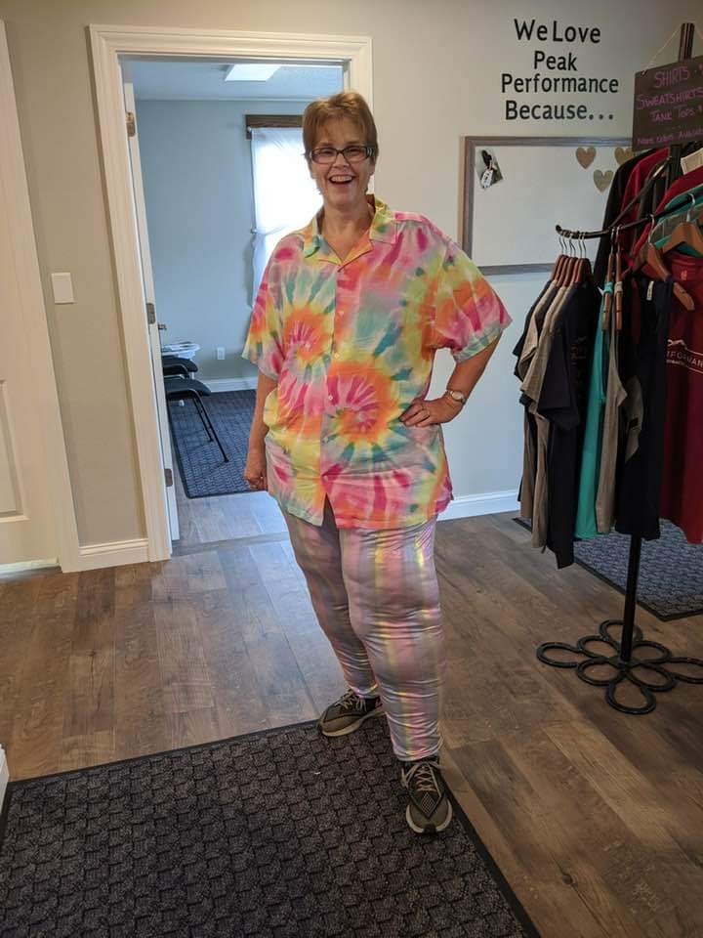

We can’t have Rolling Hills Summer Camp without S’mores!

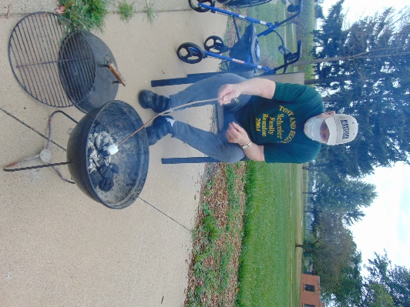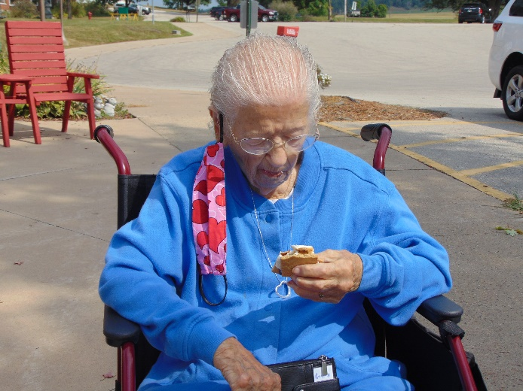

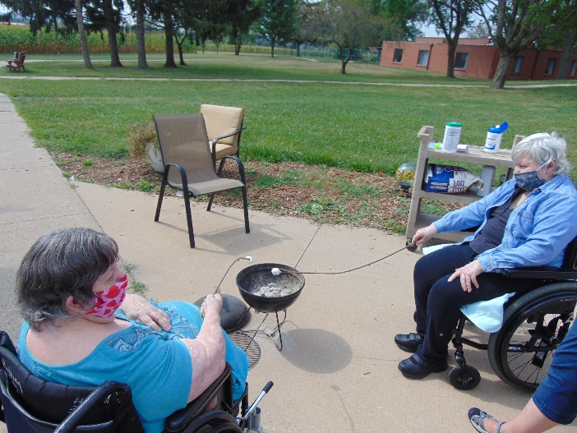 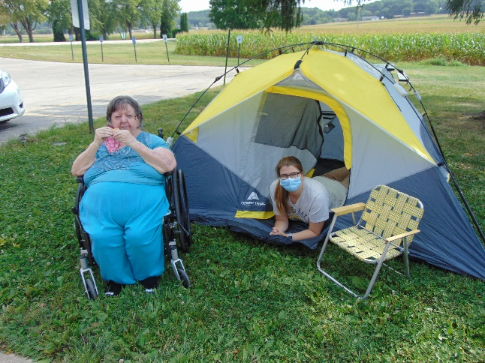

We even tried some animal track Pictionary

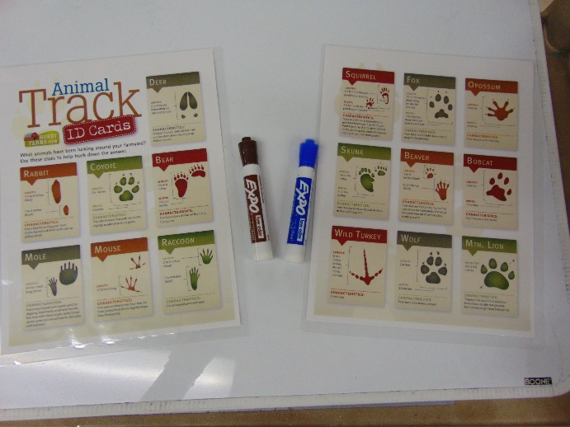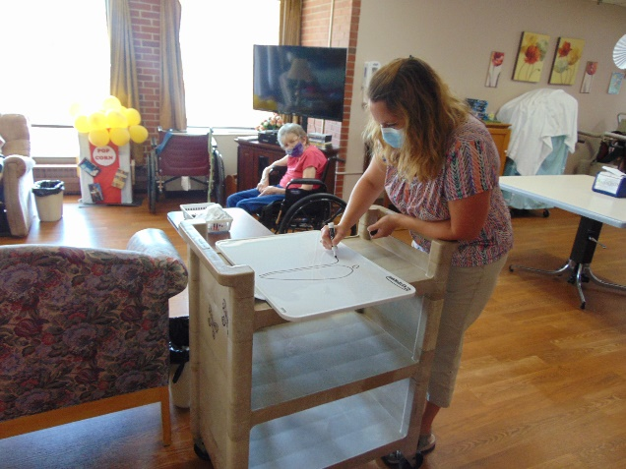

And Marshmallow Toss

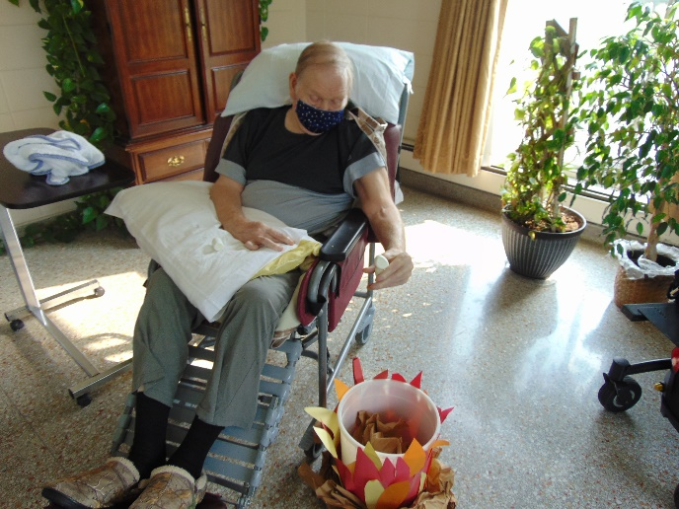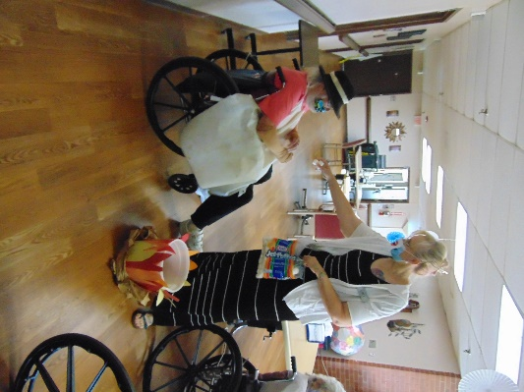

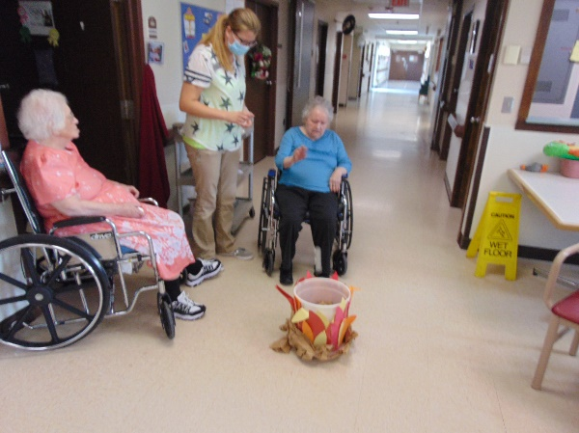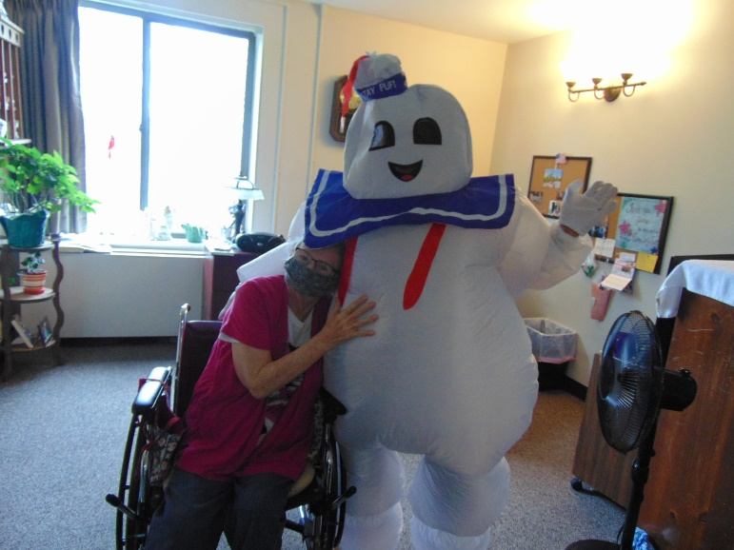

Of course if we are talking about marshmallows, Stay Puft should make a showing!

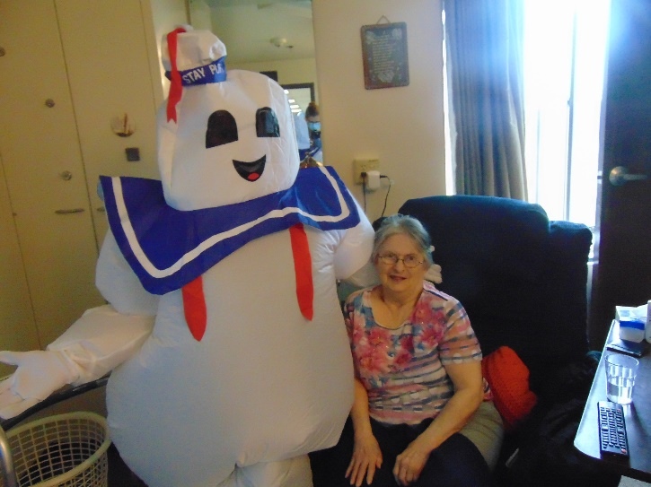 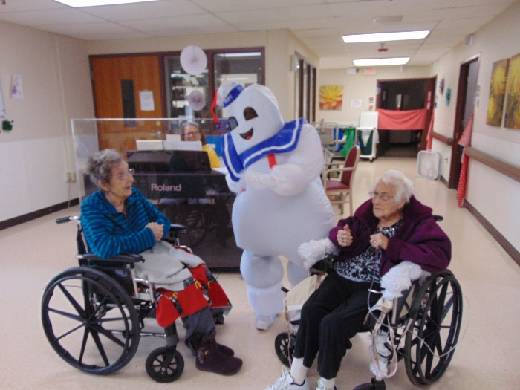

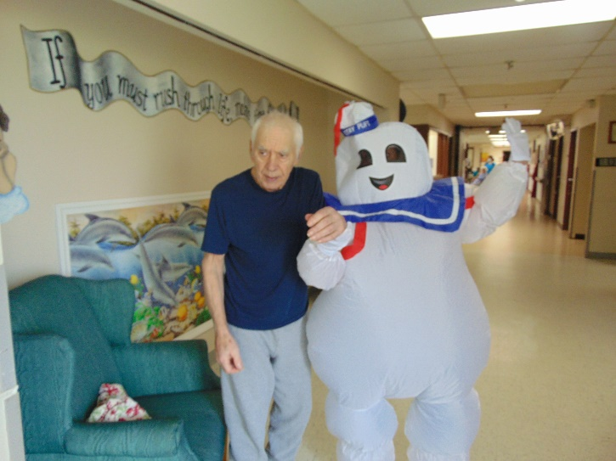 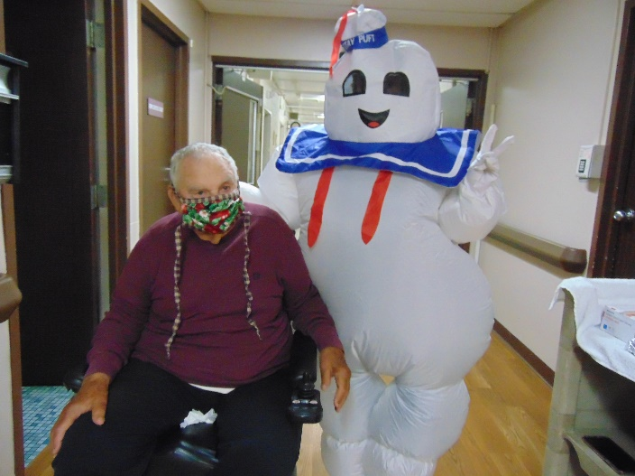

The last Friday of August is here! This past week we finished up our Rolling Hills Summer Camp Theme by having a Marshmallow toss and eating s’mores! Interesting fact, we found many of our residents have never had a s’more and enjoyed one for the first time. We roasted marshmallows on a grill, but they still were good. We talked about camping, as we had a tent all set up too! Of course with talking about and eating marshmallows, Stay Puft had to come and say hello, bringing smiles along his travels too. One morning, that we didn’t have the high heat warnings, we did manage to sneak in some scenic drives, seeing many wildlife on our travels. Next week we are hoping to begin our next theme, this time being apples. I am also including an invitation to make a scarecrow to decorate the outside of our home. Spread the word as we are hoping to get lots of entries so our residents have some new things to smile and talk about!