August 3rd to the 7th Snapshots

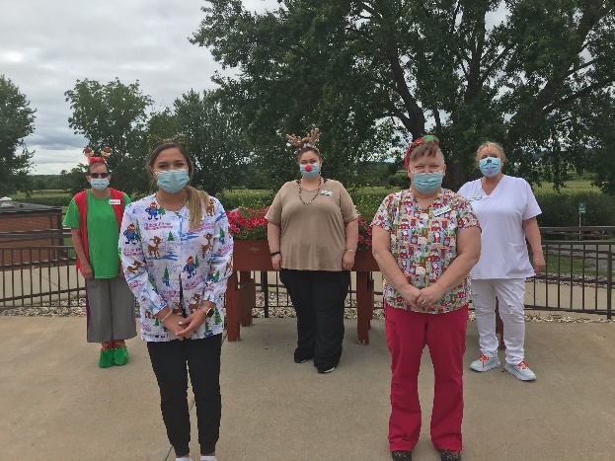 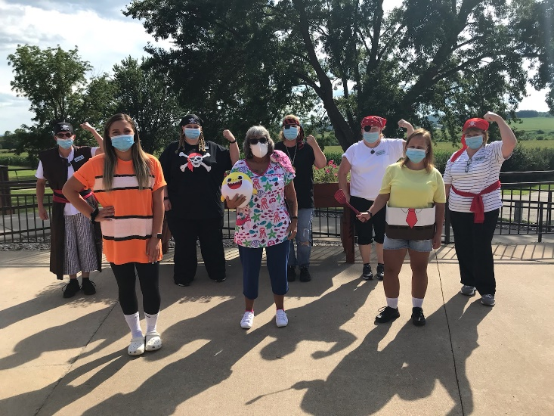

Some staff dress up days we have missed publishing; Christmas and Nautical themes

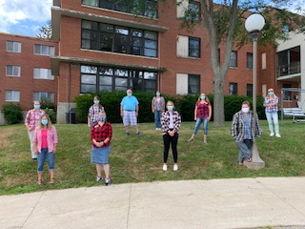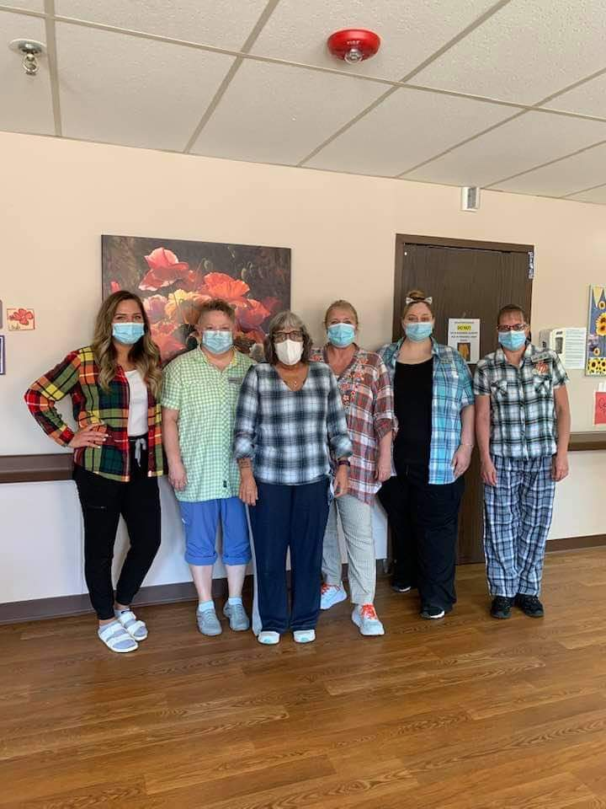

All about the plaid!

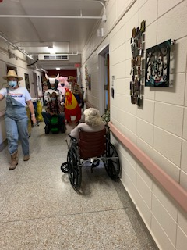 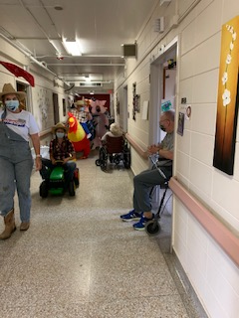 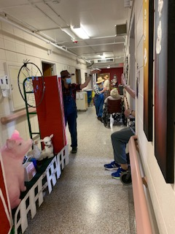

We ended our Fair Theme with a parade this week that was full of music, laughs and smiles.

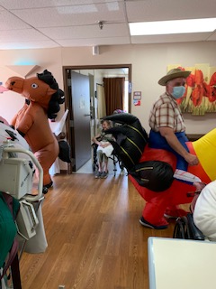 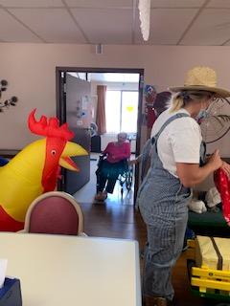

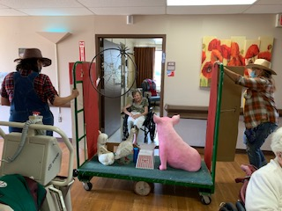 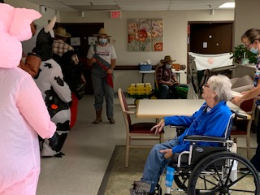

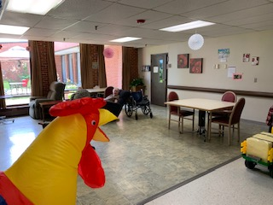 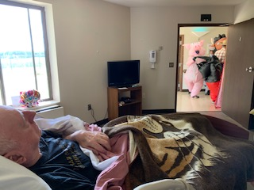

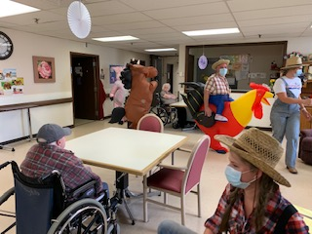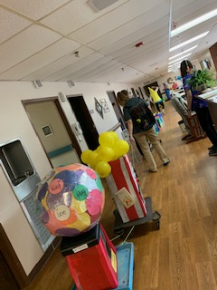

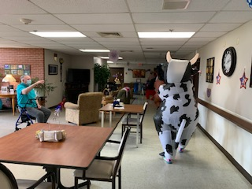 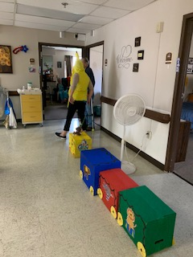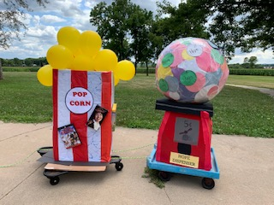

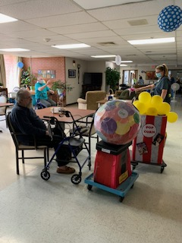 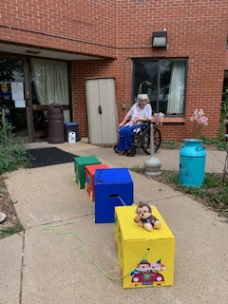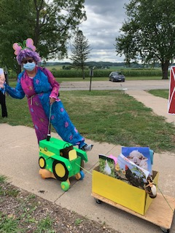

1st Place went to Maple/Lighhouse Staff farm:

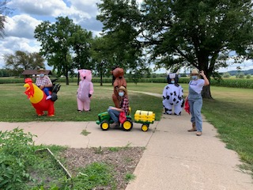

2nd went to Housekeeping/Laundry/Central supply Charlotte’s Webb:

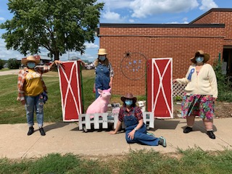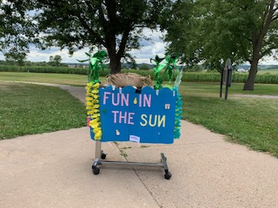

3rd place went to Meadows CBRF with their Fun in the Sun

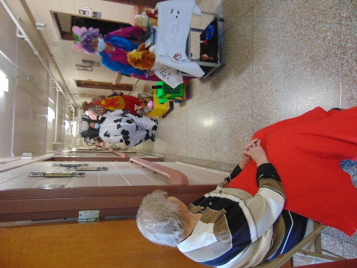 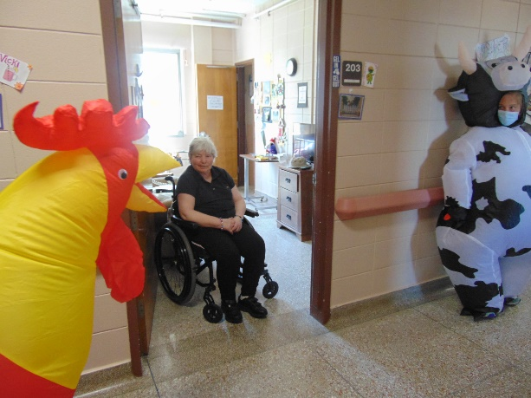 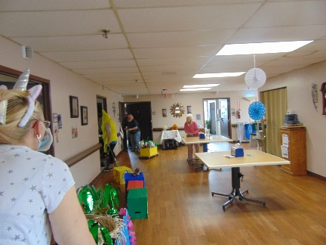

We surprised everyone with a great evening outside plus some live music with Laurel and Dianne

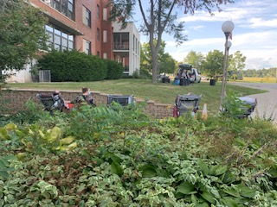 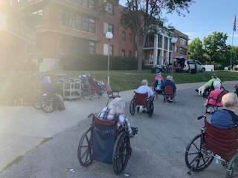

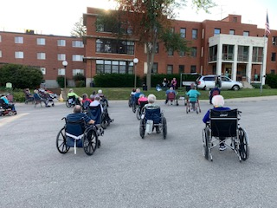 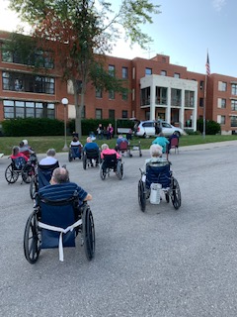

The fair theme has come to an end and ended with a bang, or rather a parade. Staff from all departments participated and there was music for some of the entries and some great creativity. I know the pictures don’t do justice, but your loved ones were smiling, waving and laughing with us!

Our next theme to do some new activities around will be: Rolling Hills Summer Camp 2020! We hope you will enjoy seeing the crafts and pictures of what we have planned for the next few weeks.

We even decided to throw a surprise concert for the residents outdoors one night. I may have been a “hall monitor” that served as a reminder to keep your mask on, don’t move your wheelchair or chair, we all have to keep 6’ apart and oh yeah, be sure to sing and have fun! I am happy to report they all did and the weather was beautiful to listen to the accordion music. Not even one mosquito ruined our night!

We hope you all have a healthy and safe weekend.

Until next week,

Linda