Snapshots from June 28th to July 2nd
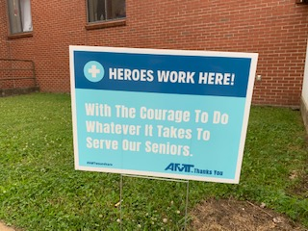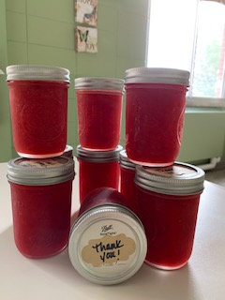
Thanks for all the continued community support!

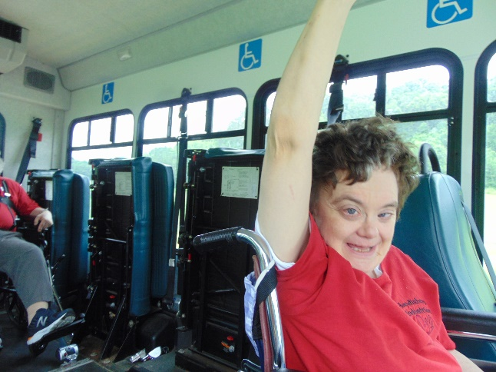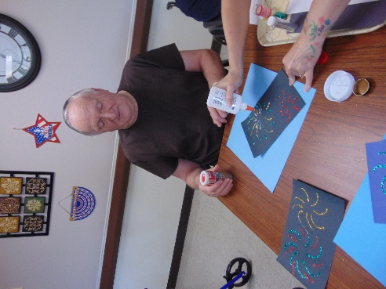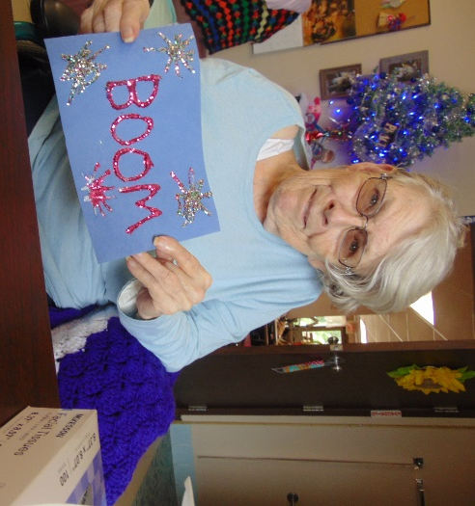
Be sure to watch for us waving on our scenic drives
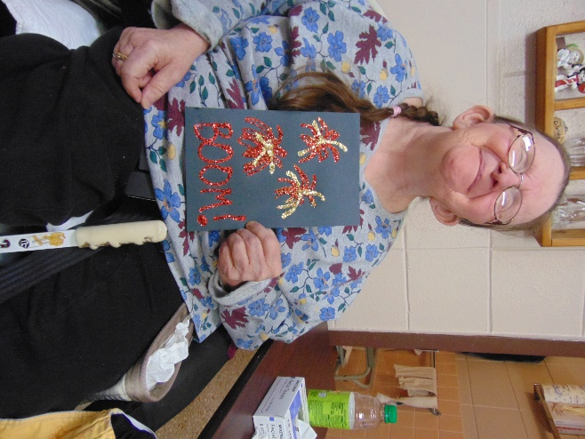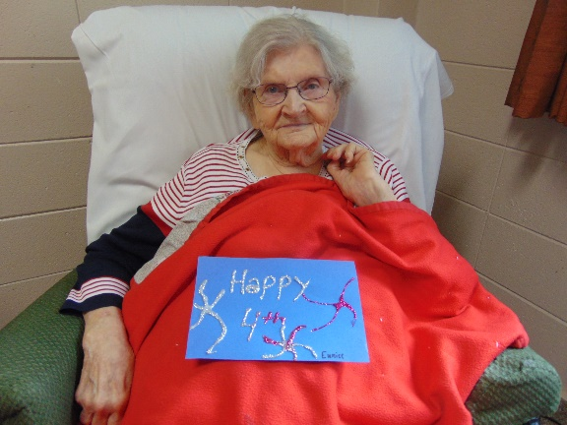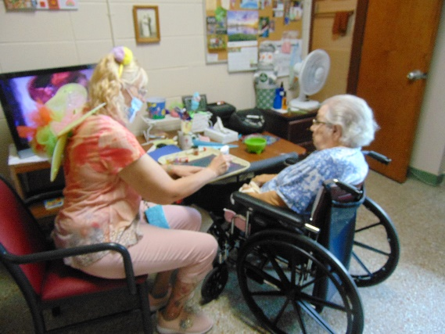
Here are some of our Patriotic messages from our craft day!

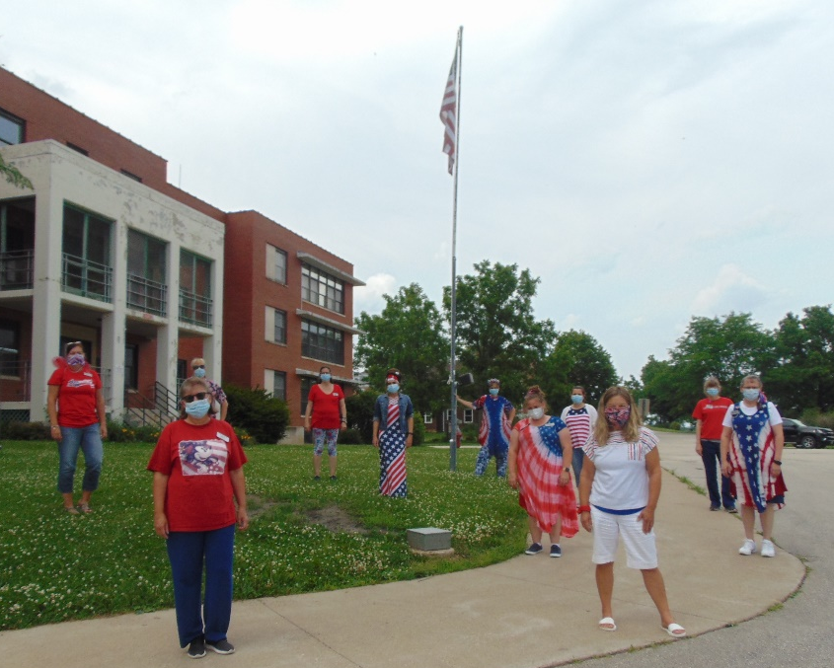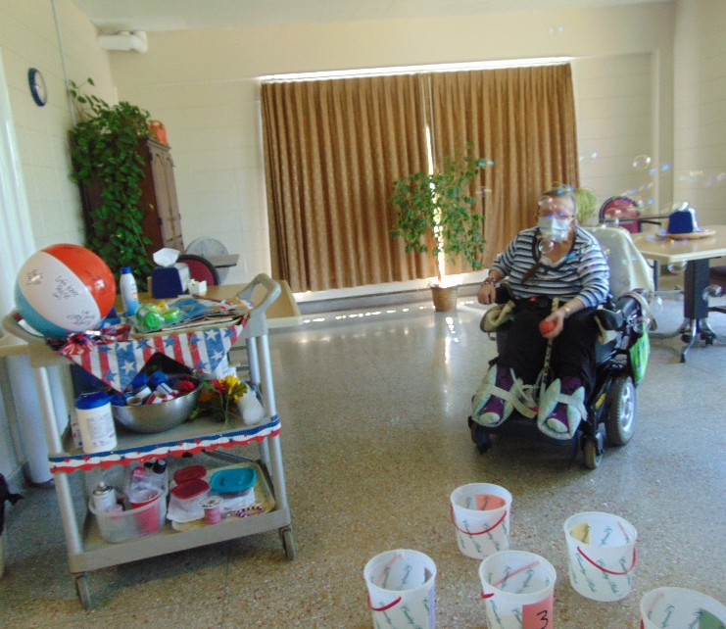
Red, White and Blue was our dress up day this week! Yard Games (inside due to heat/humidity)

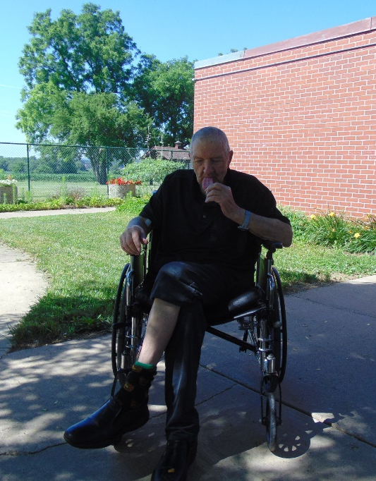 Enjoying a cool treat on a warm day

We hope you have a Happy
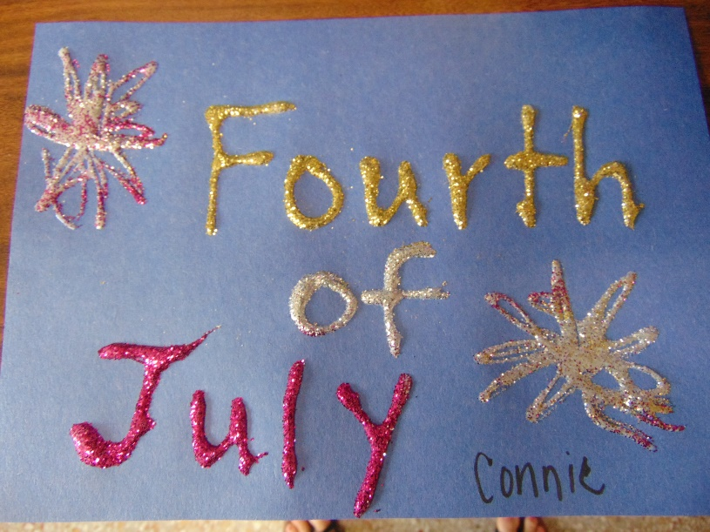

Hello again from Rolling Hills! We have been busy celebrating the 4th of July this week by making a 4th of July craft, playing bingo, 4th of July trivia, yard games, and piano music. We have continued to get residents outside when weather permits for scenic rides, walks and bike rides. This week was Red, White and Blue day for staff and resident dress up.
We thank everyone for their continued support!
Take care and have a wonderful 4th of July!

