Snapshots from July 6 – July 10

Tossing water balloons on a warm day:
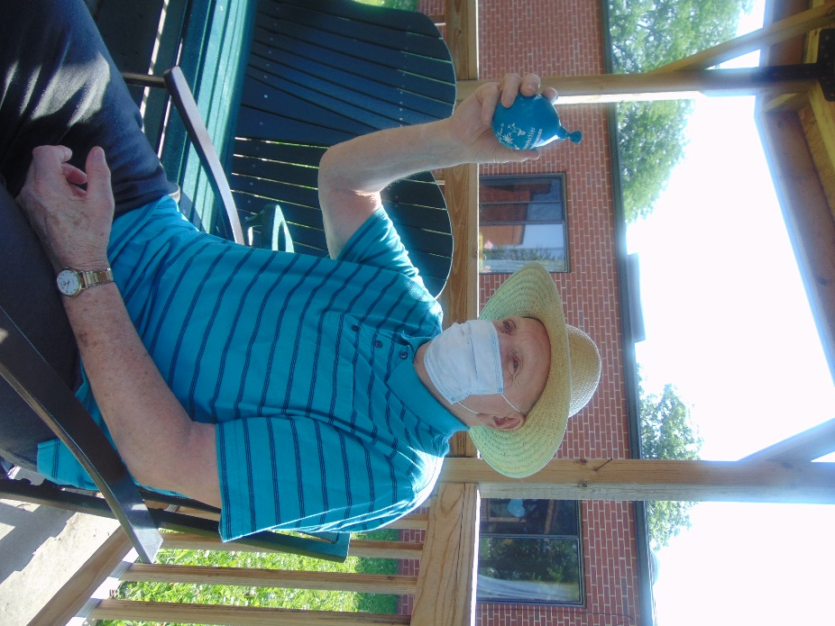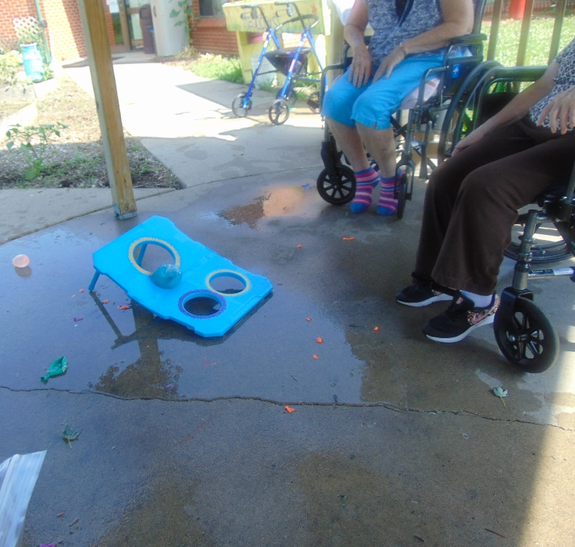

Circus was our dress up theme this week:
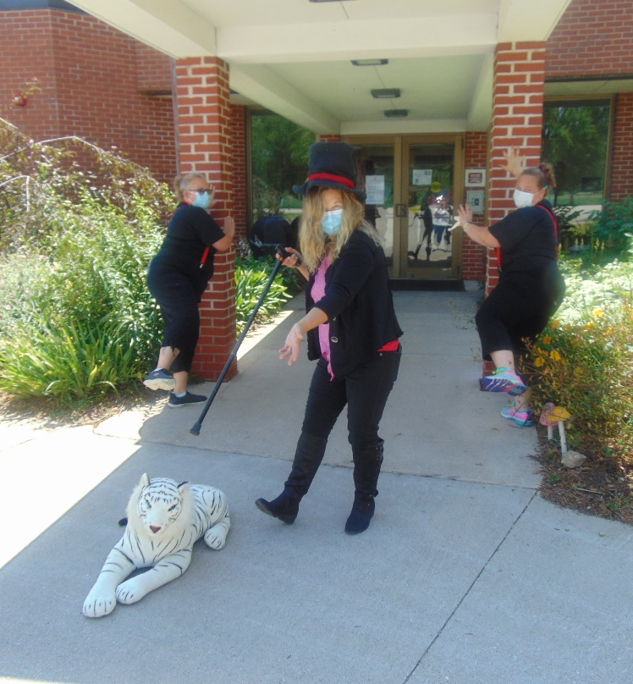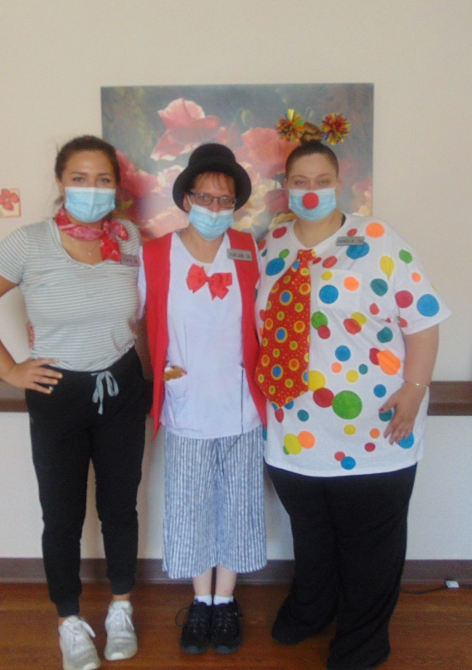
July is Berry Month, so we celebrated with some fresh berries and berry facts/trivia: 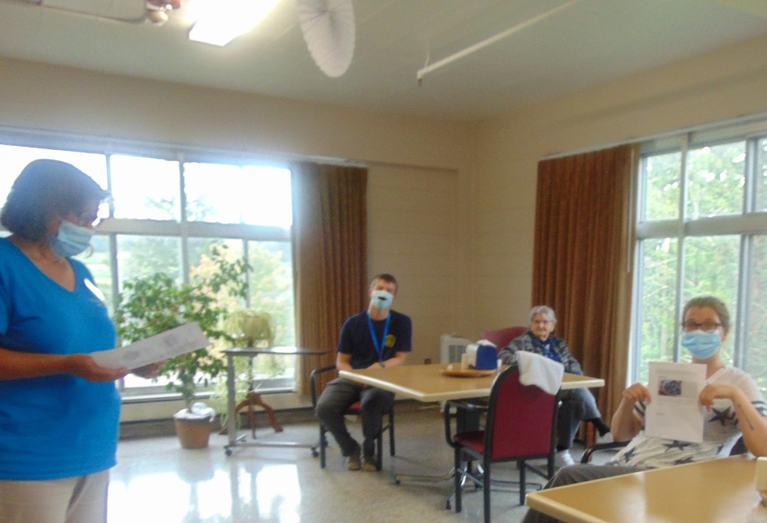
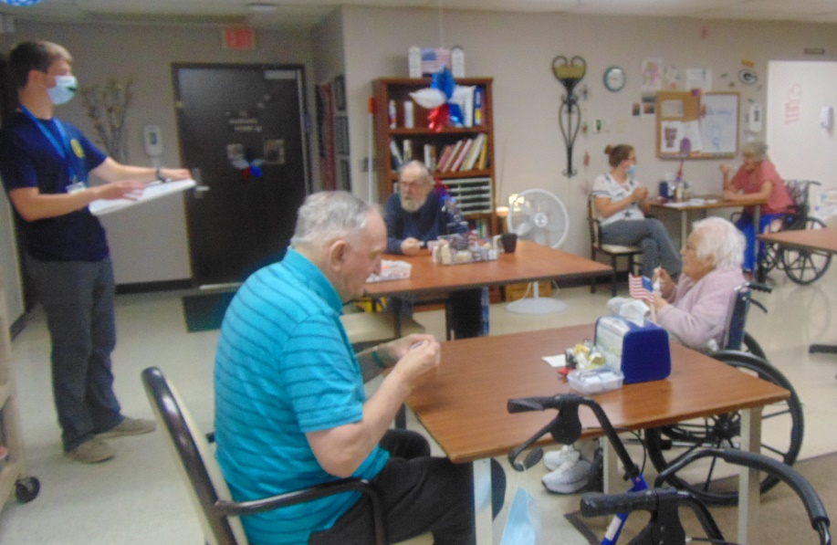

Hello once again from Rolling Hills! This week we have been dodging the heat and humidity, as we’re sure everyone else is too. We did squeeze in some scenic rides, tossed water balloons, and tried to fit in a fishing trip. The fishing trip will have to wait until better weather, as we had rain that day. Otherwise, we’ve been keeping busy with piano/banjo music, café cart, a “Berry Fun” program in celebration of Berry Month, and a variety of other programming on our in-house TV channel 25. This week, our themed dress up day for staff was “Circus”. We hope everyone stays cool. Thank you all for your continued support, and have a great weekend!

