Snapshots from July 27th to July 31st
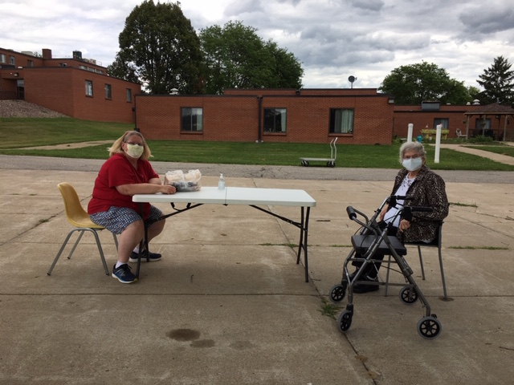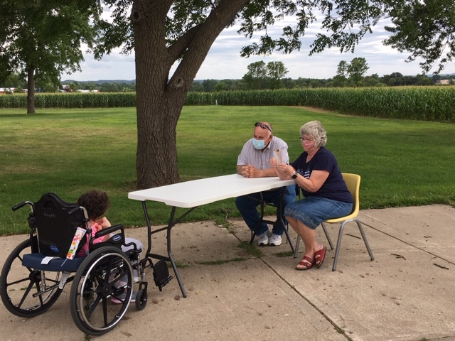
So happy to have our outside visits occur! Here are a few captured visits
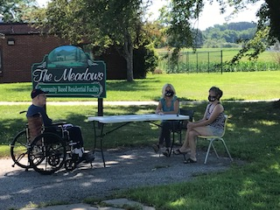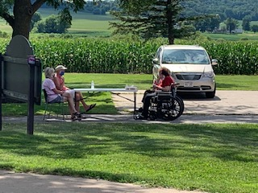
Some of our Fair Fun included the staff this time, including a “Dunk Tank” and Pie eating contest.
A video was made and shown on channel 25 for all staff and residents to enjoy!
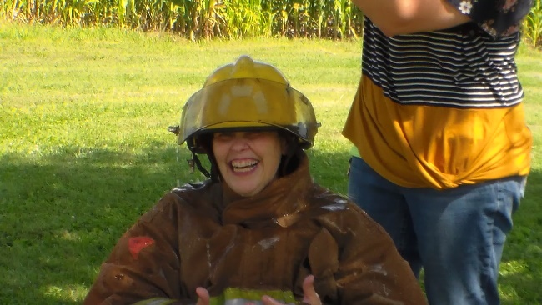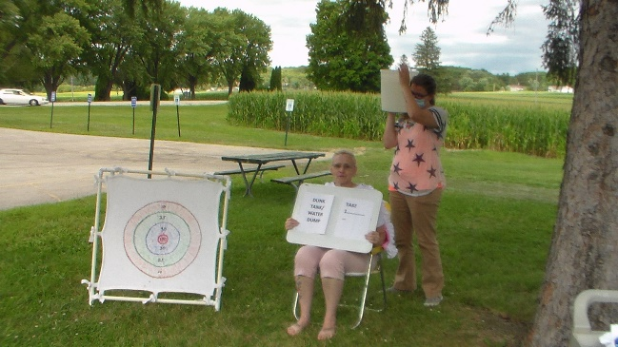
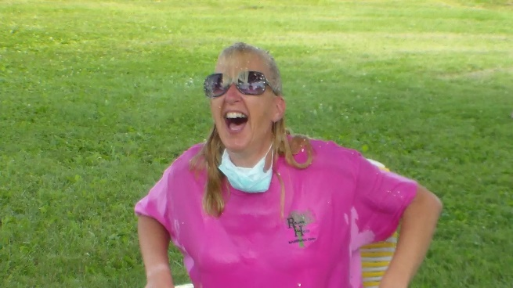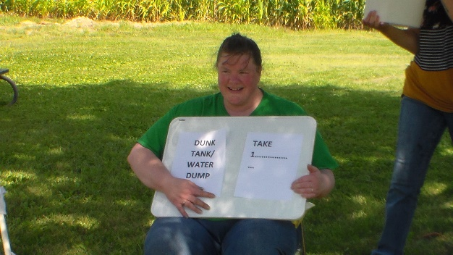
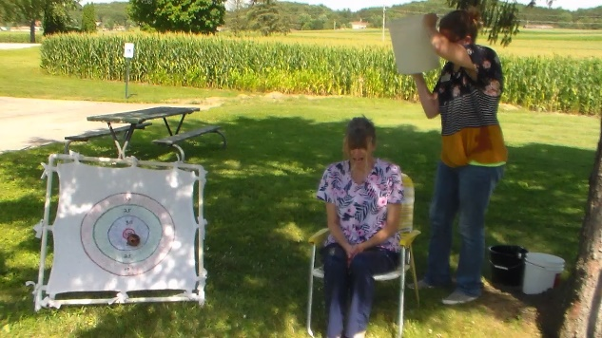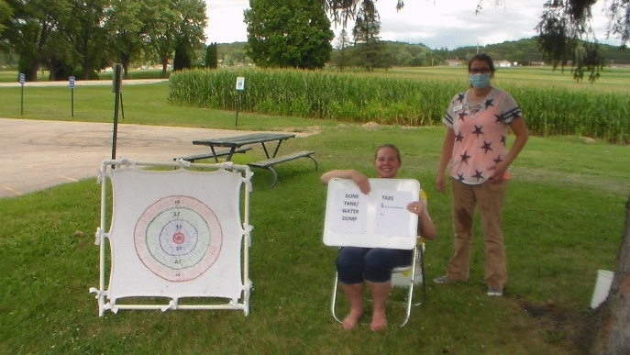
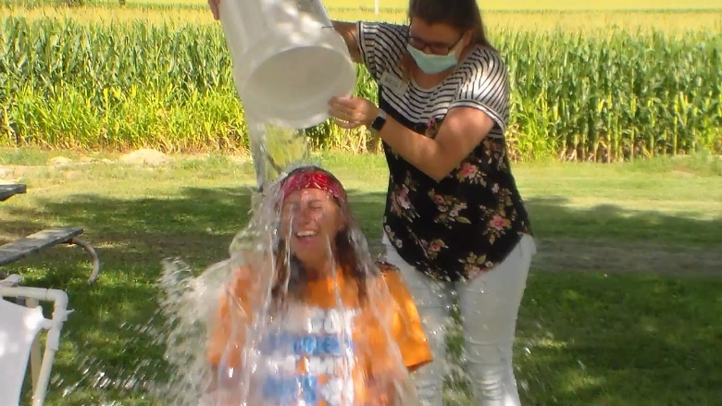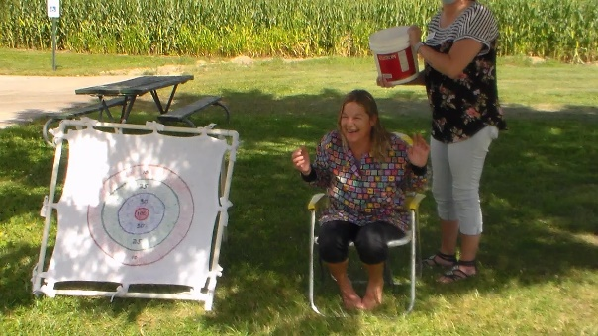
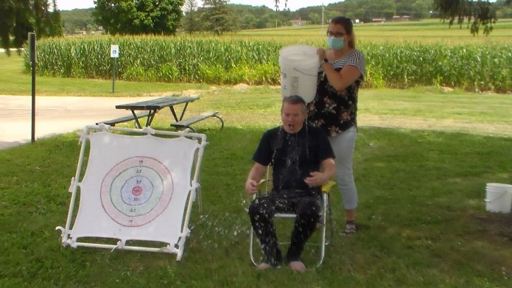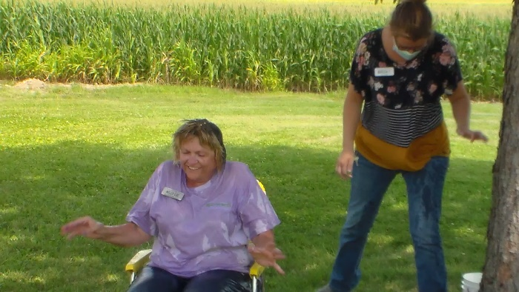
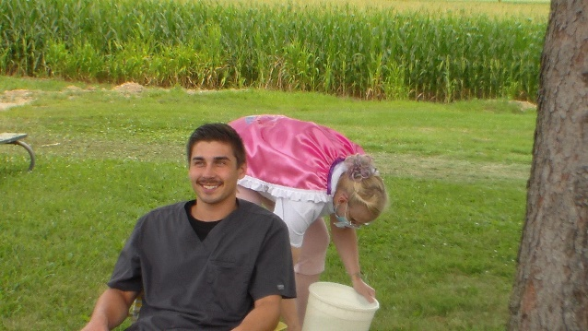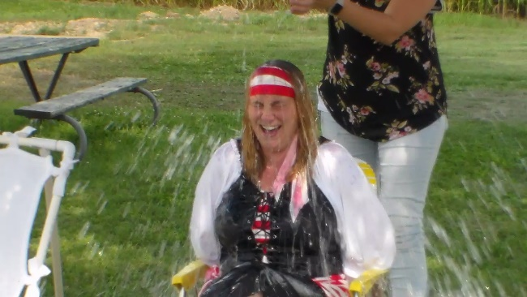
Dress up day for all was a Nautical theme
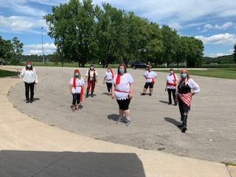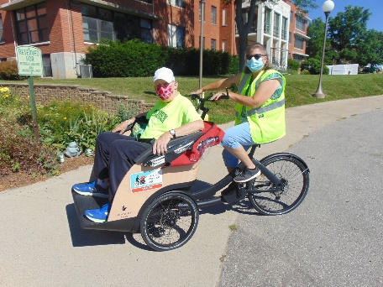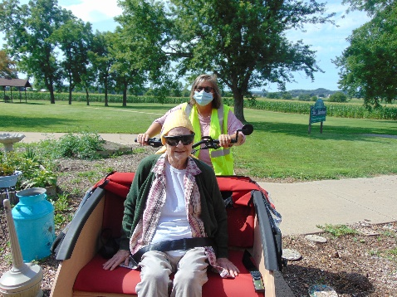

Happy Friday everyone!
First, we wanted to share that our IT department has been working hard the past couple of weeks with our phone service, internet and e mails. We have had periods of the day when we cannot receive calls or send/receive e mails or use the internet. If we do not respond in a timely manner, we apologize and hope the IT department can fix it as soon as possible. This does impact some virtual visits, so if we lose you and cannot reconnect, we do apologize.
For Outdoor family visits, since residents need to keep on their masks during the visit, we wanted to say if you bring them food, they will not be able to eat it during visits. We will set it aside and save it for them to enjoy after you leave. We are excited we were able to begin these visits. Lots of smiles, laughter and conversation on some nice afternoons occurred.
We continued our fair theme with some fair food and facts as well as got to watch a video of all the staff that joined in the fun as well. We offered them a chance to go in a “Dunk” tank. If we can figure out how, we hope to post this video on our website next week. Lots of laughs were had at their expense. They also had the chance to join in a pie eating contest. This also was great to watch and both were meant to bring laughter into our working days so we can stay strong during this trying time. Chair Yoga was broadcast on channel 25, thanks to the Sparta library, to try right in their rooms. We also took advantage of the nice weather and were able to take some more bike rides or just sit outdoors.
Have a great week!
Linda

