County Fair Game – Ring Toss
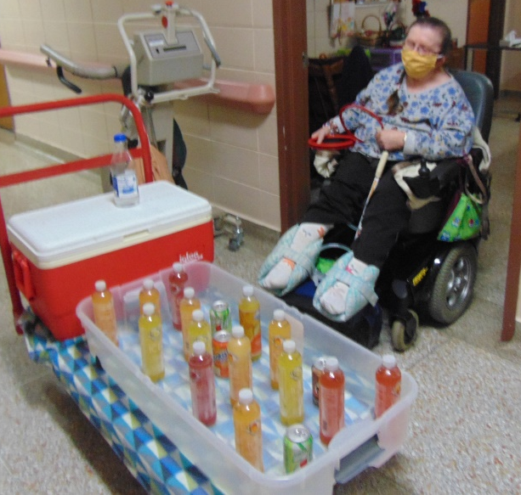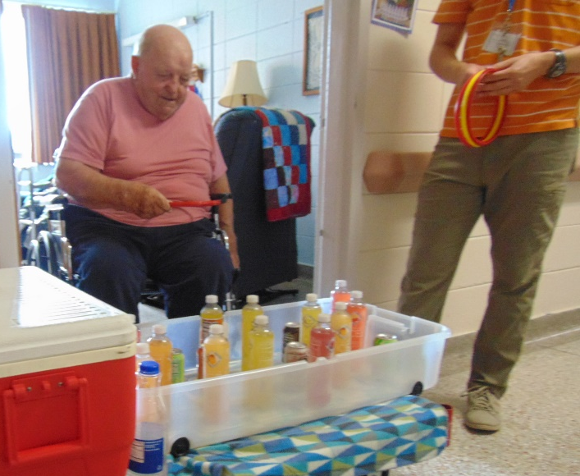

It was Jeremy’s (from Activities) last day this week. We will miss him, as well as his banjo music! He also helped some residents get a “float” ready for our fair themed parade coming up in a few weeks.
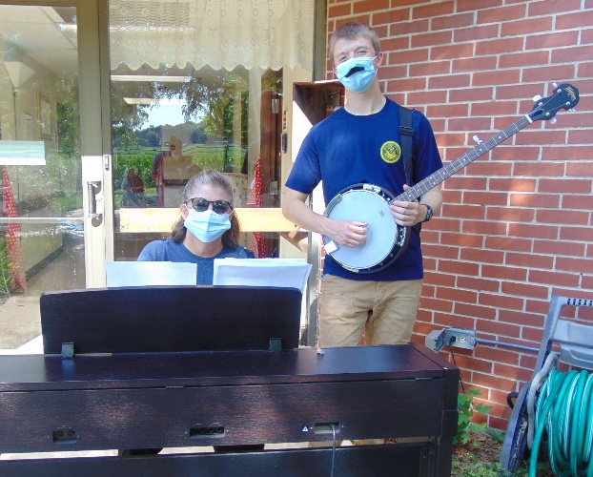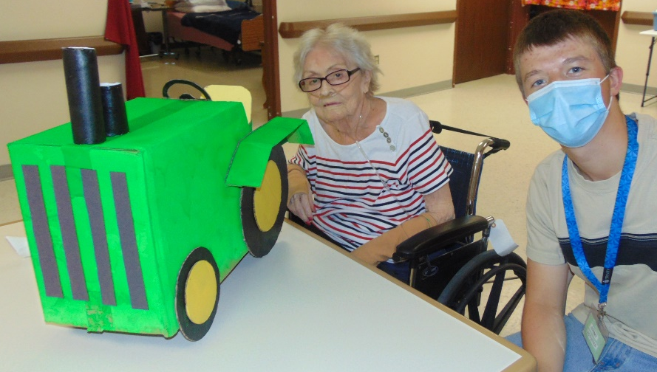

“Christmas in July” was our dress up theme this week
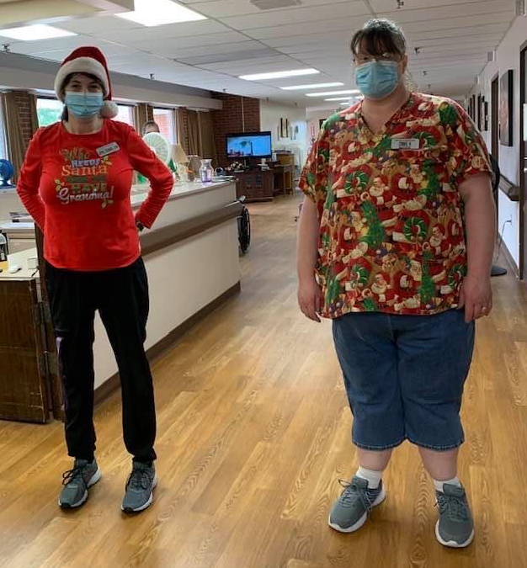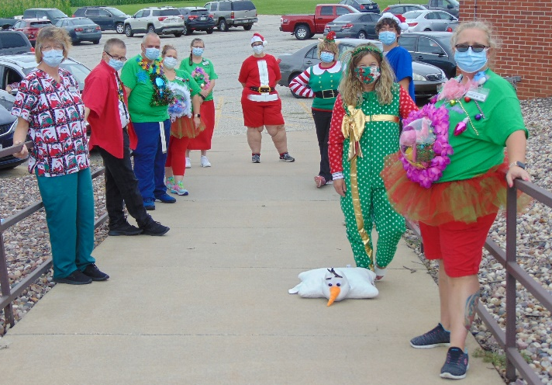

County Fair Game – Rubber Duck Pull
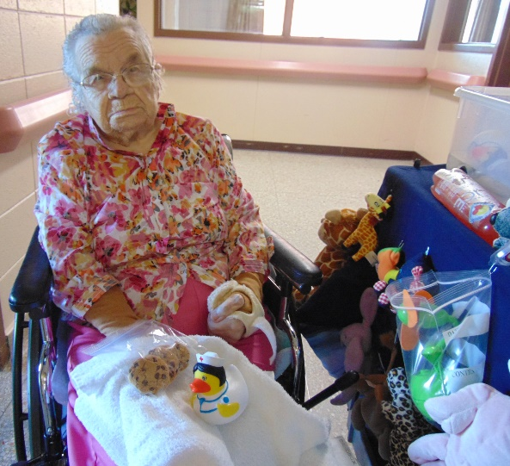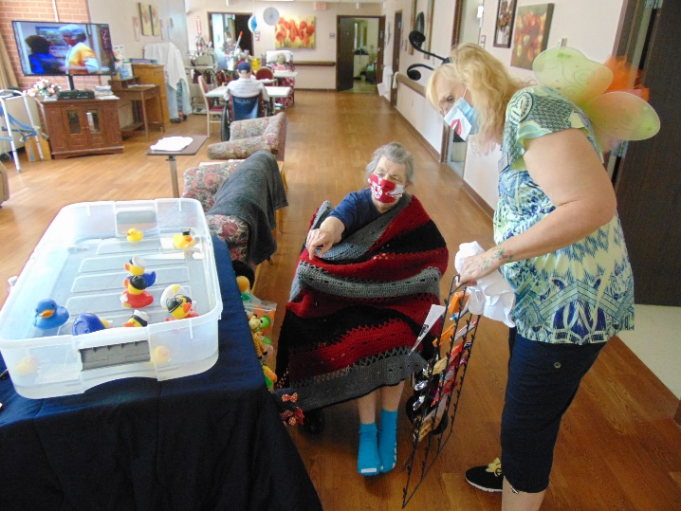
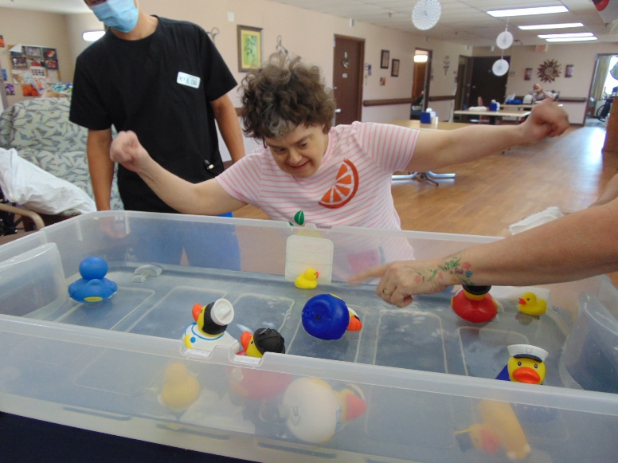

Hello once again from Rolling Hills! We are continuing our fair themed fun – this week playing ring toss and rubber duck pull. It was Jeremy’s last week working with us for the summer – we will greatly miss him and his banjo music! We also said goodbye to one of our social workers who retired this week, and we wish her the best as well. We continue to enjoy the outdoors when we can. Our dress up theme this week was “Christmas in July”, and many staff joined in the fun. Work has begun on our many “floats” for our parade in a few weeks. Wishing everyone the best, and a great week!

