Snapshots from July 13th to July 17th
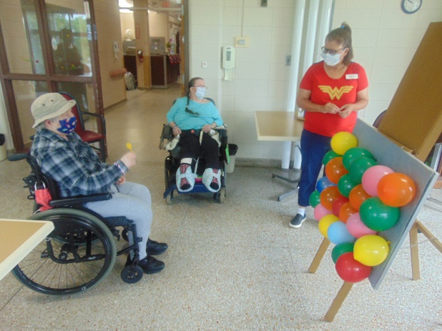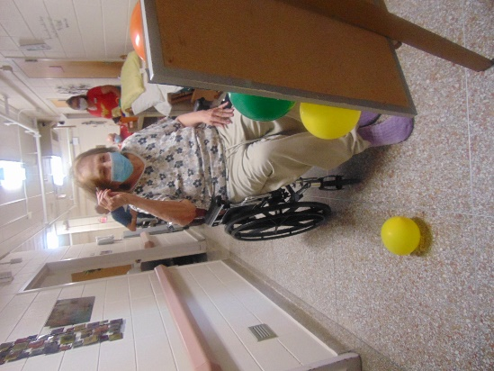
The Fair has come to Rolling Hills! Time to win some prizes with the dart balloon game
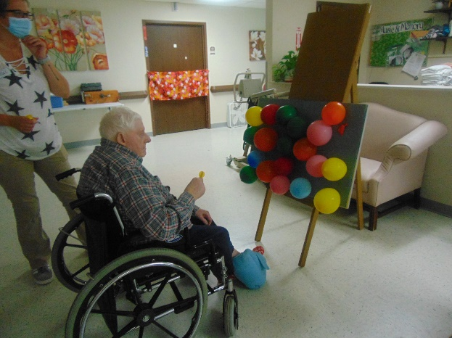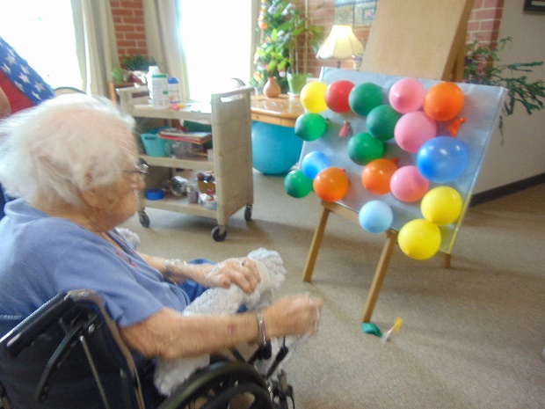
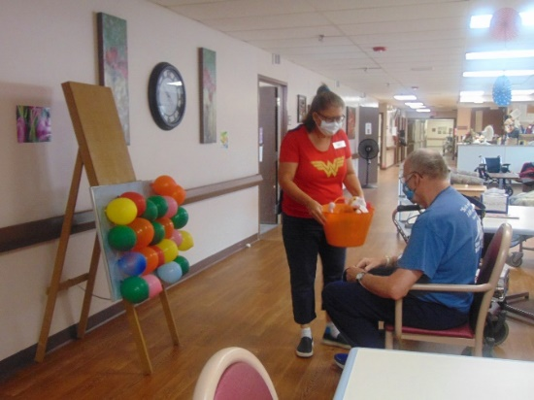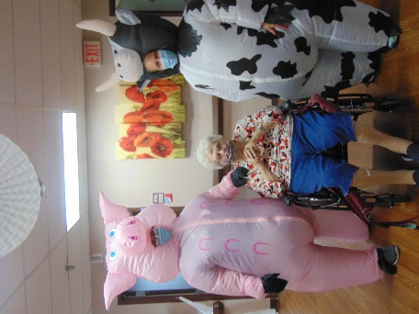
Who let the animals in???
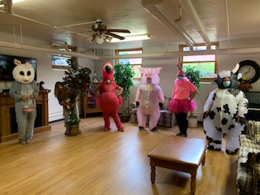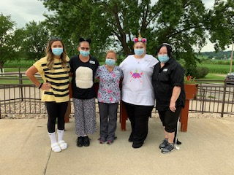
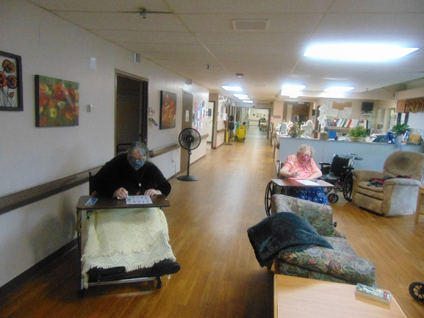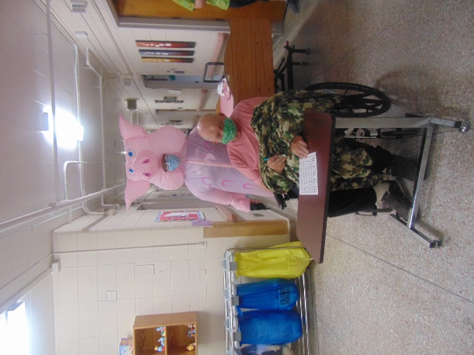
BINGO!
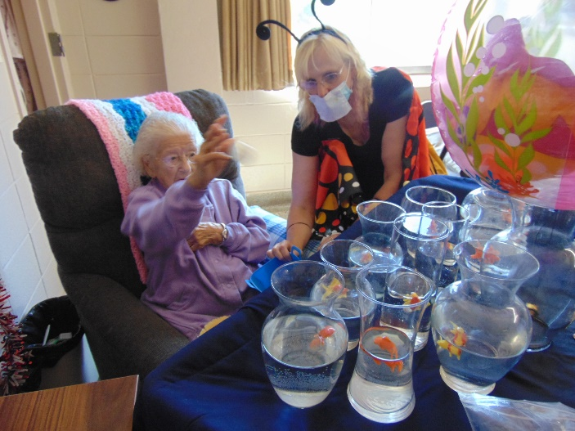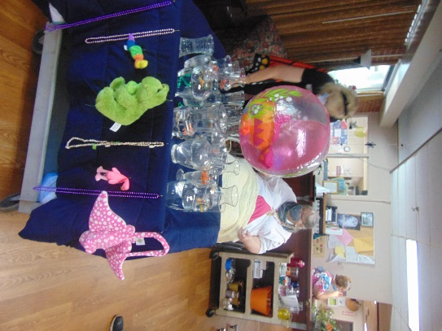
Time to win a fish or a prize!
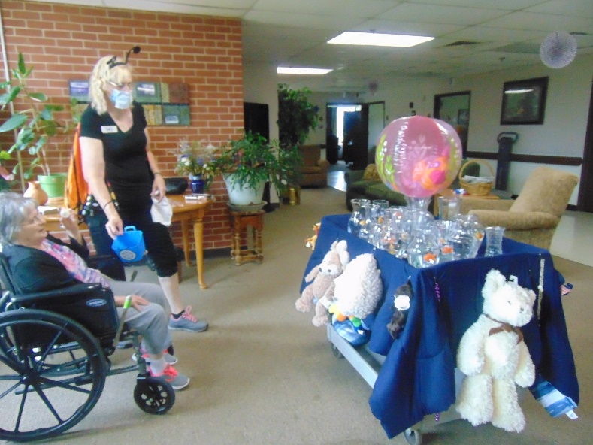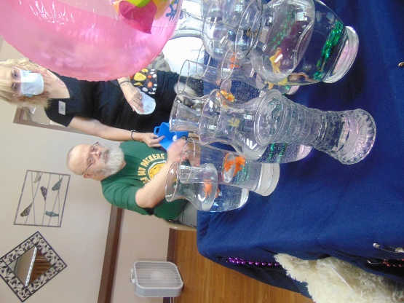

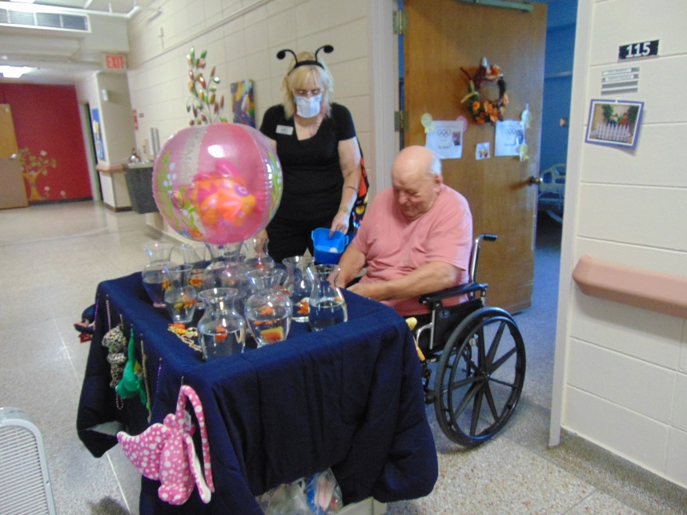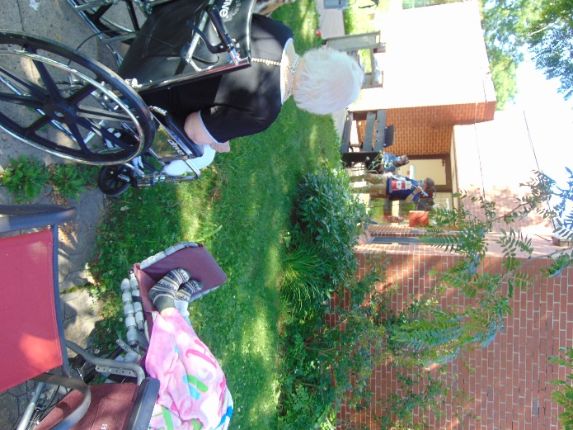
Why not have some music outside too

Happy Friday again,
The activity department decided since most fairs are being canceled, to have their own here. The residents were able to pop some balloons to win a prize as well as toss balls to win a fish or prize this week. Stay tuned for the weekly activities we have in store for them, including a parade through our halls. While they were playing, or waiting to play these games, channel 25 was playing scenes from a variety of fair activities from around the United States. If it is not too hot or rainy, we continue to offer a bike ride, walks or just to sit outdoors as well. This week, Lisa and Jeremy took their show outside too. We hope everyone is staying healthy and continue to enjoy our virtual visits.
Have a great day!
Linda

