Snapshots from June 7th to June 12th
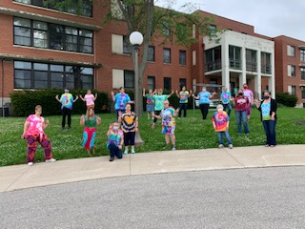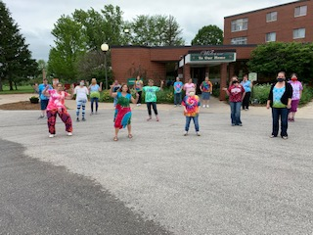
Tie Dye fun day!
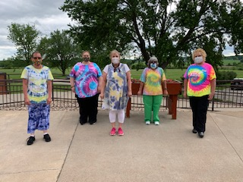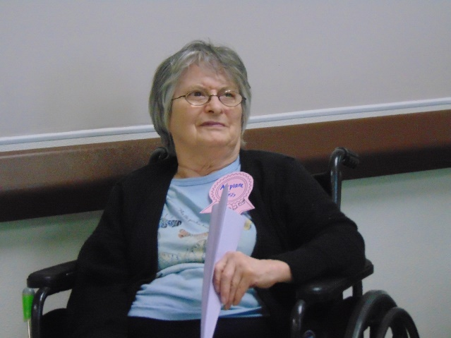
PM shift joined in the fun! Senior Olympics was Airplane toss this week!
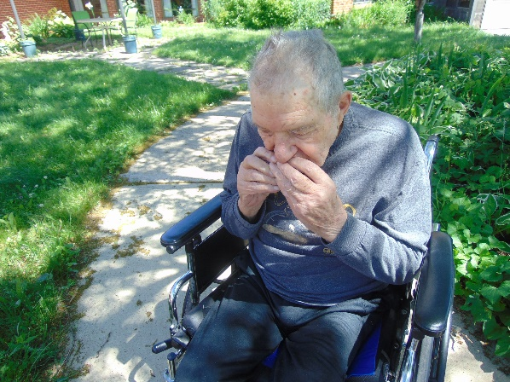
Why not enjoy some watermelon outside on a beautiful day!

More Photo booth fun!
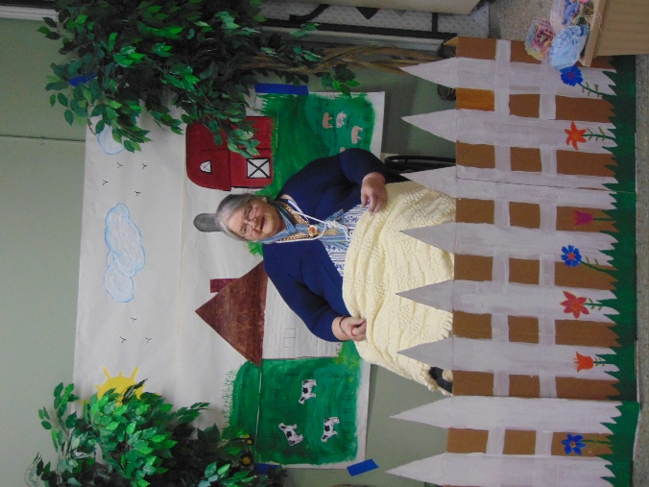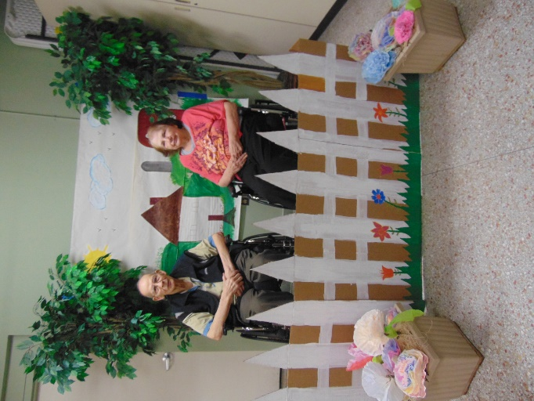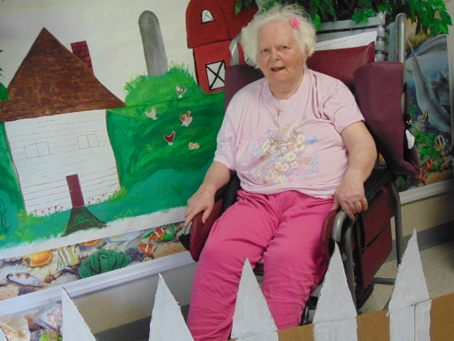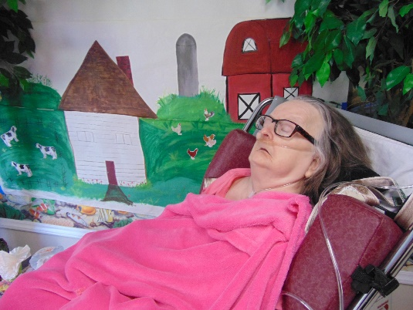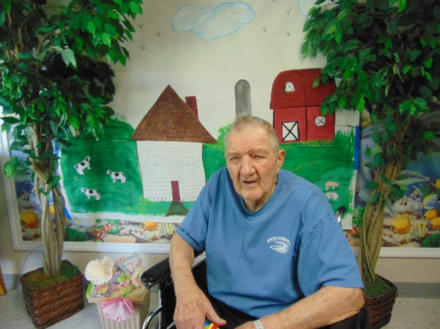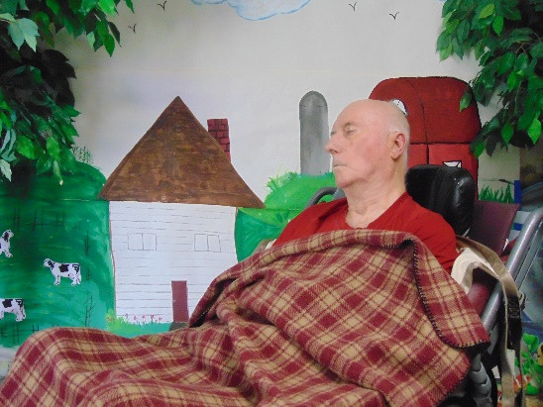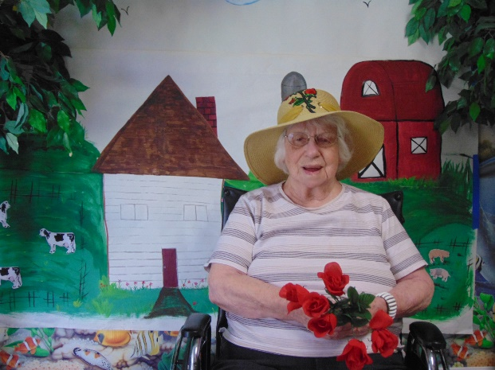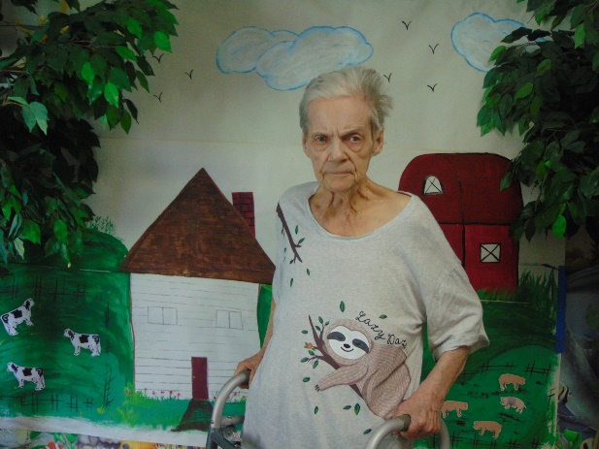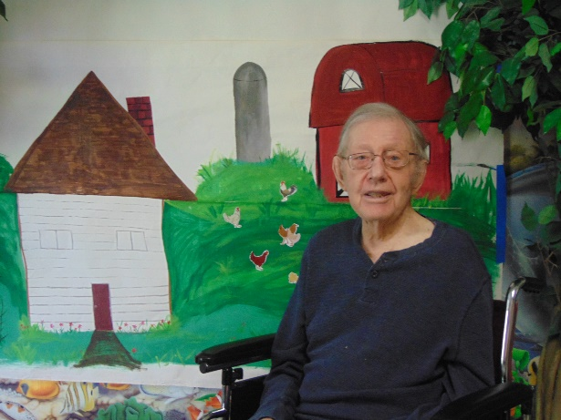

June continues to move forward and we continue to keep everyone filling their free time with a variety of activities. This has included our weekly Senior Olympics, this time flying airplanes to see who could make it soar the farthest. This was hard to capture in film though! Then we have gotten out on some more scenic drives, even driving past some prior homes of those who ventured out with us. Pictionary draws out a few laughs because our drawing is so great! We loved getting out to enjoy a nice day with some watermelon as well. We hope you all are still doing well!

