Snapshots from June 21st to June 26th

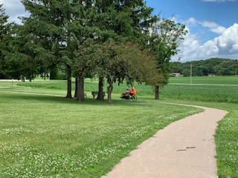 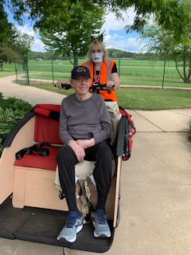

A few nice days to ride our bike

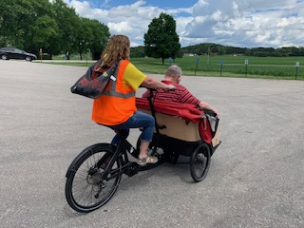 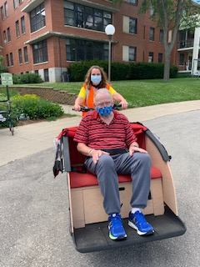

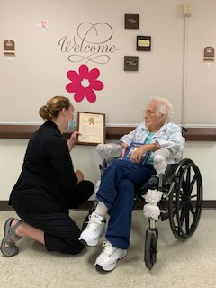 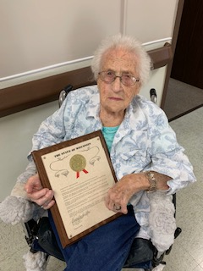

Lola was presented with a plaque from Nancy VanderMeer on behalf of the WI Legislature for being almost 107 and dedicating her career to the United States Army in food service through 3 wars and working at Camp McCoy/For McCoy for 41 years.

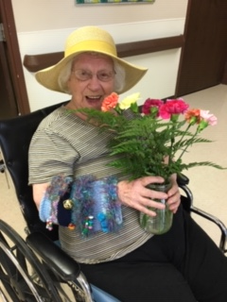 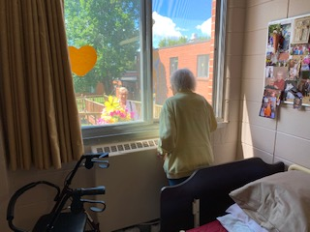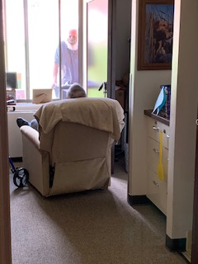

Keep those gifts coming and window visits to brighten our days here!

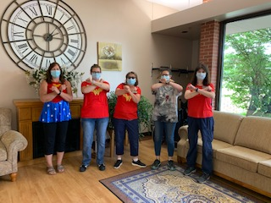 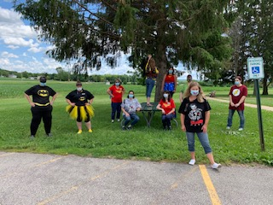

Superhero and Villain day! Wonder Women want to stop Corona!

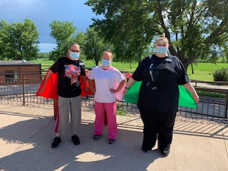 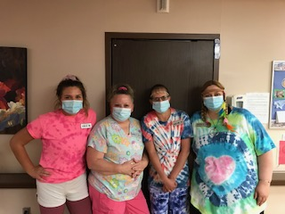

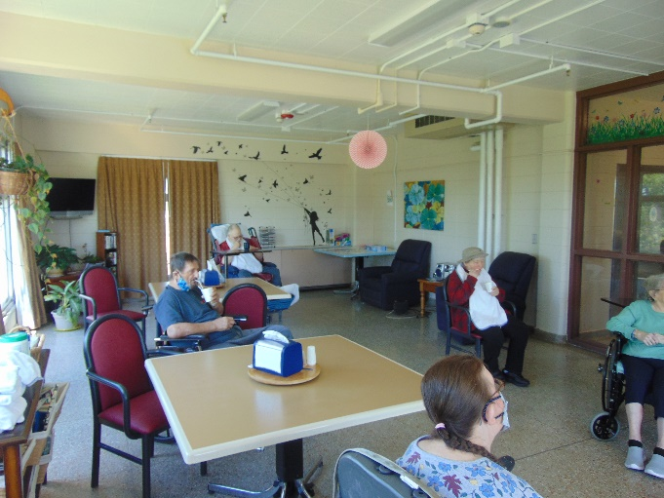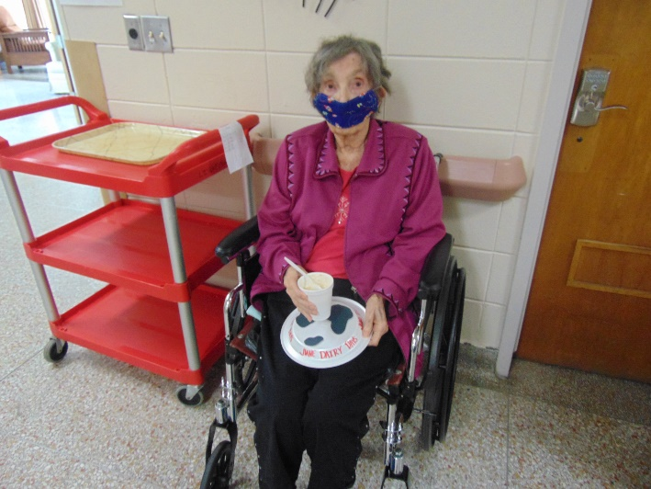

Cow Pie Tossing and Root Beer Floats as well as dairy facts for Dairy month!

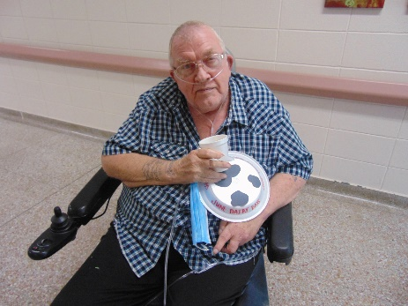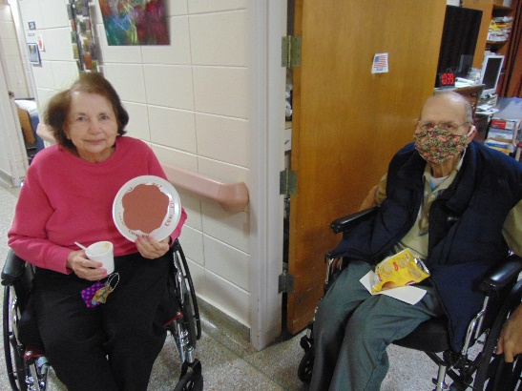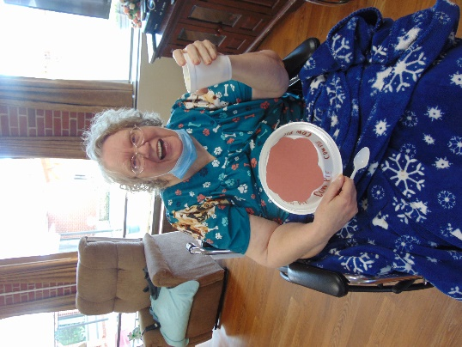

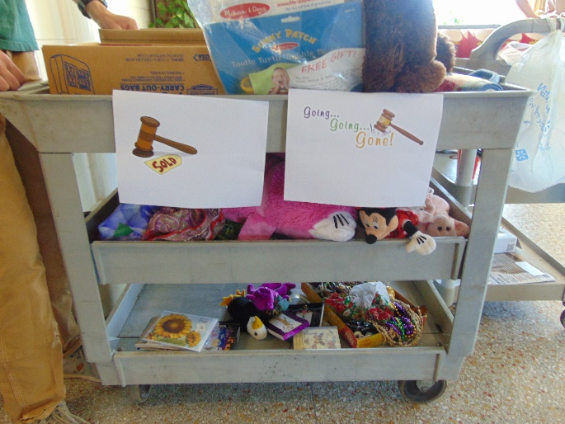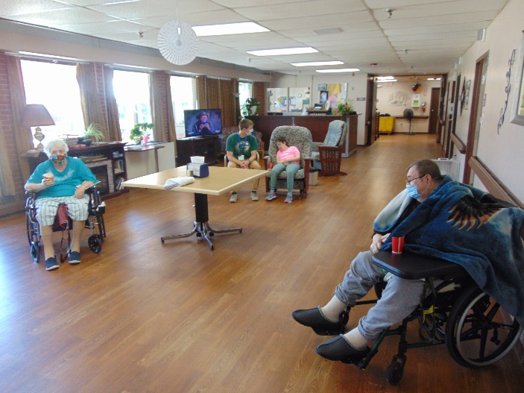

Auction Time!

Hello on another Friday! We have kept busy this week by our usual shenanigans. We have tried to get outdoors to sit, walk and ride the bike as the weather allows. We decided to try an auction this week too and that went over really well. They got to bid on items that interested them, and yes, we did have some good bidding wars! And we could not forget to take part in June dairy days either. We had fun throwing a cow pie and sipping on Root Beer Floats.

I want to share that I will be off a couple of weeks in July. I will have my voicemail and e mail notifying everyone of this when those dates arrive. In my absence, Jessica Byom, will be doing all the virtual calls and her contact information will be on my e mail and voicemail as well. Her e mail is [Jessica.byom@co.monroe.wi.us](mailto:Jessica.byom@co.monroe.wi.us) and her phone number is 269-8804.