Snapshots from June 15th to June 19th
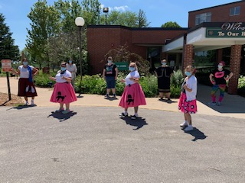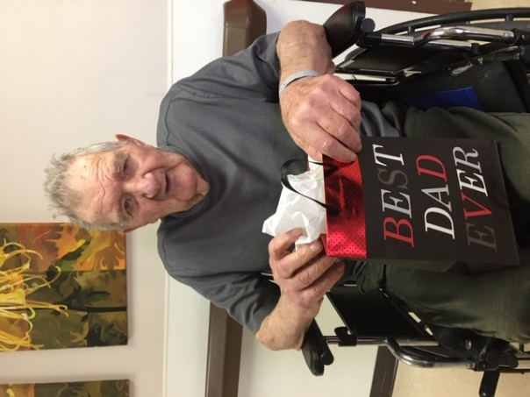
Favorite Decade for our Wednesday dress up Happy Father’s Day!
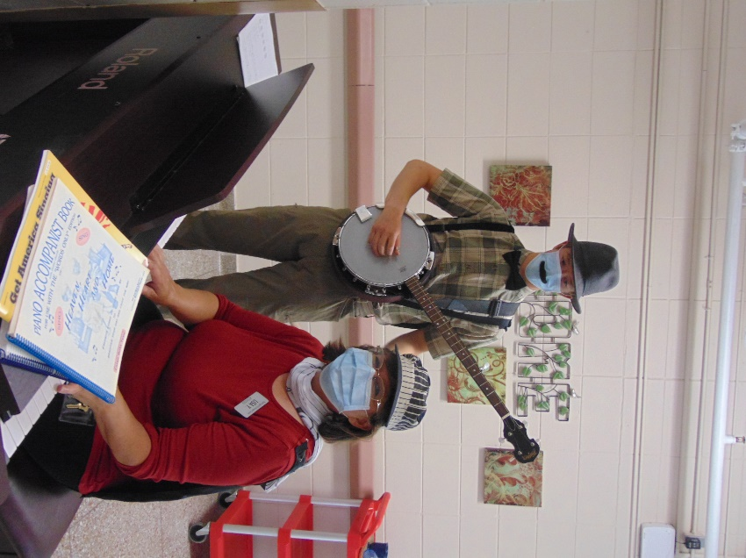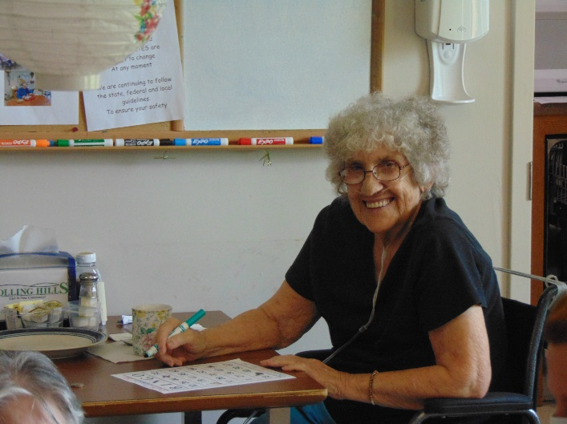
Check out the new look to the music!
We played Big Buck Bingo using money from the Lion’s Club to end our Senior Olympics weekly events

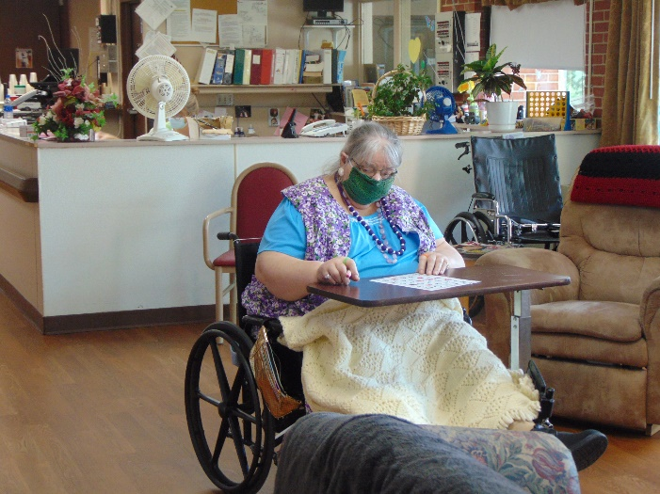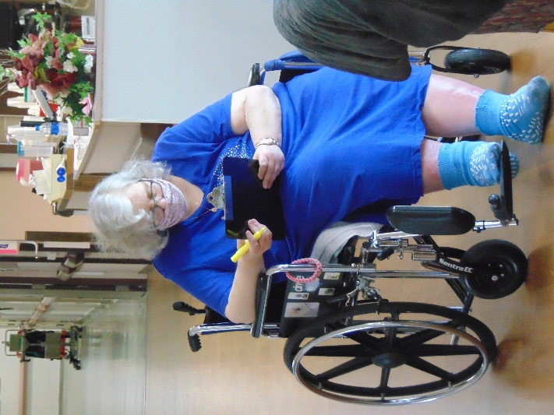
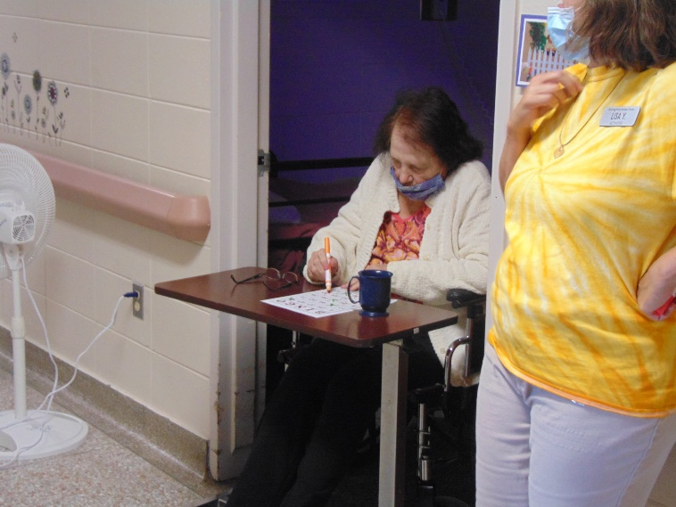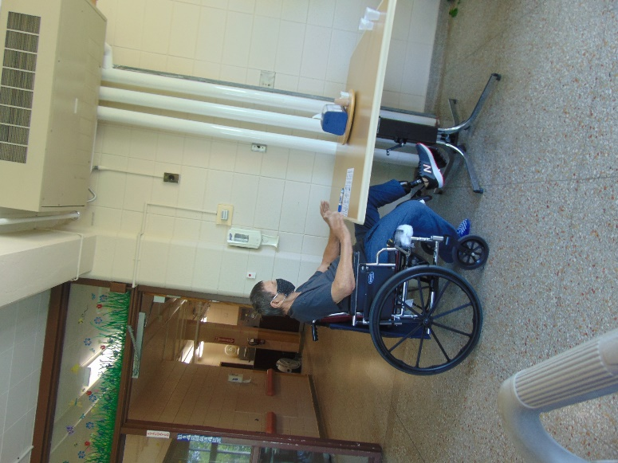

Today the social worker wanted to share some information for you all.
Attention Families:
If you are dropping off items for your loved one and coming into the front lobby you will need to have a face mask on. If you do not have a face mask, please use the red box outside to place your items in and then call the number listed to have a staff member come and get the items from the box. If you have items that are perishable or too large to fit in box please let staff know so they come right away. Signs are posted on the door and on the red box. Thanks for your assistance with this.
From the activity department, I must admit we were not too good at taking pictures this week. We ended our senior Olympics with a Big Buck Bingo Bang, sponsored by the Lion’s club. We heard the ice cream truck music again and were able to use our winnings to get a cool treat on a warm day! A few of us got to enjoy the nice weather and went outdoors to sit or walk with activity staff. Some took drives around town to see how the corn was growing and if kids were out playing. We also enjoyed some “travel”, taking virtual tours on the Ipads to a variety of places.
Take care and Happy Father’s Day to the Dads out there!
Linda

