Snapshots from May 4th to May 8th

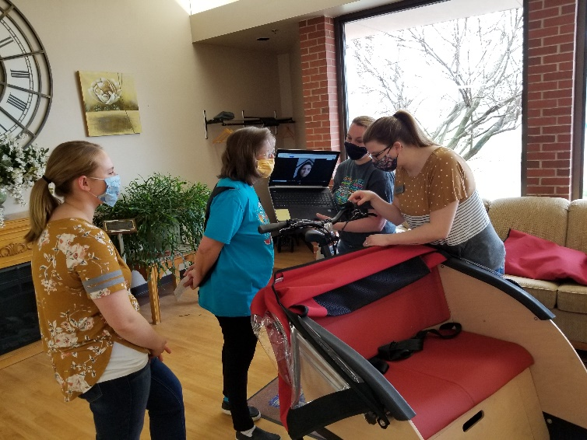 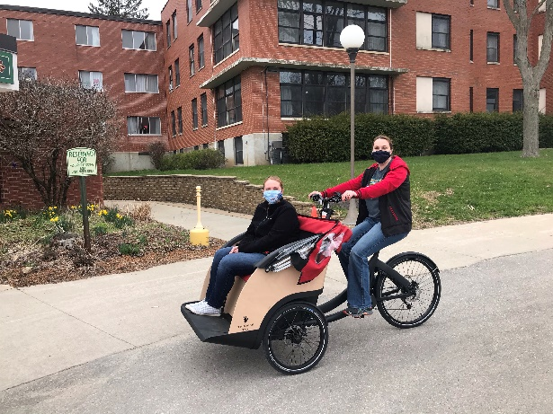

Learning how to use our new bike; look for consents to sign soon!

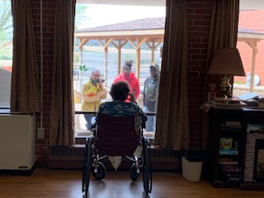 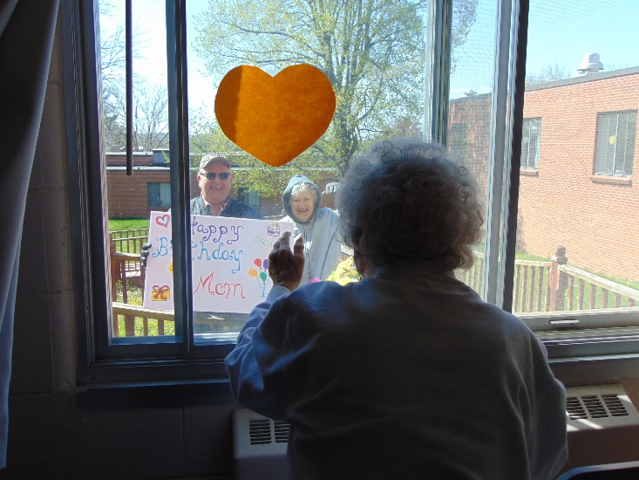

A window visit and a birthday window visit

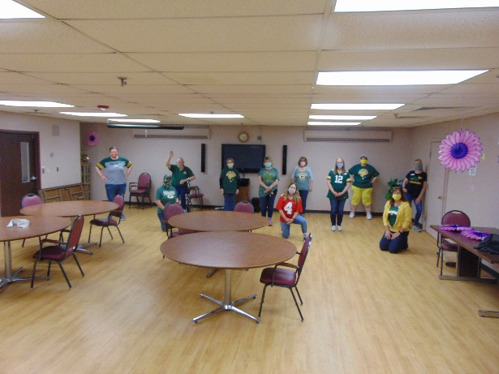 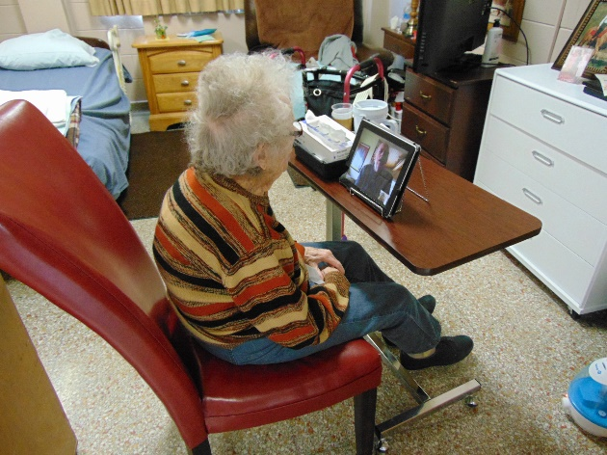

Packer Spirit Day! Video Calls

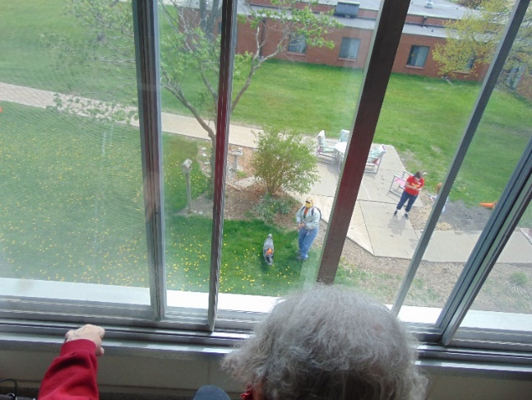 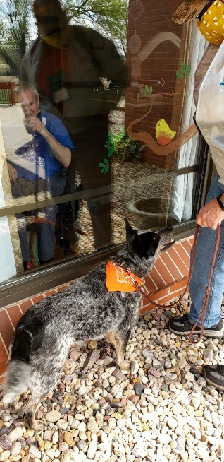 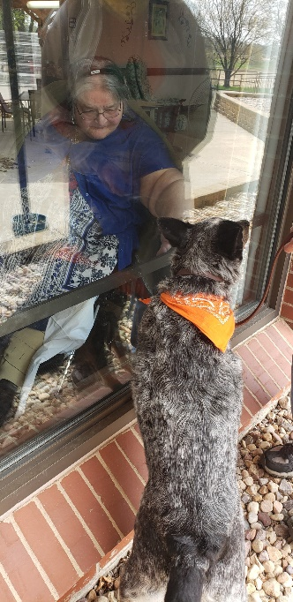

Window Pet therapy; loved seeing Keota and Patti

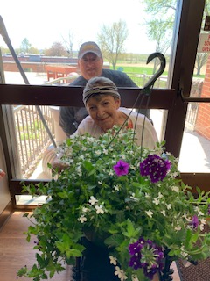 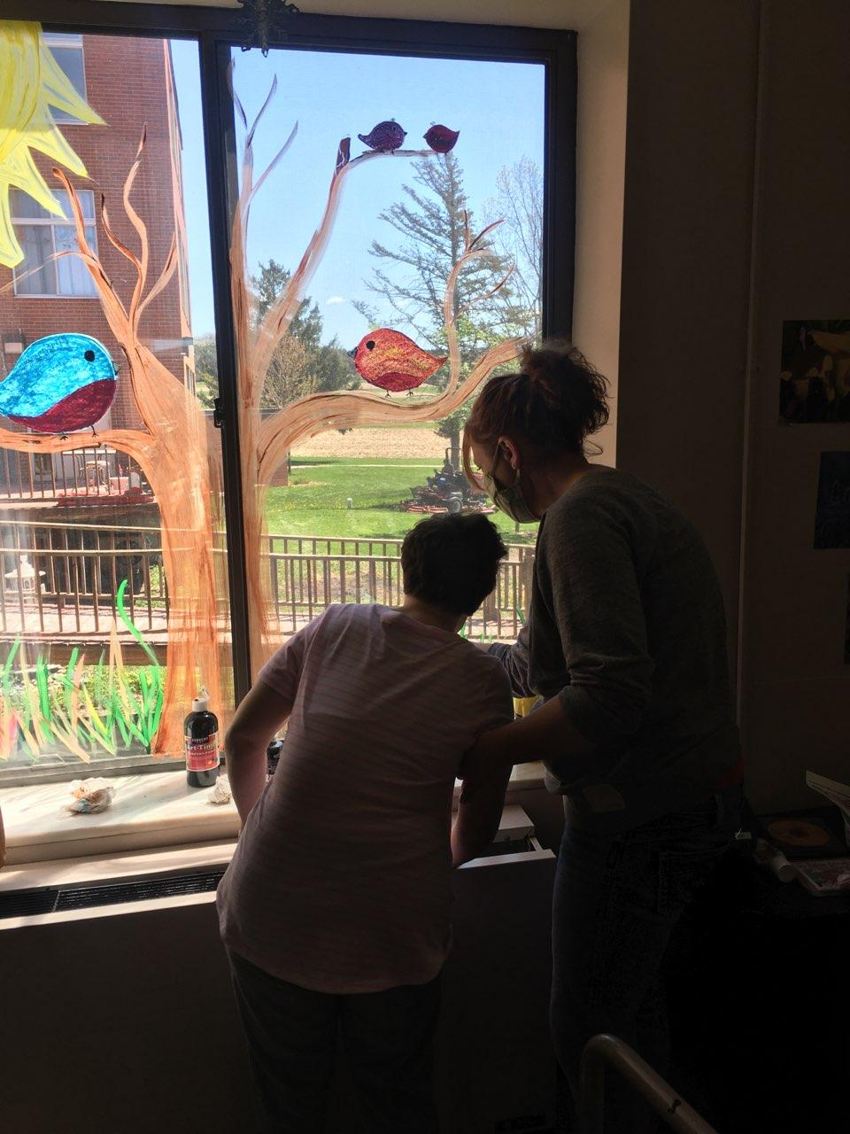

One of the flower baskets! Still painting windows too!

Happy Friday everyone!

Here is another work week end update for you to share with your family. We have been continuing to enhance our programs being offered. Bible study now has the lyrics on the screen for hymns being sung as Linda continues to use technology to make things better. The activity staff continue to assist with hair as they are able, as we do try to keep everyone looking nice with the absence of a beautician. We continue to assist families with delivering gifts and care packages in our home. We do try to make any special events special for them, including birthdays and anniversaries with your help. 4H is now done with their weekly performances and we did enjoy seeing them perform for us every Monday. Norseland Nursing home is now joining our weekly zoom with Laurel on Thursdays so they can enjoy her readings and voice. This is pretty neat to have us collaborating with another nursing home during social distancing ☺

Unfortunately we could not have our annual flower fundraiser sale as usual, so this year we offered county employees the opportunity to pre order hanging flower baskets. Since some trusted us to pick out their flowers, we did take the residents through our make shift green house, AKA activity room, to see and smell them prior to delivery! We have a special surprise in store for Mother’s Day too. We did some window pet therapy as Keota and Patti were missing their visits and that seemed to go ok, although many wished they could reach through and touch her!

This past week our activity staff used the computer to learn how to use our new trishaw bike. Pernille, from Holland, assisted us via a video call to teach us what gadgets and gizmos we will get to use. By next week, Linda is hoping to send off an e mail with consents for residents to ride this bike. If you are their HCPOA, please sign and return, or e mail me yes or no. We will have the bike the last 2 weeks of the month to take residents for rides. Our older community members, through the Aging and Disability Center (ADRC) will have the ability to use it the first two weeks of the month. We can’t wait to ride this to the park or even downtown for ice cream when it’s safe again!

As always, stay healthy!

Linda