Snapshots from May 26th to May 29th
Be sure to click on link to see the pictures
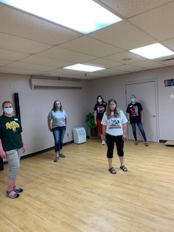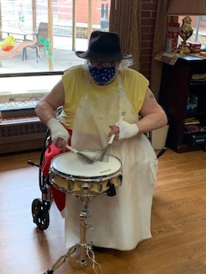
Showing school Colors this week Brian joined Lisa & Jeremy this week
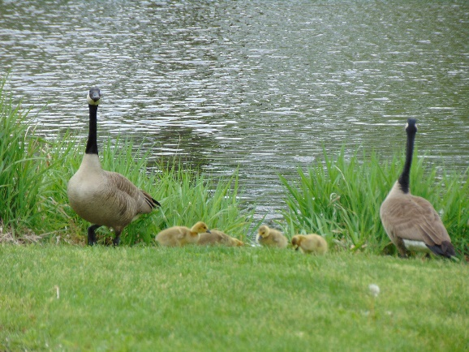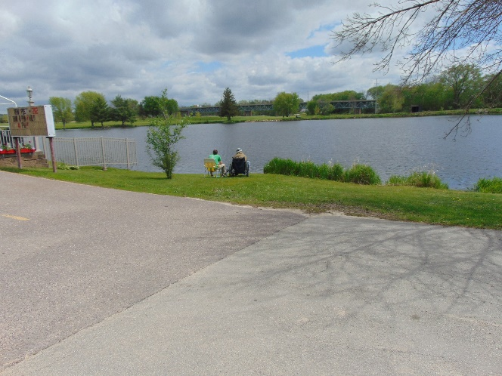
Social Distancing fishing; thankfully no one else was around so we could partake and see some wildlife
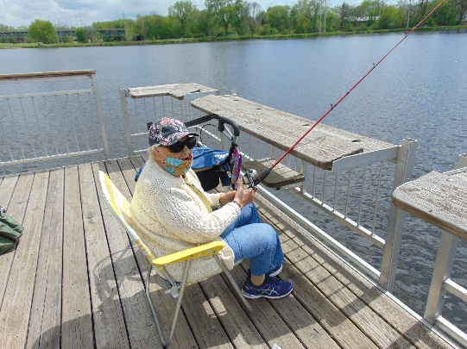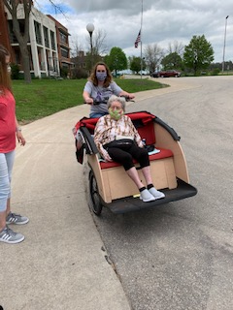
The first bike ride was a success, but we are learning how challenging it can be to get into it so we may build a ramp to assist in being able to use this bike more

This week for Olympic Games we had the Discuss Toss
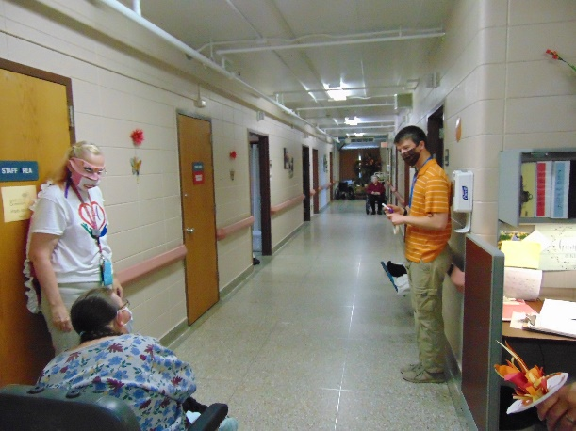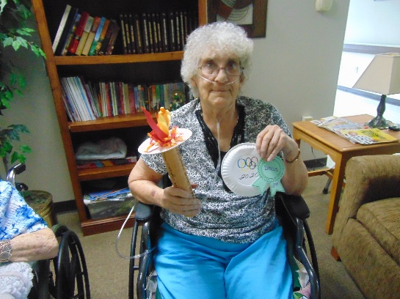
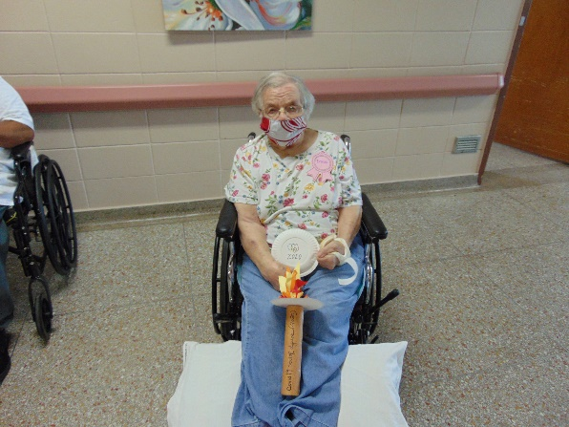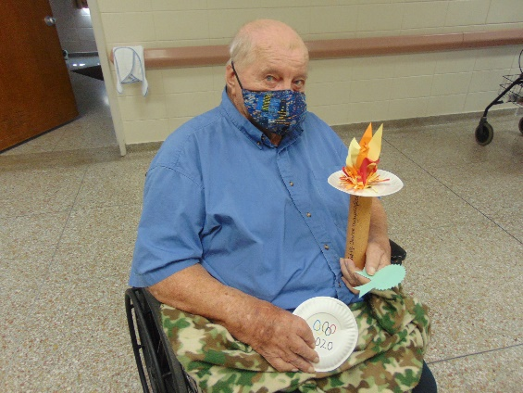
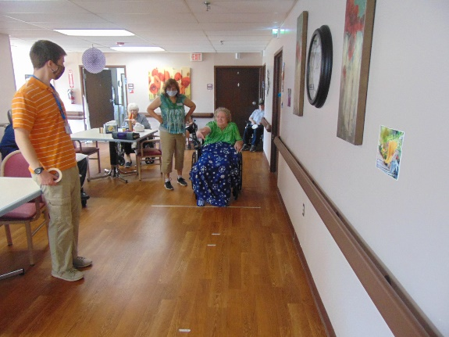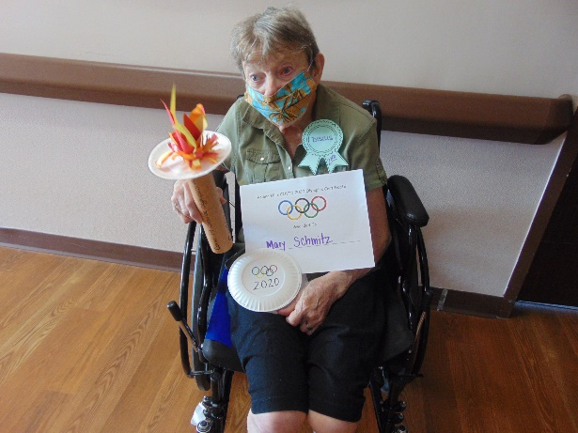
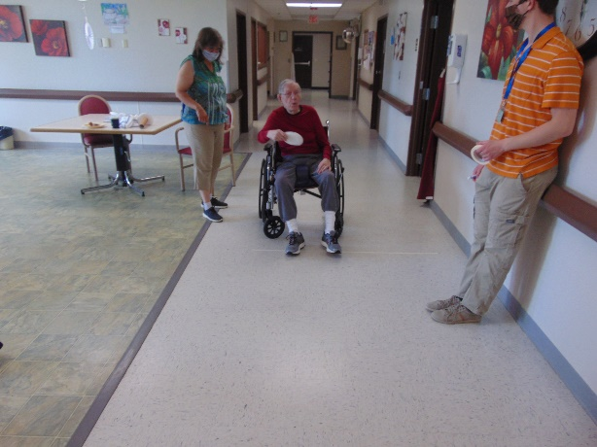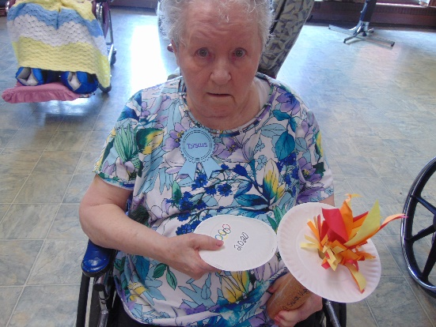

Another week has come and gone. We have kept busy this week by listening to music in the halls, playing bingo, going for some scenic drives and continuing our summer Olympics with the discuss toss. The café cart continues to roam the halls on Sundays, Tuesdays and Fridays. We attempted our first bike ride and discovered we may need to build a ramp to make it easier and safer to enter and exit the bike. Our first rider did enjoy the trip around the campus though. One of the residents joined in the live hallway music this week! Linda keeps busy with the zooms and face times to ensure all those that want can see and talk with their loved ones. The in house channel continues to entertain our home with jokes, Bible studies, educational shows and music.
We do miss seeing all of you and hope everyone is staying healthy and well! I did hear there is a task force being developed in the state to open the discussion about how and when we can start to have visitors again safely. Thanks for your support and understanding.

