Snapshots from May 10th to May 15th
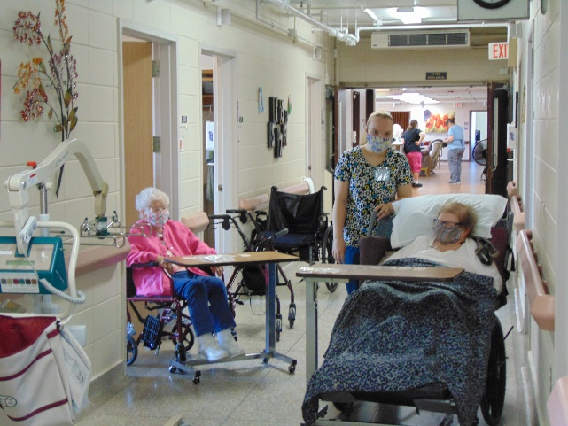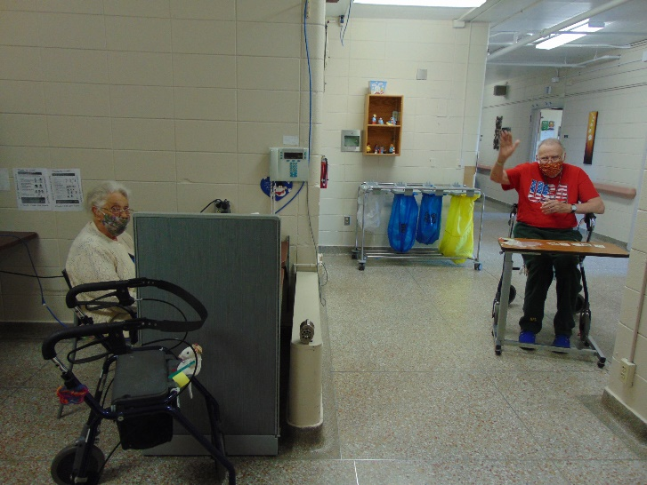
Card Bingo being played on a Saturday
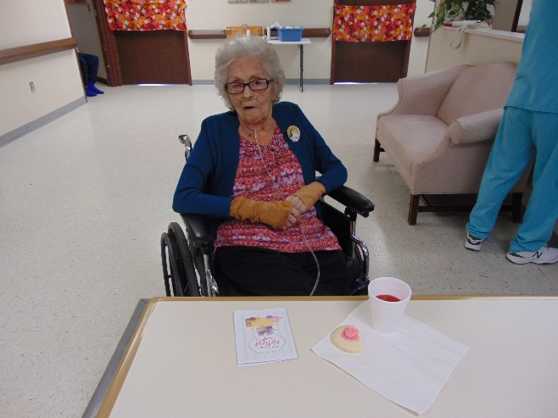
All our ladies were treated with a corsage, cookie, card and punch to celebrate Mother’s day;
we did give the men some treats too!
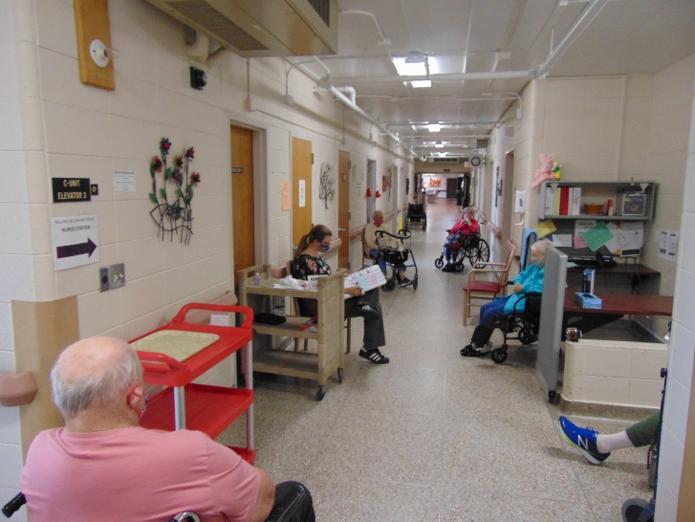
Word Games being played with our white boards Cruising around
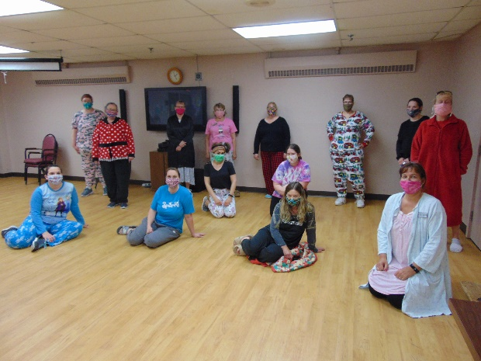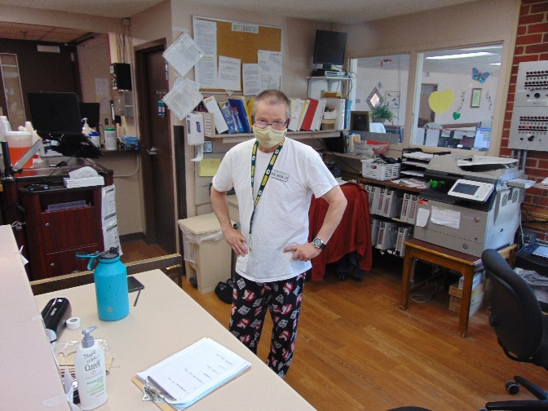
Pajama Day was hit with staff and residents alike
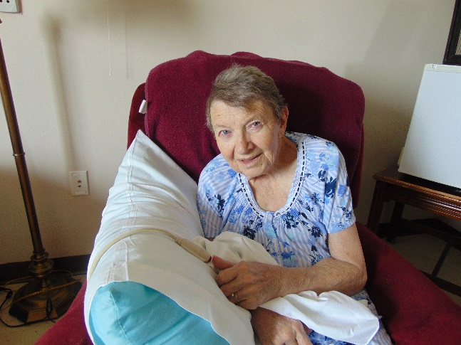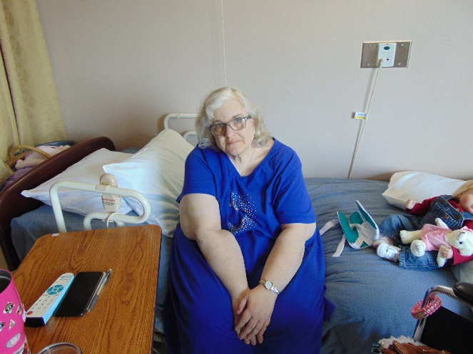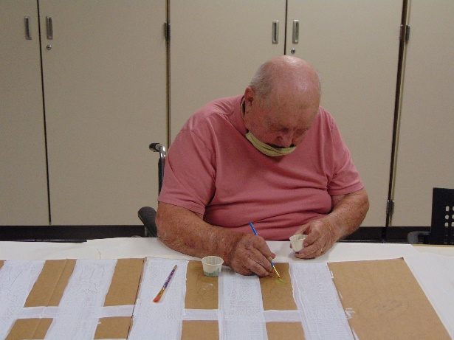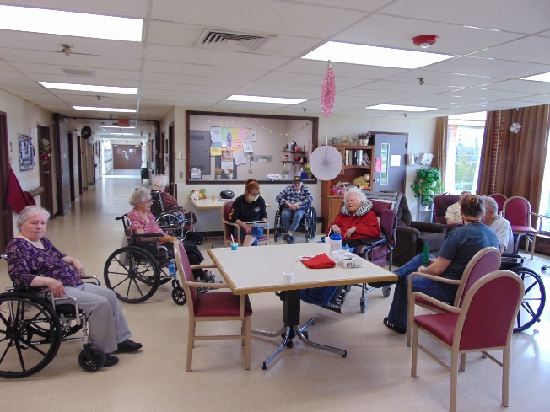
Finding projects to work on solo; Reading and reminiscing!
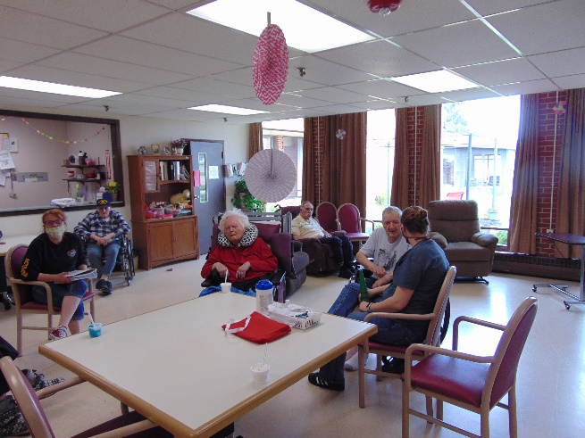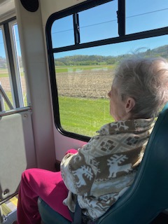
Another day of dress up for national nursing home week, this time a western theme and then tropical!
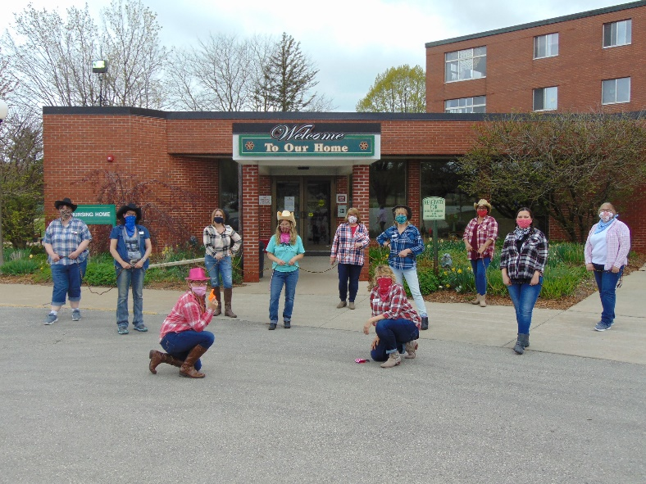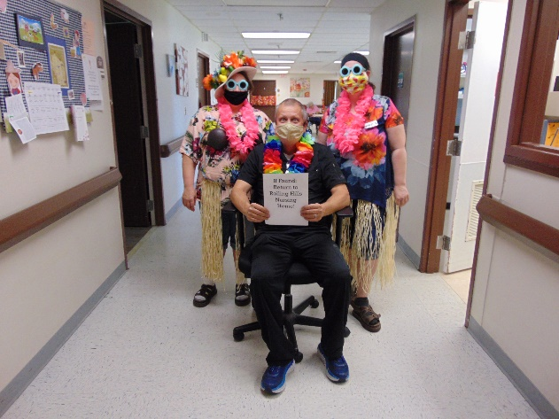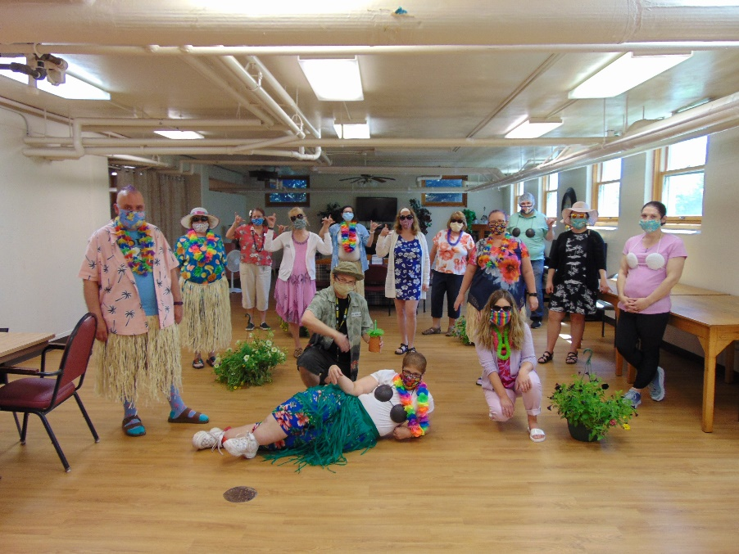

Community support outside and in!
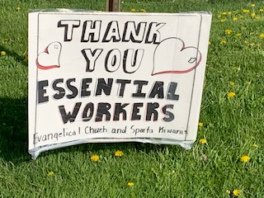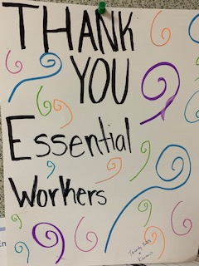

Here is yet another Friday update and we hope this finds you well. This week was national nursing home week, so we had a few extra dress up days to brighten the spirits of all.
For activities this past week we continued to keep residents busy by setting them up with projects in their rooms, using channel 25 for some great jokes, leading Bible study and even reading community letters. We also played Jeopardy on the Ipads in the halls this week, challenging their minds. Lisa continues to bless us with her piano playing skills and this sounds so good as you walk the halls. On beautiful weather days, we still enjoy going for scenic drives and seeing the beautiful colors appearing.
Next week we will bring out the ice cream truck and are looking forward to getting outside and cleaning up our gardens.

