Snapshots from April 26th to May 1st
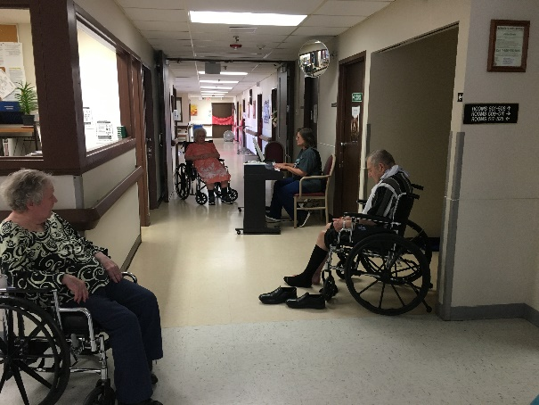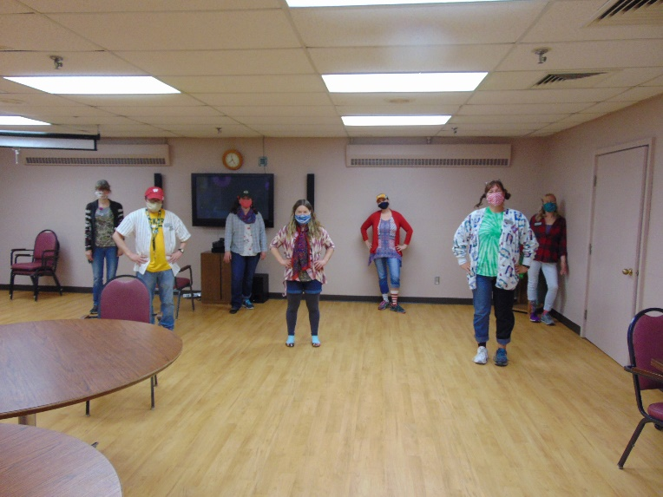
Hallway Piano music Mismatch Day
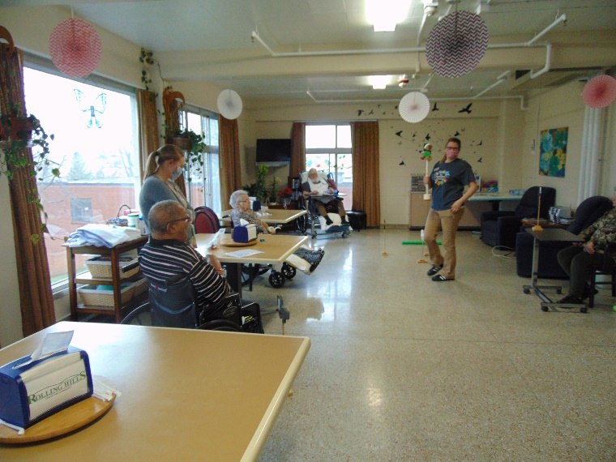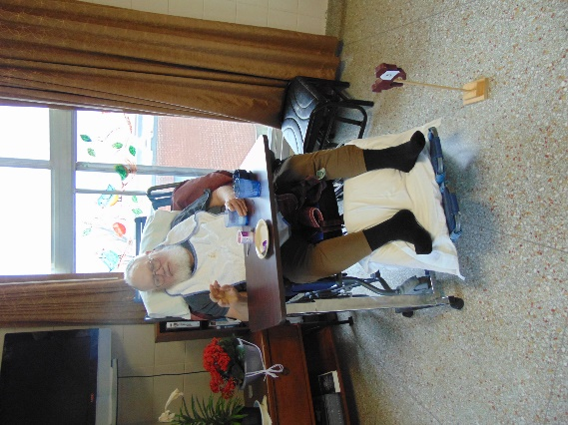
Horse racing and bingo in the halls are fun pastimes for us
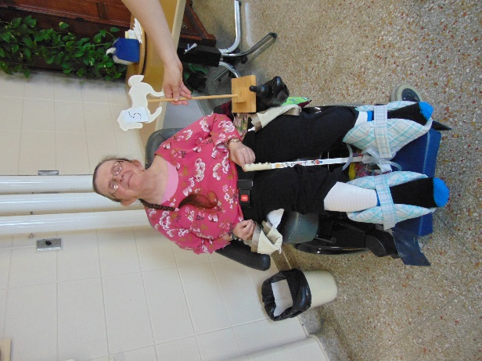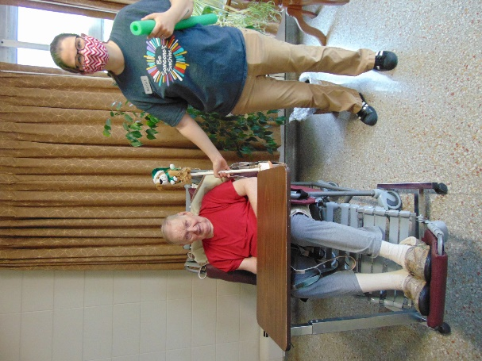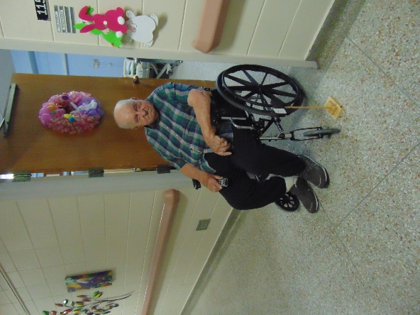
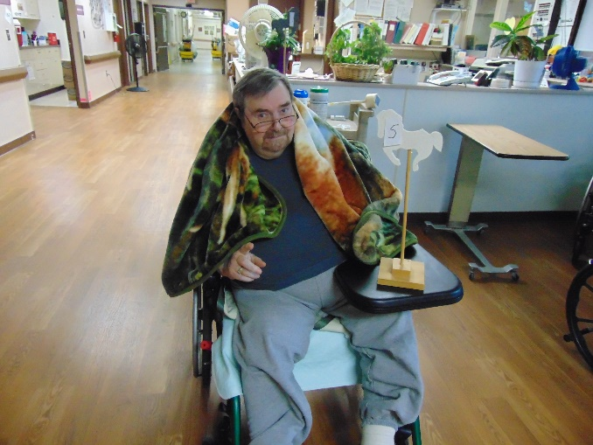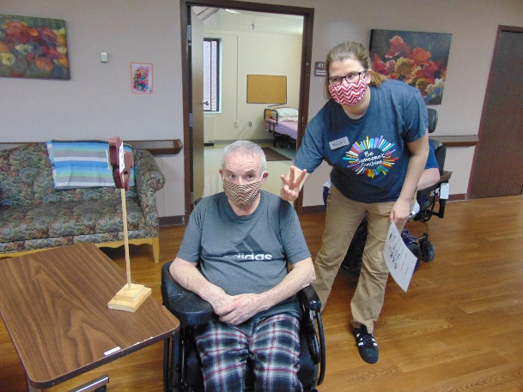
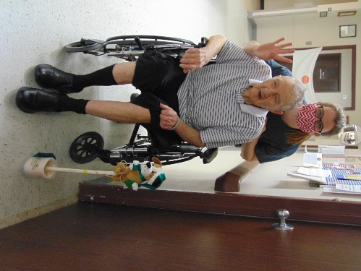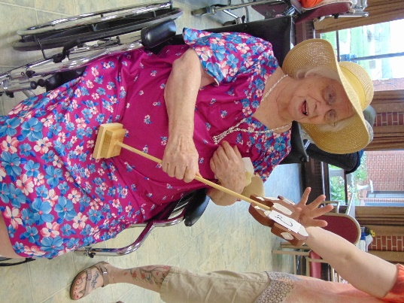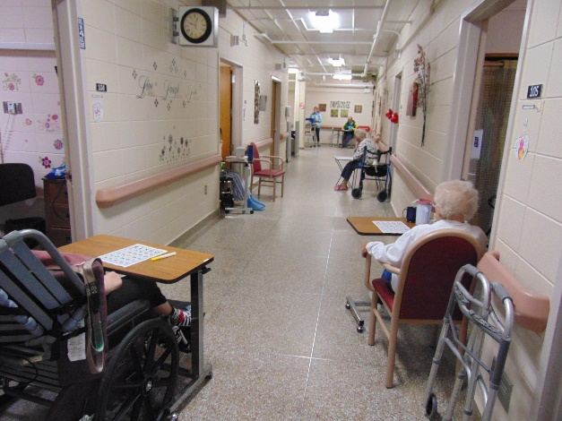
We were blessed once again by community members remembering the residents on May Day! The smiles they had were priceless.
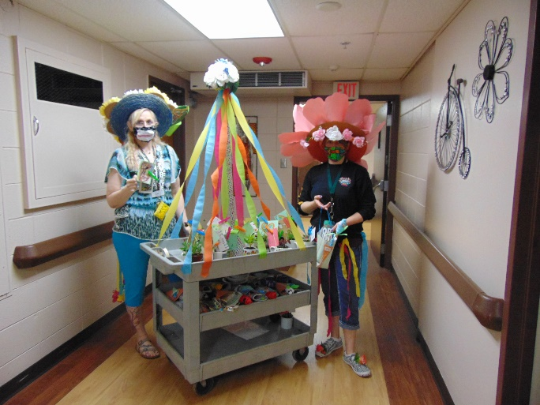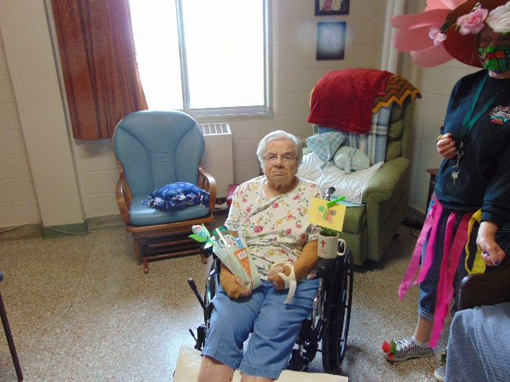
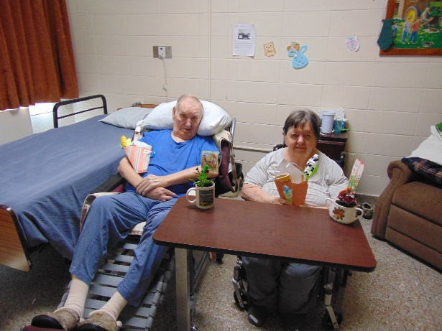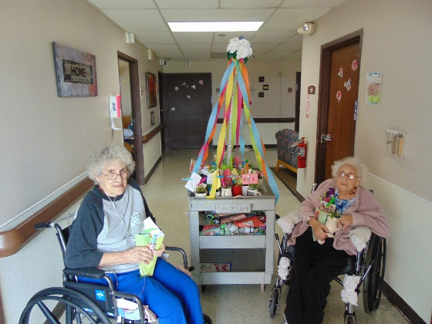
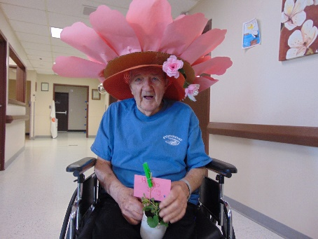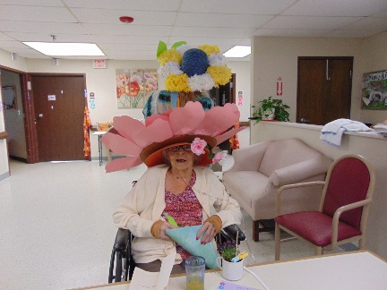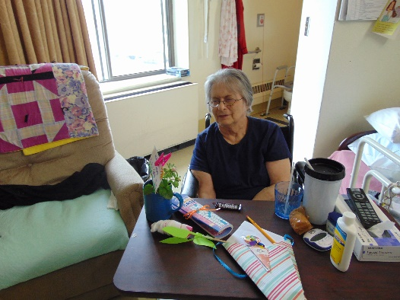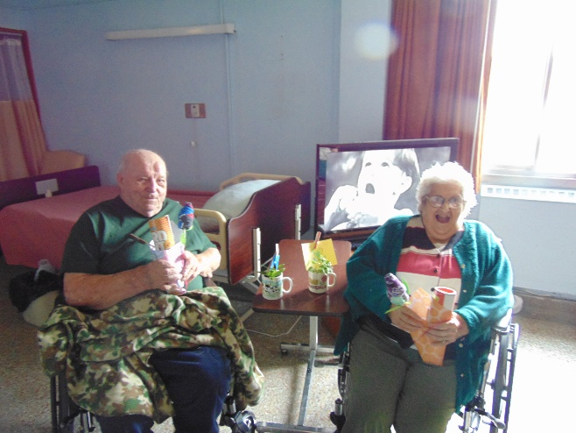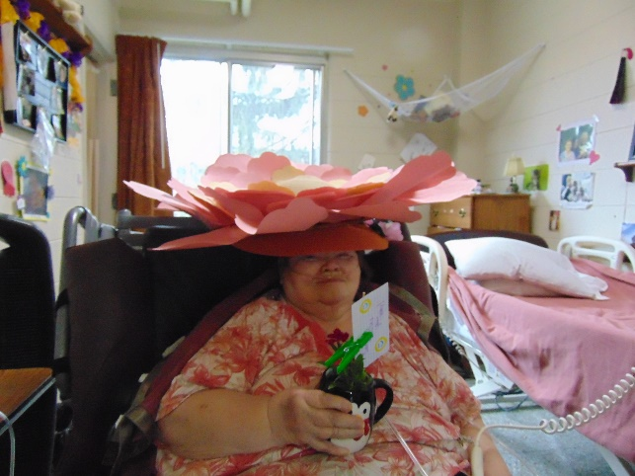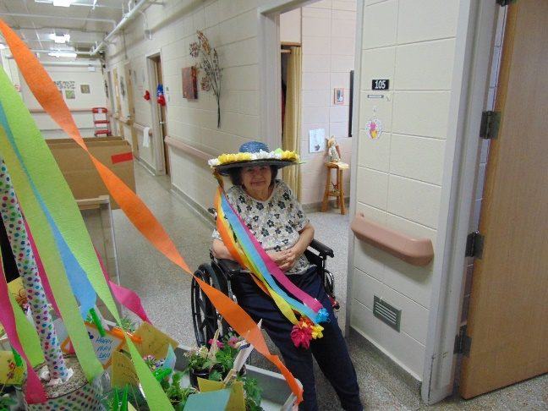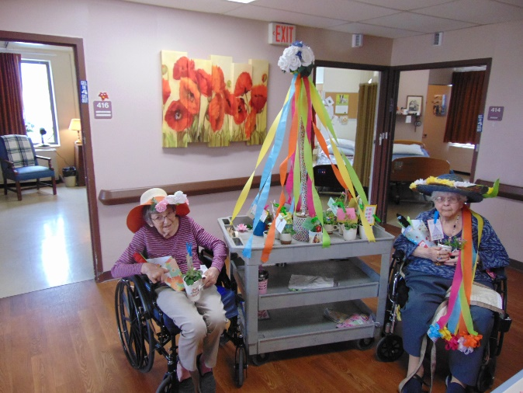

Well another week has passed and we continue to provide smiles and things to do. Some of our pictures show our horse racing game. The residents have fun cheering on their horse and rolling dice to move them forward. We have had the café cart go around a few days as well to bring on the needed snacks and caffeine! Linda continues to set up zoom and facetime for families to keep in touch. Lisa plays music in the halls weekly too. We used channel 25 for watching the 4H performers and this week Norseland nursing home joined our zoom with Laurel so they could also listen to her beautiful voice and guitar playing. Of course Linda also shares letters of hope, encouragement and support as well as some corny jokes and good stories on this channel too. May Day was made special by many of our community members. We were able to brighten their days by bringing them the gifts that were provided.
Take care and stay healthy!
Linda

