Snapshots from April 6th to April 9th

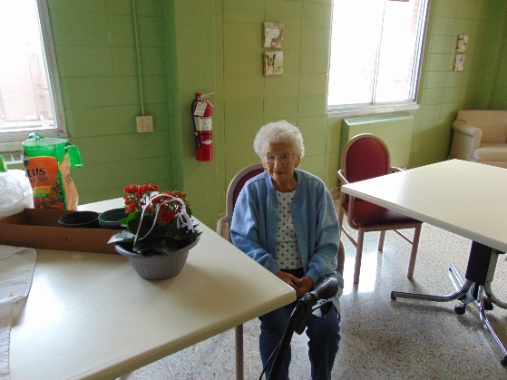 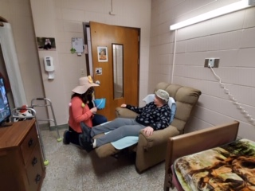

Replanted some flowers Easter Visits

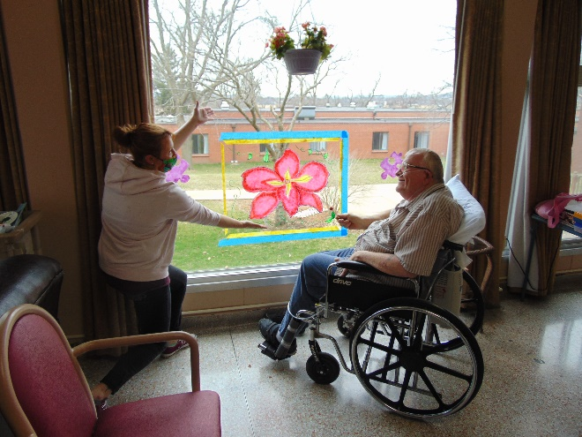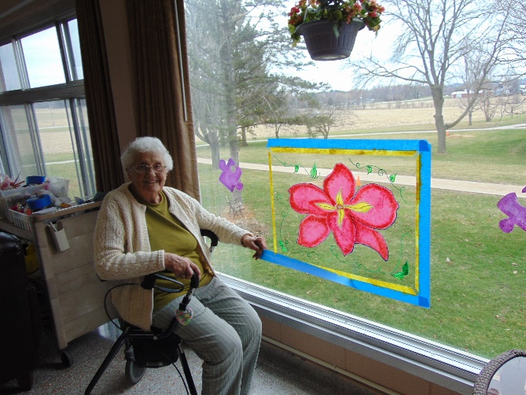

Decorated some more windows

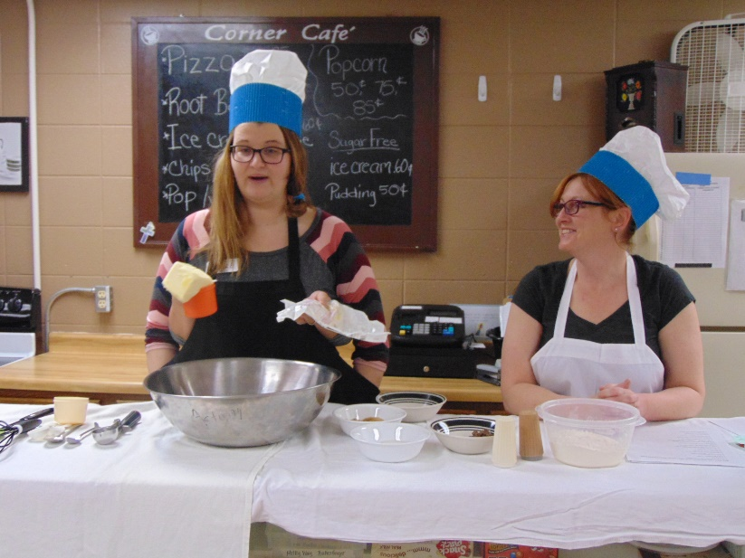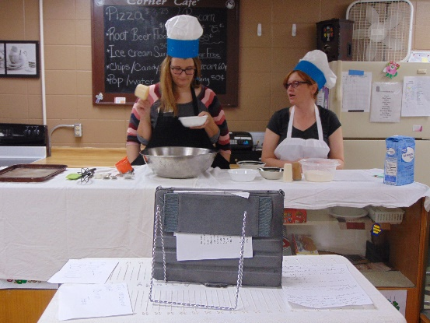

Chef Covid and Renowned Chef Corrin Teen had a very interesting cooking show for the residents on channel 25!

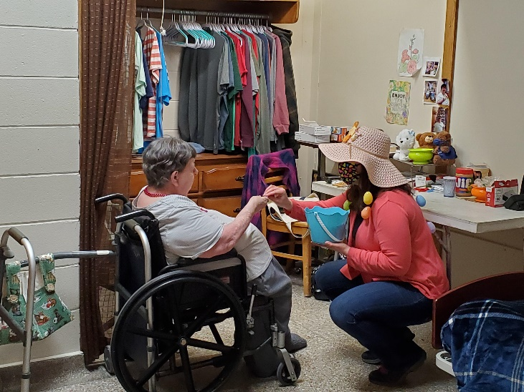 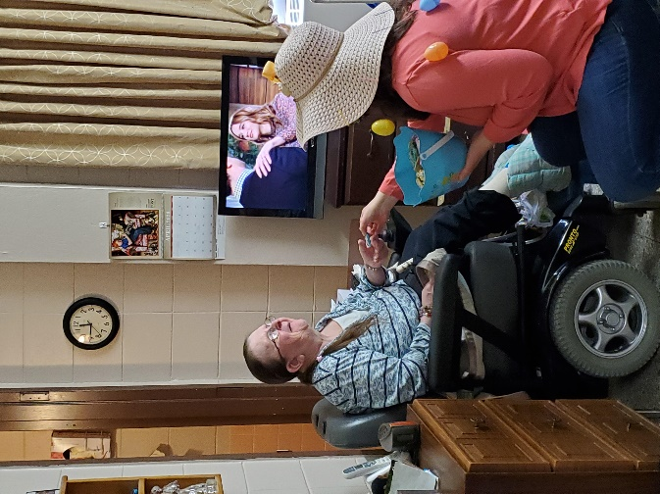

The Easter Bunny, AKA Christine Nelson, delivered chocolate bunnies

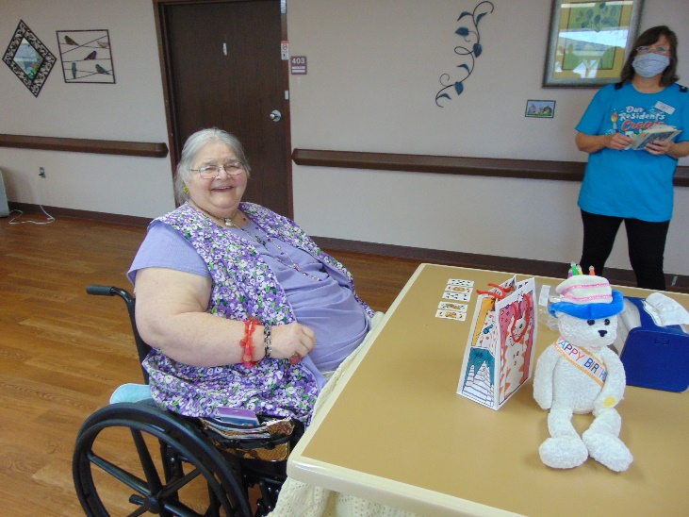 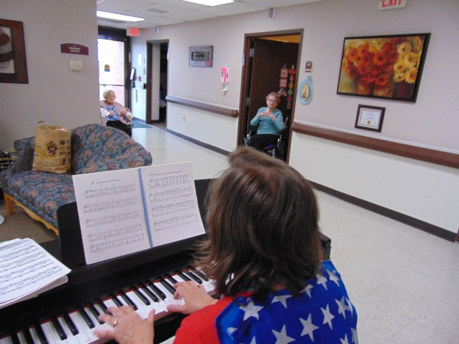

Playing some card Bingo in the halls Doing a sing-a-long /w Lisa in the hall

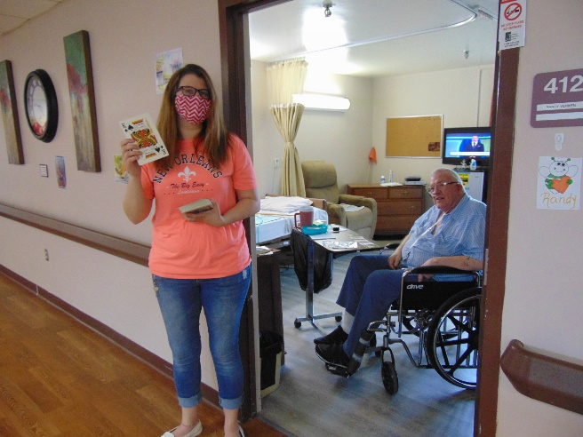 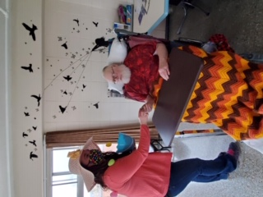

Card Bingo Easter visits

Well another week of adjusted programming for us. We entertained everyone with a cooking show on our in house channel 25. The residents watched in horror as pepper was added instead of salt, chocolate chips and flour went flying all over and eggs were broken on heads to make the cookies! These cookies (well maybe properly made ones) were then distributed about the home. Commercial breaks with food facts were also shared along with some great food and cookie jokes! Then we played a little card bingo, sang along while Lisa played the piano and also continued to enjoy stories, jokes and facts on channel 25 from Linda. Some more scenic drives were also taken to enjoy the nice weather. We have been part of a writing campaign put on by United Way, so letters of support and encouragement have been arriving for “any resident”. We had been reading them to different residents, but now will read these to anyone watching our channel in house. The in house channel has and will also allow us to share some religious services from our area churches as well.

We hope you all are doing well. Thanks for the video calls and letters and cards you are sending everyone here. We are all in this together!

Linda Fabry