Snapshots from April 12th to the 17th

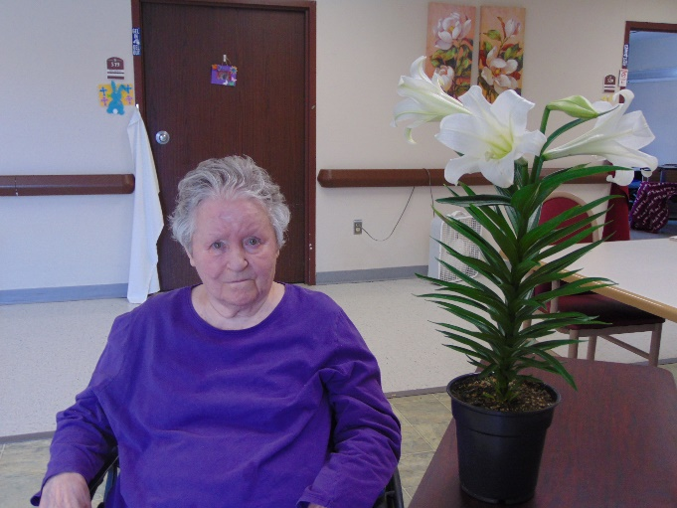 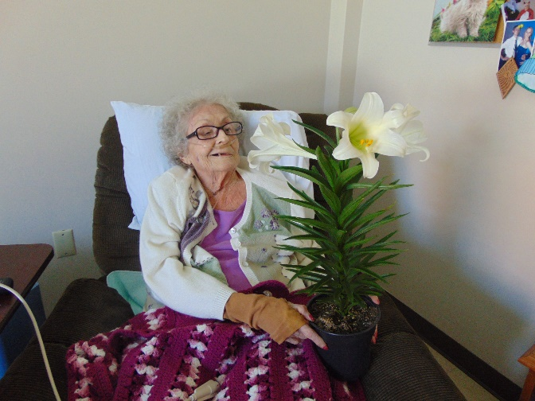

Easter Lilies provided by Sparta Floral were such a nice treat

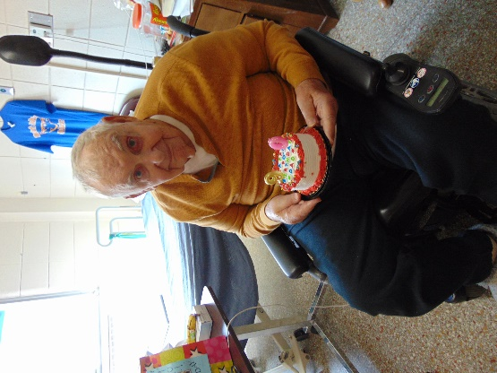 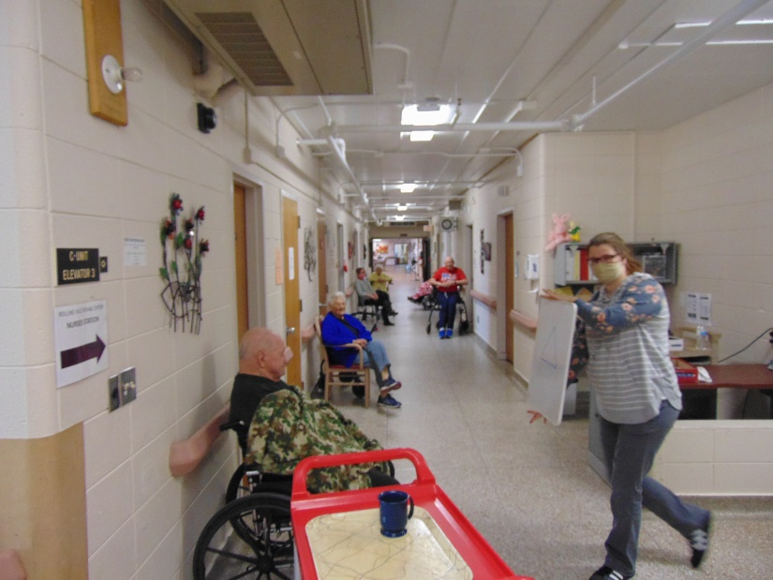

Happy Birthday Quarantine style Hallway Pictionary

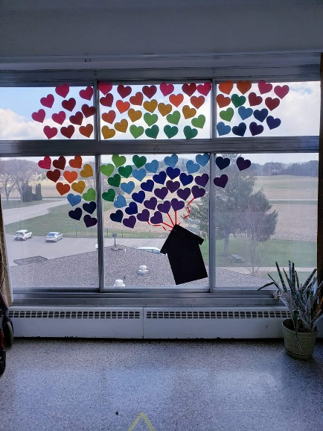Therapy decorated to bring some cheer

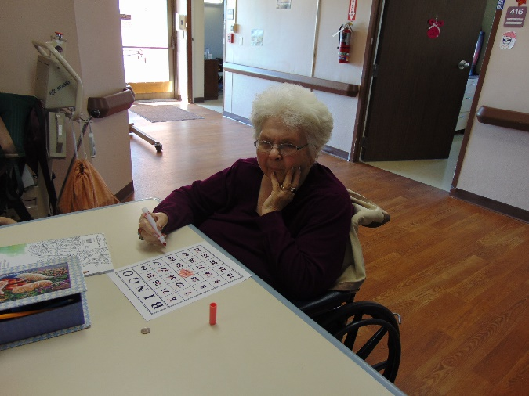 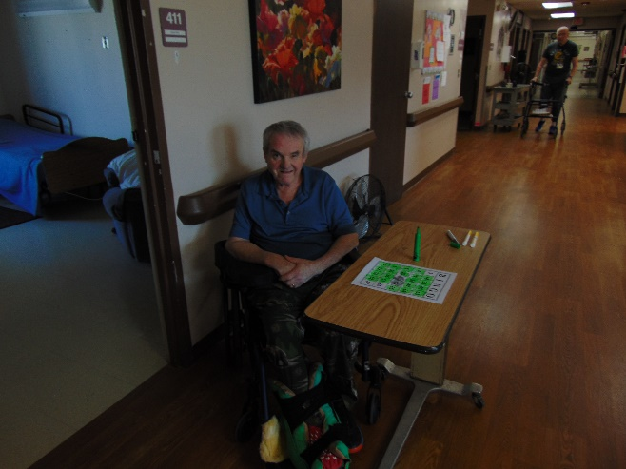

BINGO

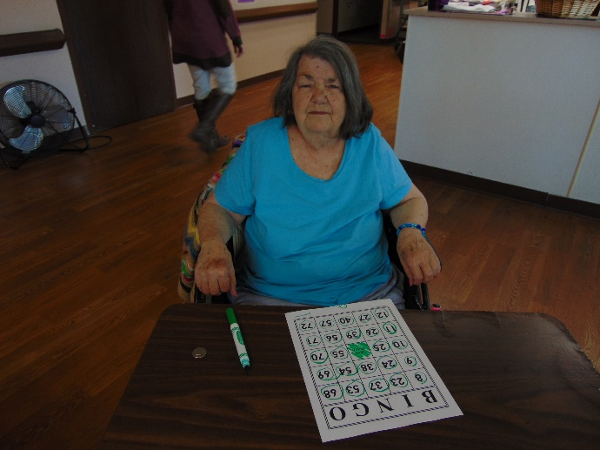 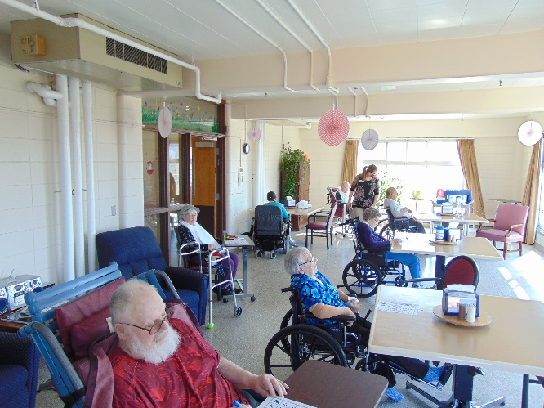

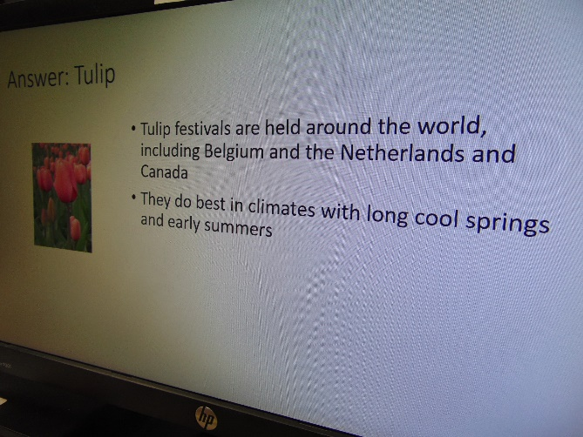 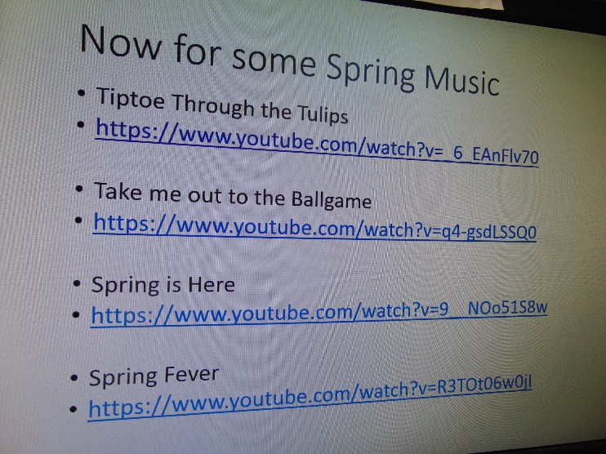

Linda used Channel 25 to do a Spring Program complete with trivia, pictures, songs and facts. They even watched some cleaning product commercials from years past

Hello and Happy Friday everyone!

Looks like we have another month of adjusted life and activities here at Rolling Hills.

This past week we have had the opportunity to watch our in house channel 25 and see some local 4H children offer their projects for all of us to see. Some played instruments, one sang and another taught us to draw and color a picture. We will be doing this the next 2 Mondays and are happy they included us in on this through zoom.

Linda and Lisa led another virtual Bible study, this time acapella as we found the piano and our computer speaker just don’t work the best together!

Live and learn and learn some more has been our motto this week.

We did some hallway Pictionary, word games, singing and bingo as well. Linda is using channel 25 more and more to share cards received from the community to read to everyone, keep everyone laughing with her horribly awful corny jokes and also to read a few uplifting stories.

She tried something new, and was able to lead an educational program through the tv all about Spring. The residents got to see spring flower pictures, hear some facts, smile at cute pictures of children, sing along to some spring songs and also watch some cleaning supply commercials from years ago!

Next week we have some new tricks and entertainment up our sleeve that we can’t wait to try.

As always, if you are interested in using face time or zoom to see and talk with your loved ones, please email Linda at [linda.fabry@co.monroe.wi.us](mailto:linda.fabry@co.monroe.wi.us)