Pictures of what we did the week of April 19th

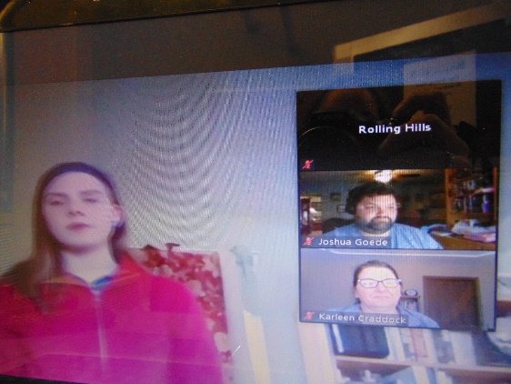 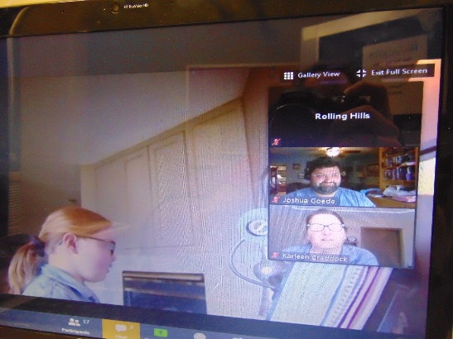

Watched the talented local 4H kids perform for us

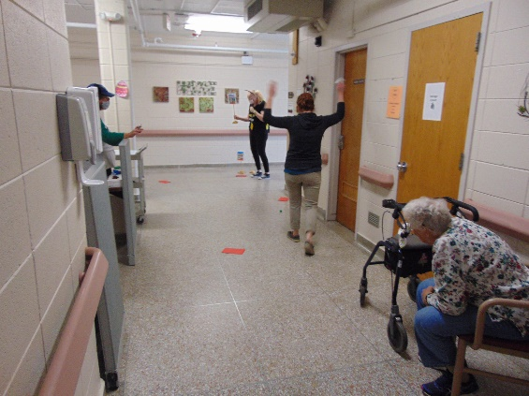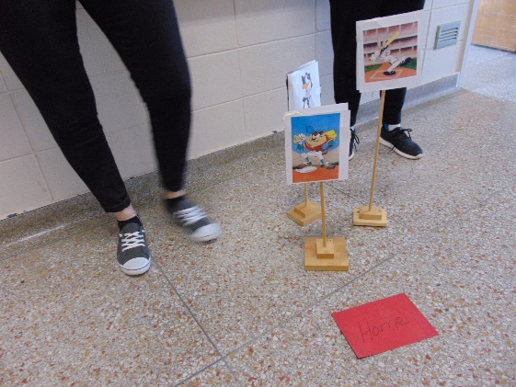

Played A game of Dice “Baseball” in the halls. It was Looney Tunes vs Disney

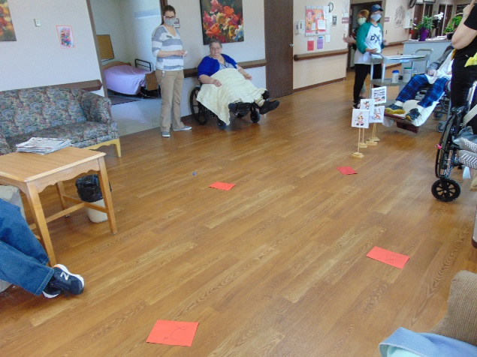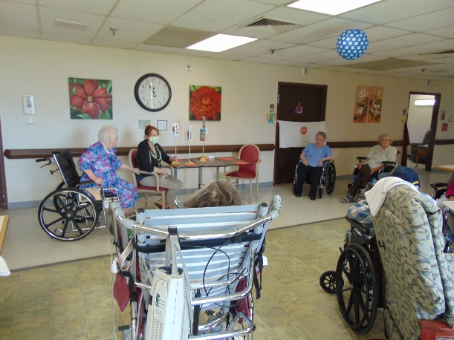

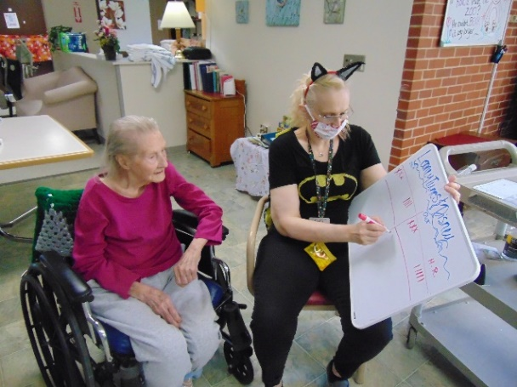 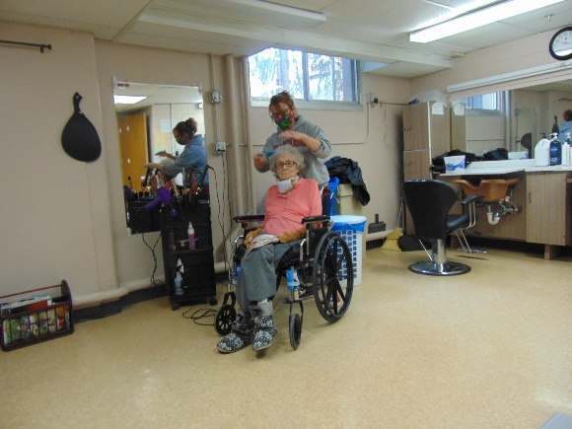

Continued trying to look nice with curls and cuts

On Crazy Hair & Hat day for staff, we also did a Makeup and Hair Tutorial on our in house channel

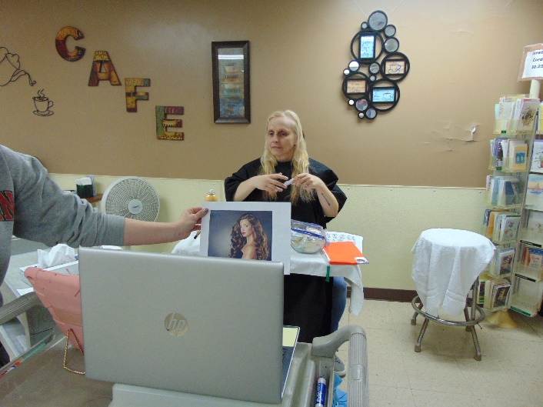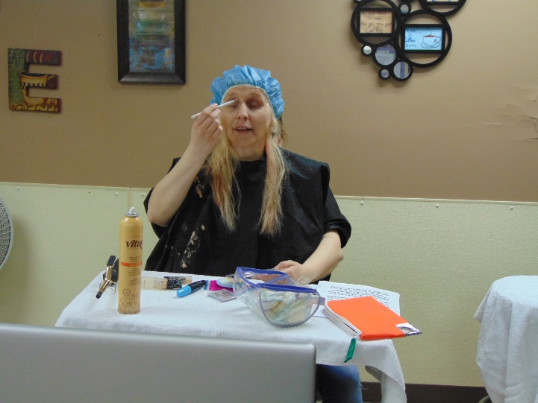

This was the start and what she was supposed to look like

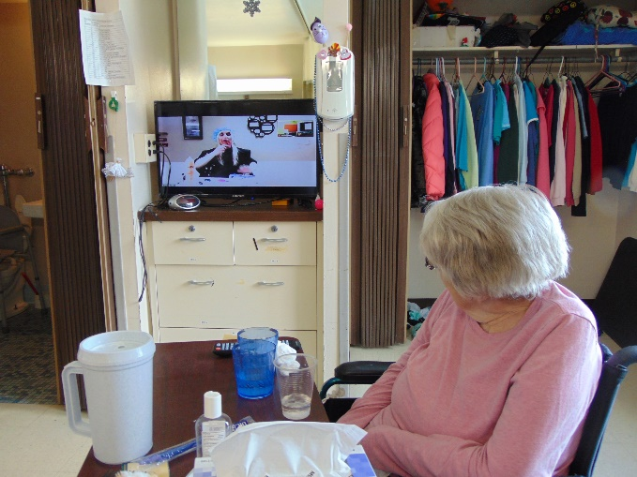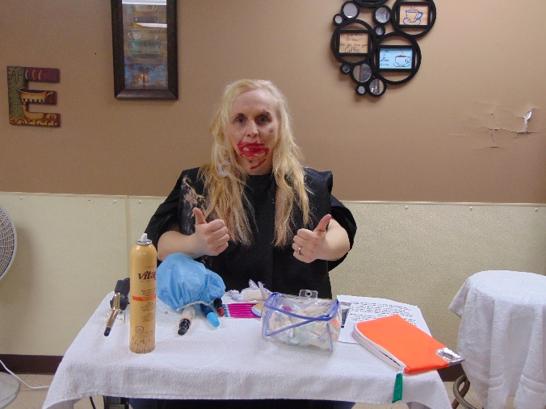

Laughs were had as our production was on all the TVs. I am sure you will hire us so you can look like this!

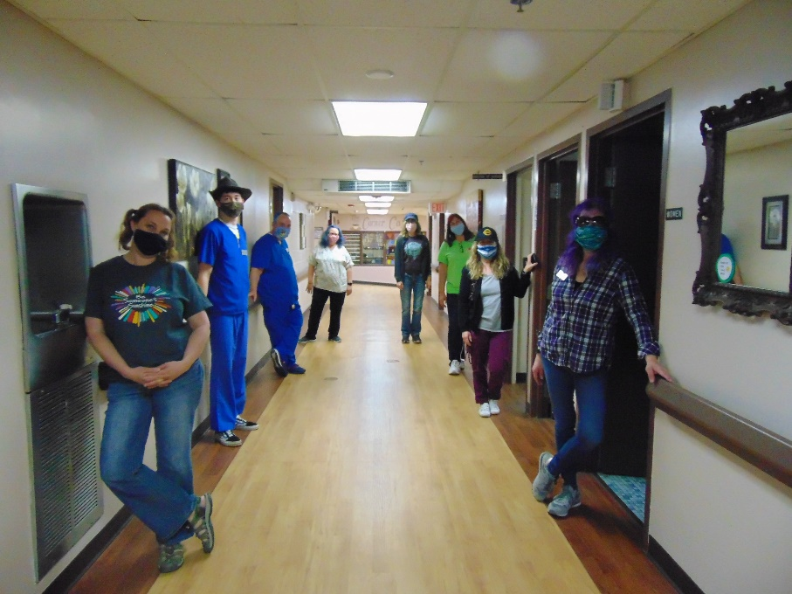

See the purple, Blue and pink hair??? Fun hats and pigtails ☺

We also are very thankful for all those in our community and beyond that have brightened the day of the residents and staff. We have received Lilies from Sparta Floral, Pizza from Dominoes and Papa Murphy’s, numerous cards of support and chalk messages, Fit testing solution from Tomah health and On Site Medical Service, N95 masks from Spartek and Stellar Mold and Tool, many homemade face masks and so much more. We know this is not an easy time, but our community is truly in this together!

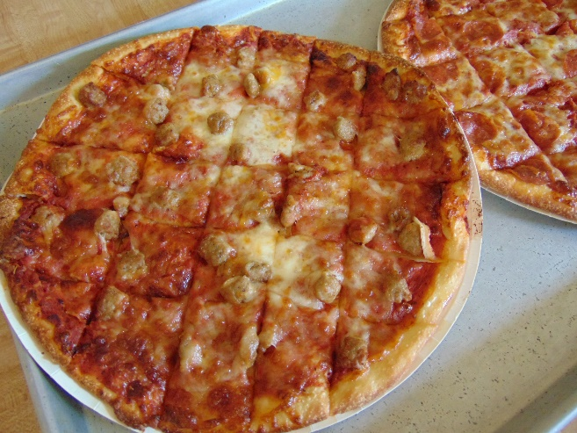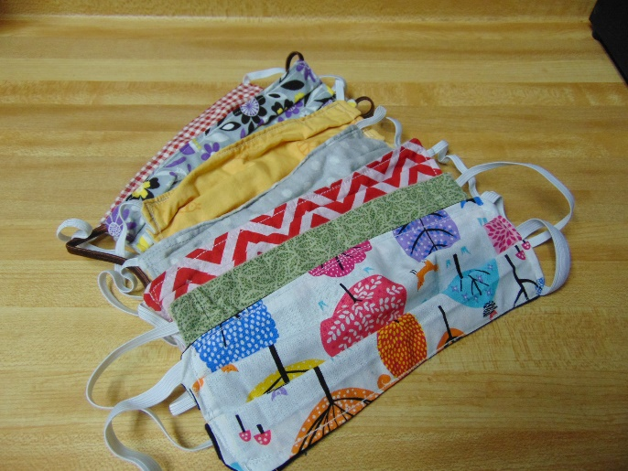

Laurel Adams from Cashton entertained with music and stories and was well received!

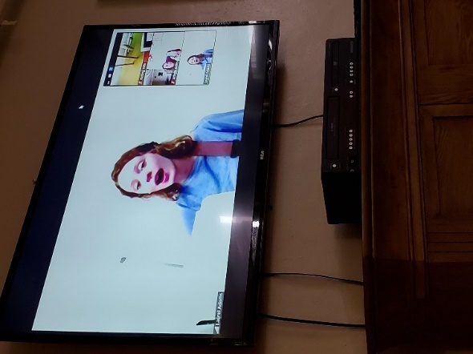 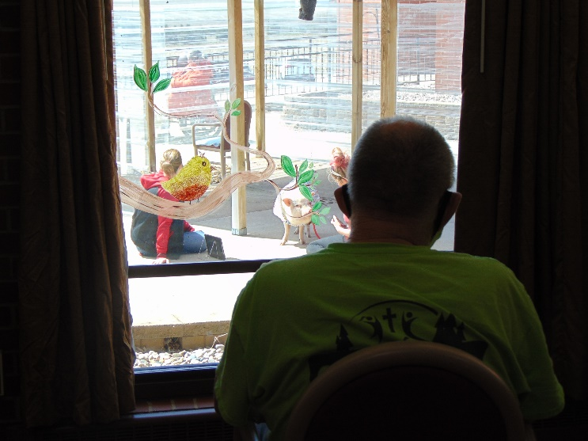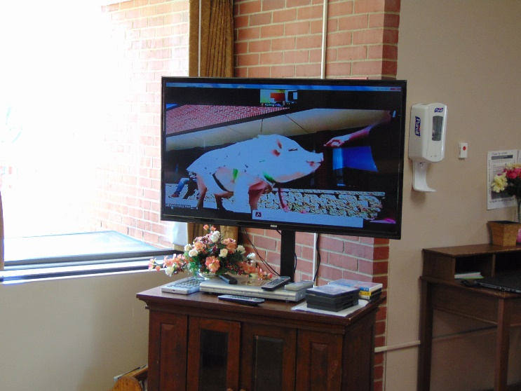 Brutus stopped by for a visit outside and was broadcast inside to all our rooms ☺

Happy Friday everyone!

Here we are with another week of unique opportunities!

We decided to have some fun with a theme day of crazy hair and hats for the staff and that day the activity department put on a silly production on channel 25. They gave a hair and makeup tutorial that if you see the pictures, we know you will hire us for your next special event! (I must say it is hard to be the arms of someone else, but the laughs that it brings are priceless)

We decided to play a little dice “Baseball” this week too. And we of course had to sing Take me out to the ballgame during the 7th inning stretch. Each hall had a different team win, having Disney vs. Looney toons for the game of the week. To end our week we had Brutus, our pet therapy pig, come out and enjoy his cheerios for tricks and sunshine. Some could see him from their windows and others watched their tv’s.

We hope you all continue to stay safe and healthy!